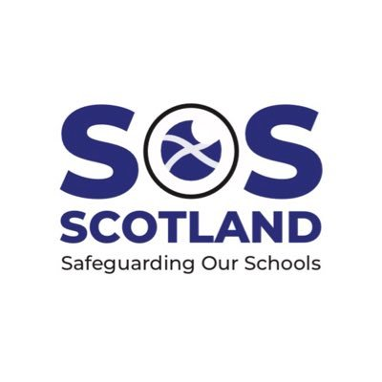

We have asked our lawyers and they say the policy meets legal requirements.
Ask the school how the policy is in line with the Equality Act 2010, Getting it Right for Every Child, and Education Scotland’s Child Protection Policy which states:
“In all Education Scotland’s work, the needs, interests and wellbeing of children and young people and protected adults must be put above the needs and interests of all others. Hence, this Policy and the guidance contained within it must have priority over all other policies and advice”.
If the policy is a Transgender Inclusion Policy that is similar to the Oxford ‘Trans Inclusion Toolkit’ which was withdrawn following legal action, ask the school if they are confident their lawyers would be able to defend their policy in the event of similar legal action.

