What will preschool be like for me?
Mummy & Daddy or your grown up can come in for registration.
There is NO red and blue group, it will be one big playroom.
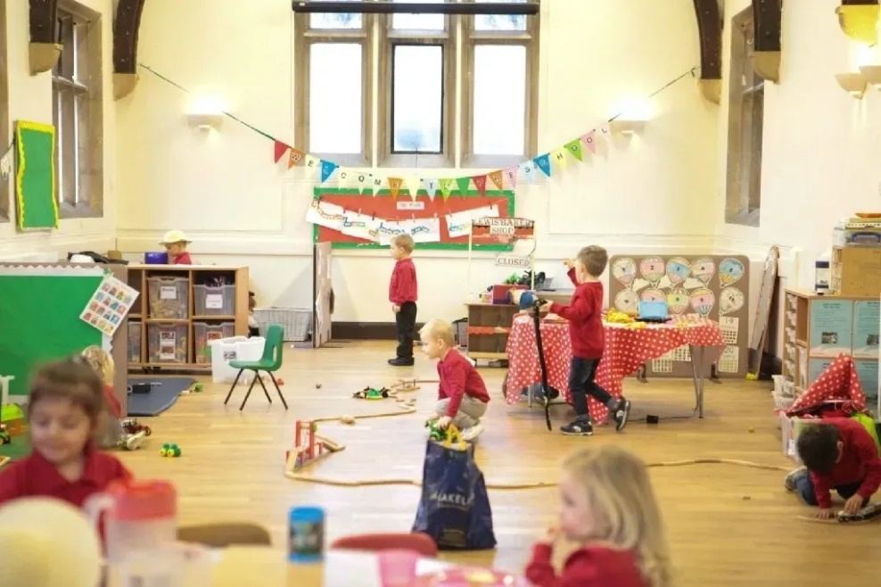

There is NO red and blue group outside, it will be one big playground.
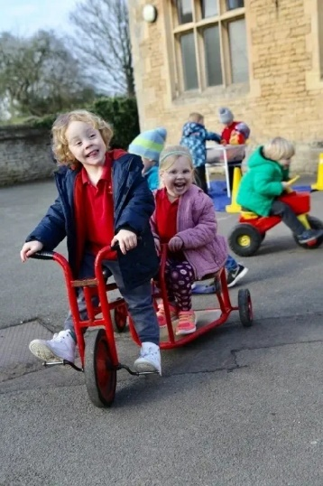
The ladies are all going to be able to play and help you.

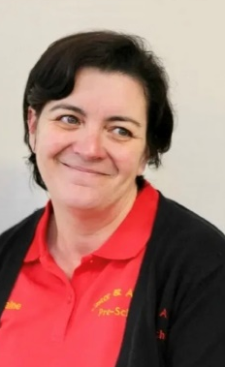
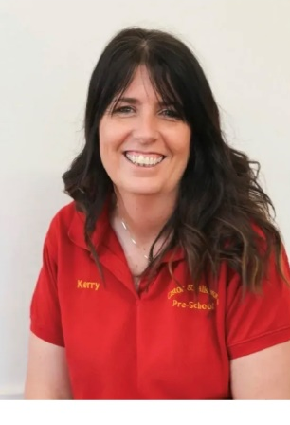
All ladies working together again!

There is NO red and blue toilet, there is just one for children.

Look forward to seeing you in September!
Kerry, Jenny, Sam, Elaine & Amanda

