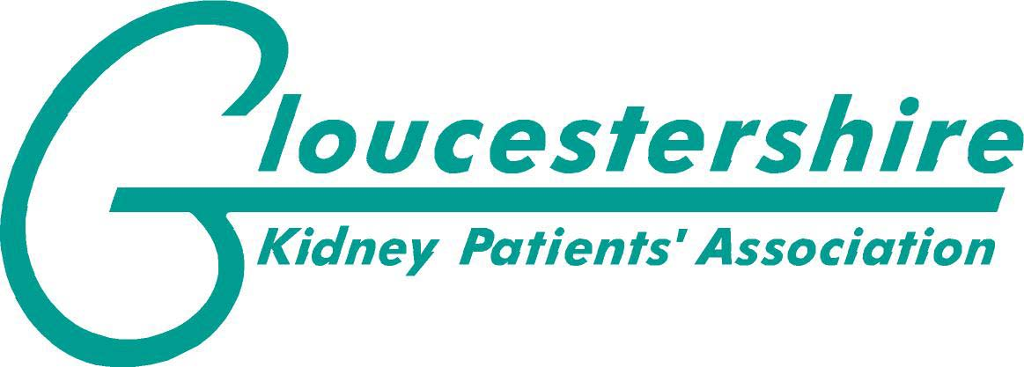

**Newsletter April 2020**

During this difficult time we are conscious that many of you will be self-isolating and feel disconnected with what’s going on so we’re sending our first newsletter for 2020 just to let you know we’re still here for all kidney patients.

The newsletter is shorter than usual and obviously our plans for the year are on hold.

An apology to anyone who normally has the newsletter by post but I am unable to get it printed and posted out as I am in self isolation with my husband who is a transplant patient. If you know of anyone who isn’t on email I would be grateful if you could pass a copy onto them.

The AGM has been cancelled and will take place later in the year. We will let you all know as soon as we know the date.

No decision has been taken about the holiday yet.

We have information about Covid 19 on our website with some helpful links to Kidney Care UK, Public Health England and World Health Organisation.

Kidney Care UK are providing lots of information and it’s being updated regularly. If there’s anything you’re not sure about they will probably have the answer.

**Coffee and Chat**

Our second Coffee and Chat was held on 6th March at Tescos.

Obviously Covid19 was uppermost in everyone’s mind so attendance was low.

We will start the meetings up again as soon as life is back to normal

Before Covid19 struck we had two successful events for World Kidney Day.

The first one took place on 9th March in the Atrium at Gloucester Royal Hospital while the Renal Clinic was on.

Thank you to everyone who stopped to have a chat and a welcome to the new members who joined.

The second event was in Kings Walk Shopping Centre on Thursday 12th March.

It was a cold and windy spot but there was plenty of interest and lots of people stopped to find out who we were and what we were about.

If you have any questions for us please don’t hesitate to contact us.

Details below.

Email <gloskpa.org>

Phone 01452 311199 GKPA is a registered Charity No 900181