Bulletin Information
DATE: | March 16, 2026 | TYPE: | Information | NUMBER: | 009-26
SUBJECT: | 2026 Spring Change Of Card Online Bid Instructions

Details
Attention All T&E Employees,
Please be advised that we are ONLY accepting bids submitted through the COC online bidding portal.
Bids or Changes will not be accepted by fax or email
Below are the instructions on how to submit your bid online.
IF YOU ENCOUNTER ANY ISSUES WITH ACCESSING OR SUBMITTING YOUR BID, CALL THE IS HELP DESK at 1-800-387-1833

From External Website (employees.cpr.ca)
If signing onto CP Station externally, you must access the AV bid form from the employees.cpr.ca landing page. The link has been added to the bottom (Change of Card Bid link will replace the Mileage Date Bid link pictured below). Once you click on the link, proceed to step 5.
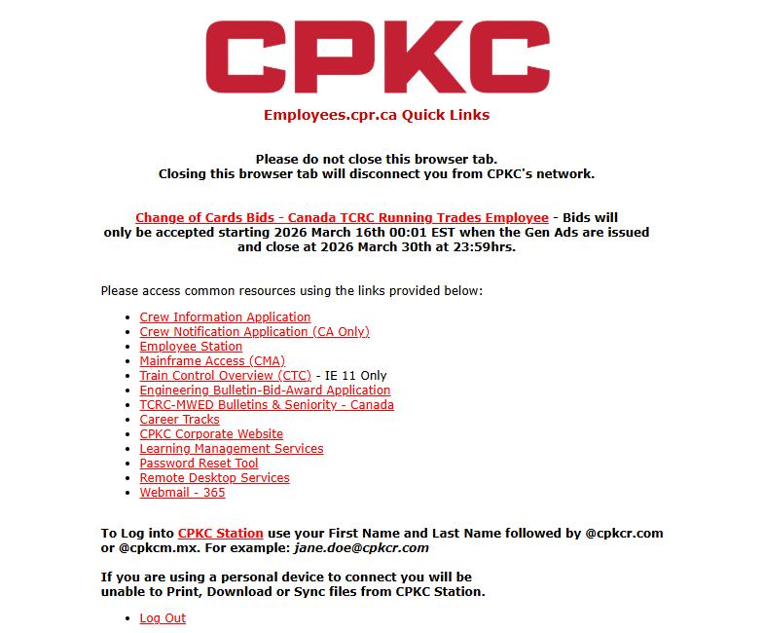

Step 1
CTRL + F3 to take you to CP Station
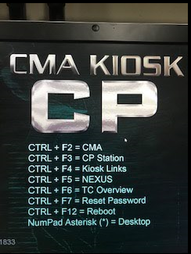

Step 2
Click the CP Logo at the top left of CP Station, then click on the arrow beside ‘Work Tools’, then click the arrow beside the next ‘Work Tools’ and then select ‘Frequently Accessed Links’:
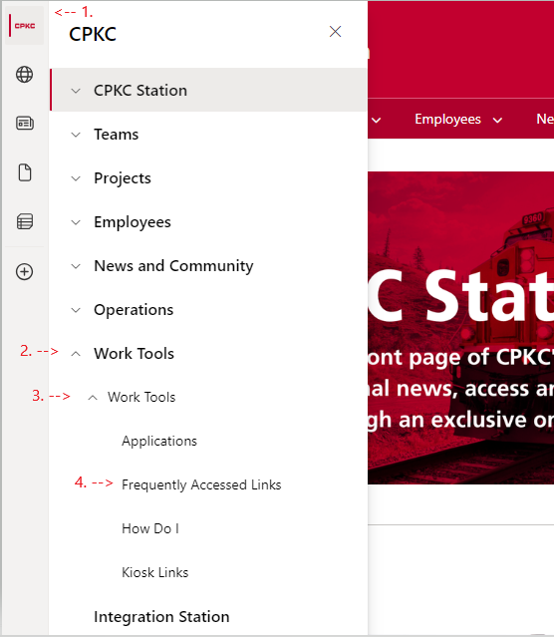
Step 3
Scroll down the list of Frequently Accessed Applications and click on ‘Crew Information’
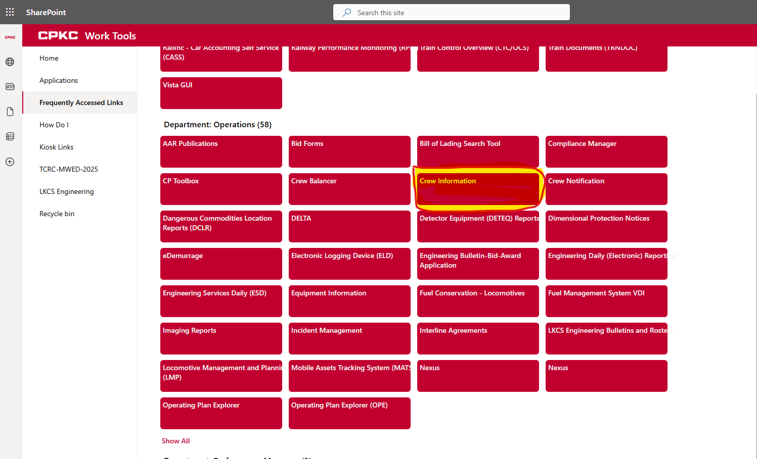

Step 4
Click the link “https://wappp0309.cpr.ca:4431/ChangeCardsBids” located under the crew information link.
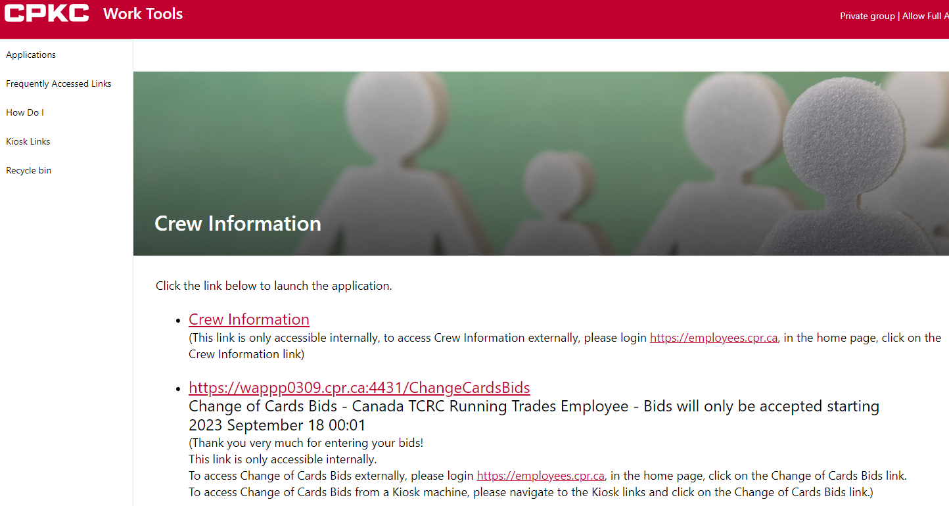
Step 5
The loaded form will need to be completed for each employee wishing to submit a change of card bid, for each craft they wish to bid (ie. Engineer positions will be bid by selecting ‘Bid Craft’ option ‘Engineer’. All CTY crafts will select ‘Conductor’).
- You must fill out your employee number in the “Employee CP ID#” field
- You must fill out an email address in order to receive an email confirmation of your bid. This can be to any valid email address, internal or external
- You must fill out your name as it appears in CMA in the “Employee Name” field
- You must select your current home terminal from the drop down menu.
- If you are wishing to change home terminals, please select the checkbox “Requesting to change home terminals” option. If not, please leave this blank.
- You must select “YES” in the user agreement to verify you are submitting a bid on your own behalf and not for another employee
- Once these fields are filled in, click the Bid Craft drop down box and select the craft you wish to submit a bid for.
Your information should be entered before you continue to enter your bid choices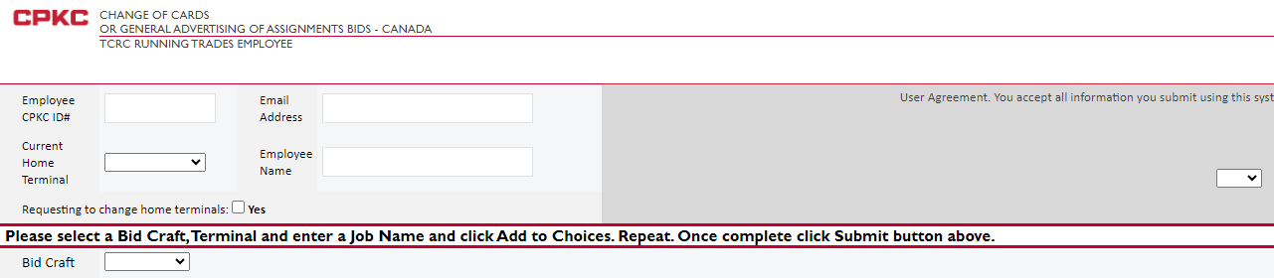

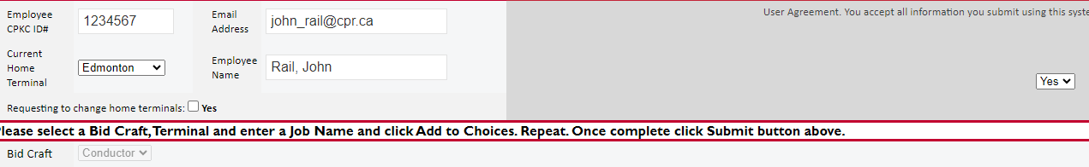
IF YOU ENOUNTER ANY ISSUES WITH ACCESSING OR SUBMITTING YOUR ID, CALL THE IS HELP DESK @ 1-800-387-1833
Step 6

For the selected craft you are bidding, select any of the extra bidding codes you wish for your change of card bid. Codes are only selectable for the chosen bid craft. Making changes to these selections is optional.

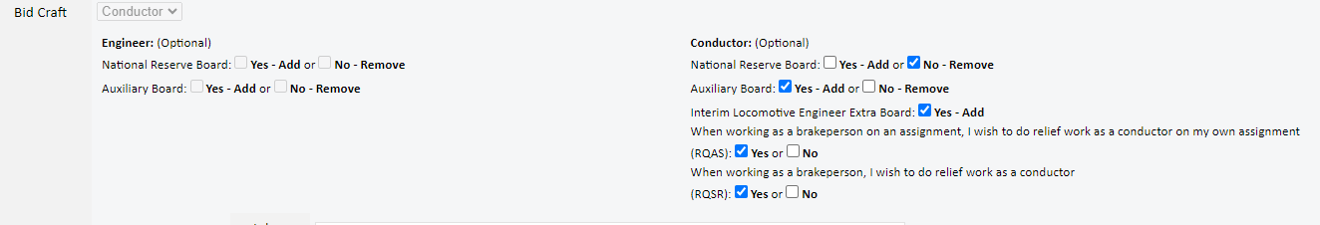

Step 7

To enter your bid choices, please select the terminal the bid job is located in, and then type in the job name in the field beside it. Please type out the job name as it appears on the change of card bulletin. Be specific, and for CTY bids, please ensure you are including which craft position (Foreman, Helper, Conductor, etc.) you are bidding. Choices that are not on the General Advertisement will be disregarded. Choose “Add to Choices” button for each position you wish to bid. If you need to undo a choice, please use the “Clear Last Choice” button to undo the last added choice.
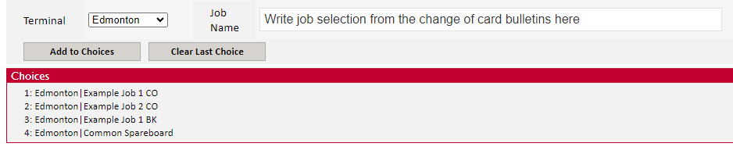
Step 8

At the top right of the form, select “Submit” once your bid is complete to submit the bid. If you wish to cancel submitting a bid, select "Cancel” and the bid will not be submitted. If you wish to enter a bid for another craft, please repeat the process above while selecting the other Bid Craft option on the bid.

Step 9

An email confirmation of your bid will be sent to the email address provided at the top of the bid. If there are errors you wish to correct, please submit a new bid through the bidding application and it will overwrite the previously submitted bid.

Bids or changes to bids will not be accepted by fax or email.

