**From External Website (employees.cpr.ca)**

If signing onto CP Station externally, you must access the Mileage date form from the employees.cpr.ca landing page. The link has been added to the bottom (pictured below). Once you click on the link, proceed to step 5.

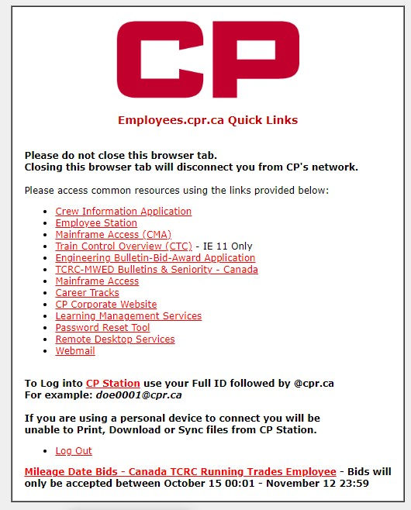

**From Within The CP Network Using a Kiosk**

**Step 1**

**CTRL + F3** to take you to **CP Station**

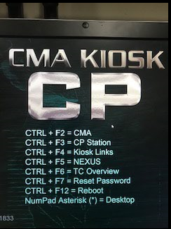

**Step 2**

Click the CP Logo at the top left of CP Station, then click on the arrow beside ‘Work Tools’, then click the arrow beside the next ‘Work Tools’ and then select ‘Frequently Accessed Links’

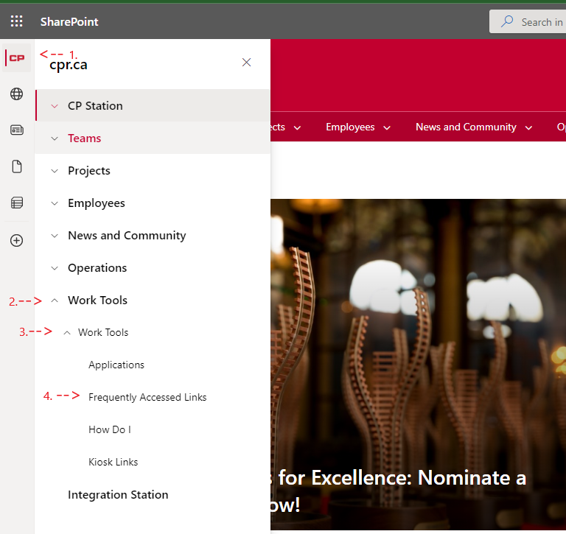

**Step 3**

Scroll down the list of Frequently Accessed Applications and click on ‘Crew Information’

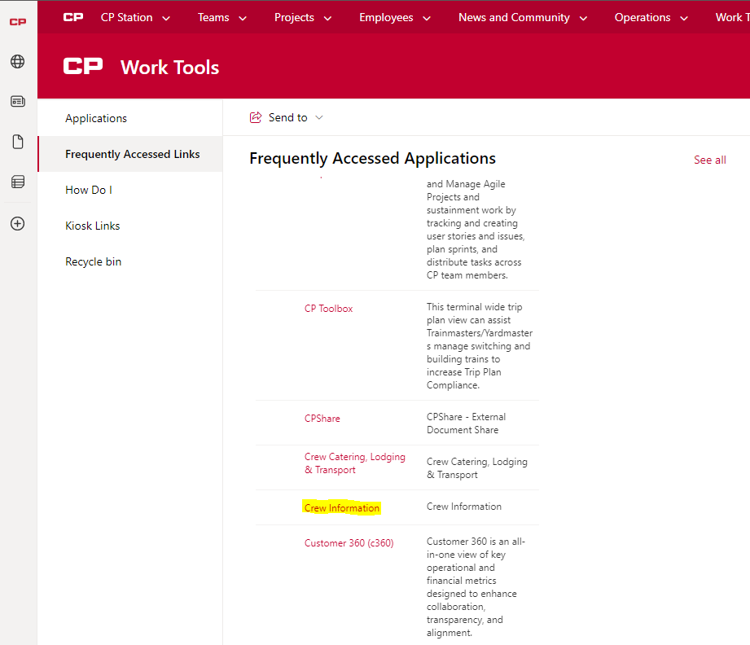

**Step 4**

Click the link “**Mileage Date Bids – Canada TCRC Running Trades Employee**” located under the crew information link

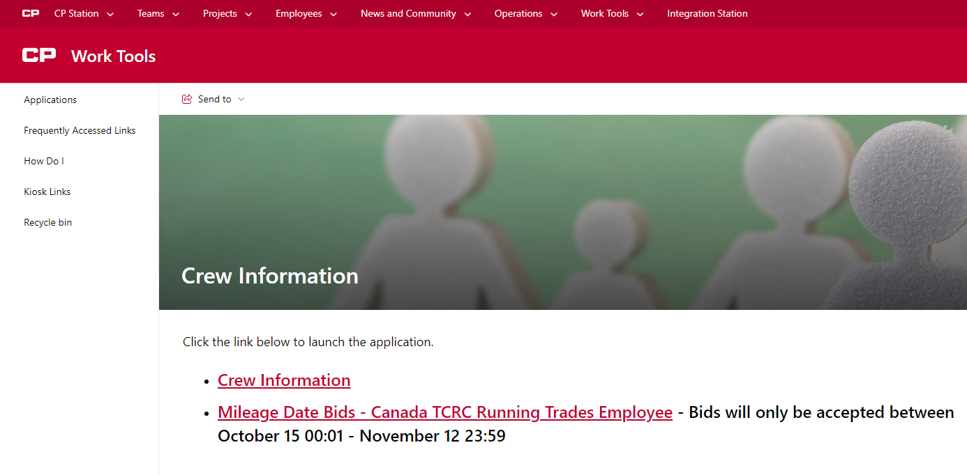

**Step 5**

You will see this form to be filled out by each employee wanting submit a mileage date bid form

* You must fill out your employee number in the “Employee CP ID#” field
* You must fill out an email address in order to receive an email confirmation of your bid. This can be to any valid email address, internal or external
* You must fill out your last name in the “Employee Last Name” field
* You must select “YES” in the user agreement to verify you are submitting a bid on your own behalf and not for another employee
* Once these 4 fields are filled in, click **continue** to begin to add your mileage date choices

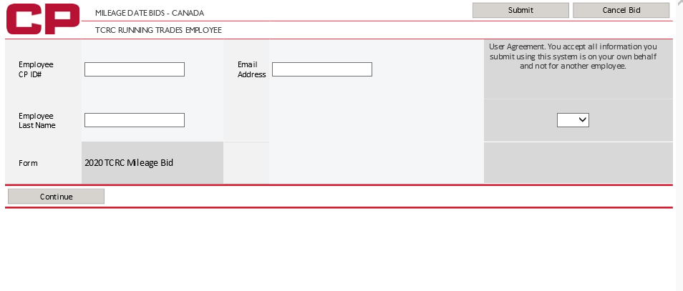

**Step 6**

* Enter up to 28 choices in the **“Enter Mileage Date”** box
* Only 1 choice at a time can be added
* After each choice is entered into the box, click the **“Add to List”** button to add the choice to your bid form
* Only numbers 1 – 28 will be accepted within the form
* If you need to clear your last choice, click the **“Clear Last Choice”** button. Only your last choice can be cleared so if you have entered 10 choices and need to clear your 5th choice, you will need to clear all choices in between 5 and 10 to get back to choice 5.
* Once you have added all the choices you desire, click “submit” in the top right hand corner

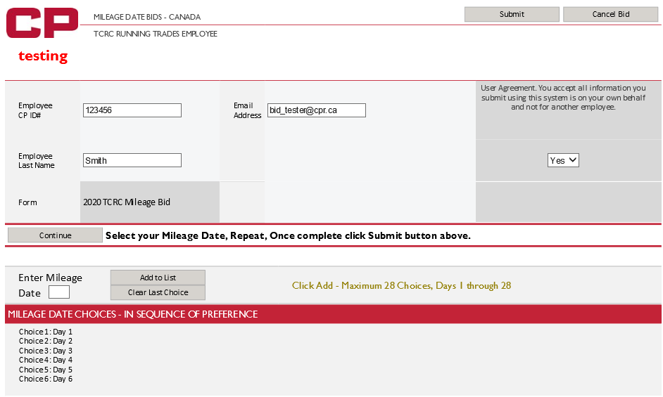

You will see this screen once your bid has been successfully submitted

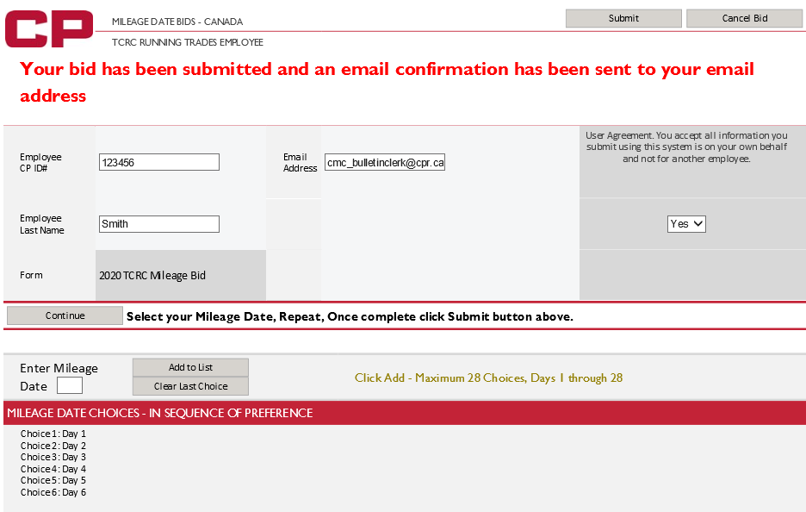

* You will receive the below email confirmation. Please ensure you receive the confirmation email and you review all information you’ve entered (employee number, bid choices, etc.) is accurate.
* If you want to make any changes or don’t receive a confirmation email, you can submit another bid.
* **Only your most recent bid will be accepted.**

