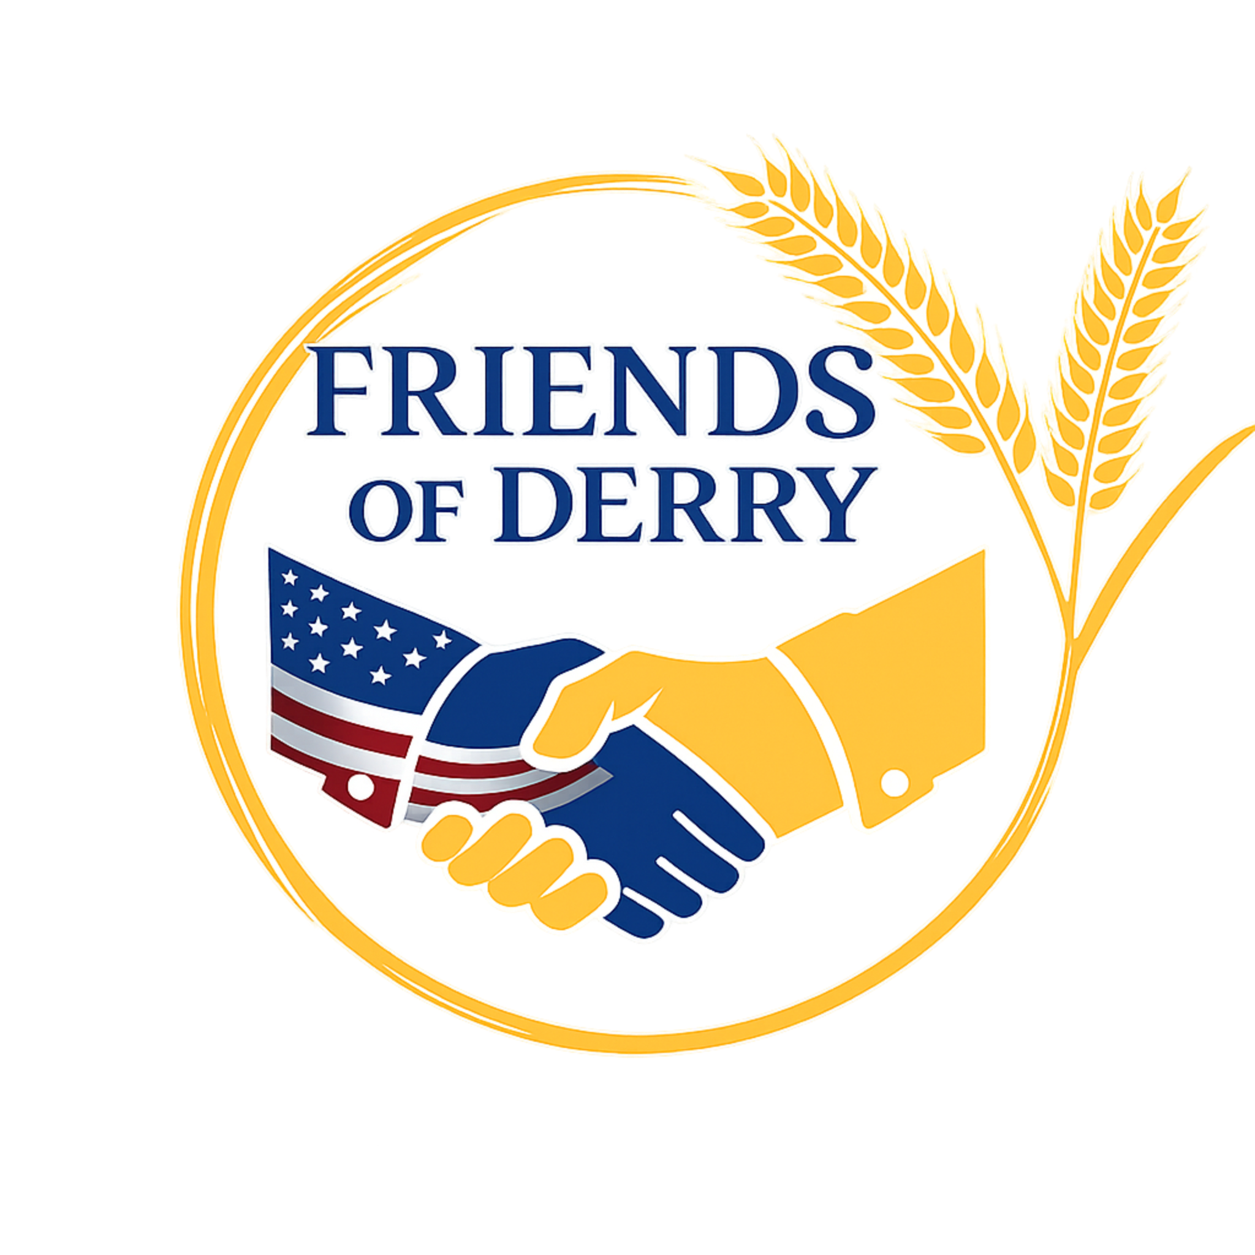

Dear Community Partner,
My name is Nathan Bundy, and I’m reaching out on behalf of Friends of Derry to ask for your support of our Bingo Fundraiser on May 31, 2026 at Cooperstown Event Center.
Friends of Derry was founded by a group of civic-minded individuals who saw a need for increased community engagement and recreational opportunities in our town.
For our Bingo Fundraiser, proceeds will benefit our three initiatives: downtown, pool, and history. Through our downtown initiative, Mossback Park continues to grow as a vibrant hub of activity through events like Food Truck Fridays. Through our pool initiative, we support improvements to one of Derry’s most cherished community assets. Finally, through our history initiative, we work to preserve and celebrate our town’s rich heritage.
We are specifically seeking sponsorships for bingo game payouts, including a $1,000 Jackpot Sponsor, as well as basket raffle donations such as gift cards, merchandise, or themed baskets.
We expect an audience of approximately 300 attendees. Sponsors will be recognized at the event, on promotional materials, and across our social media platforms, which reach over 1.4 million people annually.
We are happy to arrange pickup of donations, or you may mail them to PO Box 10, Derry, PA 15627. Online sponsorships may also be submitted at pay.friendsofderry.com.
Thank you for your consideration. We truly appreciate your support and hope you will consider partnering with us to make a positive impact in our community.

Kind regards,
Nathan Bundy
Director, Friends of Derry
Friends of Derry Bingo Sponsor Form
We thank you for your support!!
Business/Individual Name: ________________________________
Contact Name: __________________________________________
Business Address: _______________________________________
City: __________ State: ______ Zip: __________
Phone Number: __________________________________________
Email Address: __________________________________________

Please circle the type of game and amount you would like to sponsor:
Regular Quickies Special Jackpot
$50 $75 $100 $1,000
Other Amount: $__________
Additional funds in excess of game payouts will be distributed towards additional game prizes or basket raffle.

Please make checks payable to: Friends of Derry
Please mail the form and payment to:
Friends of Derry
PO BOX 10
Derry, PA 15627

Or submit payment online securely at pay.friendsofderry.com

