

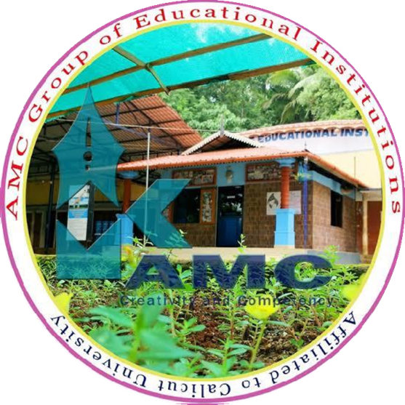
CRIETERION | 6- GOVERNANCE , LEADERSHIP AND MANAGEMENT
METRIC NO. | 6.3.3 AVERAGE NUMBER OF PROFESSIONAL DEVELOPMENT /ADMINISTRATIVE TRAINING PROGRAMS ORGANIZED BY THE INSTITUTION FOR TEACHING AND NON TEACHING STAFF DURING THE LAST YEARS.
FILE DESCRIPTION | REPORT OF FDP

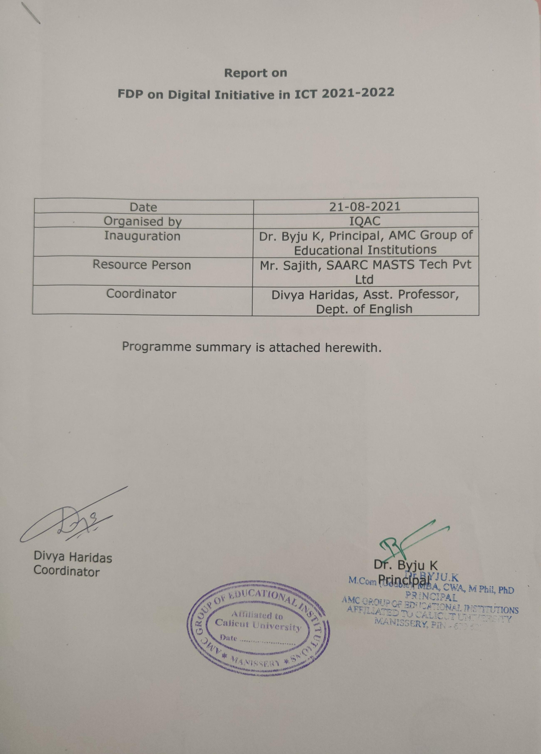

Programme Summary
FDP on Digital Initiative in ICT
Organized by IQAC
Date: 21/08/2021
Venue: Audio Visual Hall
A Faculty Development Programme on “Digital Initiative in ICT” was organized by IQAC in the institution. The programme was inaugurated by honourable Principal Dr. Byju. K. The resource person for the session was Mr.Sajith, Saarc Masts Tech Pvt Ltd. Ms. Vasanthi. P, Head, Department of Economics gave a hearty welcome to all. The Keynote Speaker gave an insight into the latest happenings and developments in the field of Information Technology. The session was very informative. It ended up with thanks giving speech by Ms. Divya Haridas, Assistant Professor, Department of English.

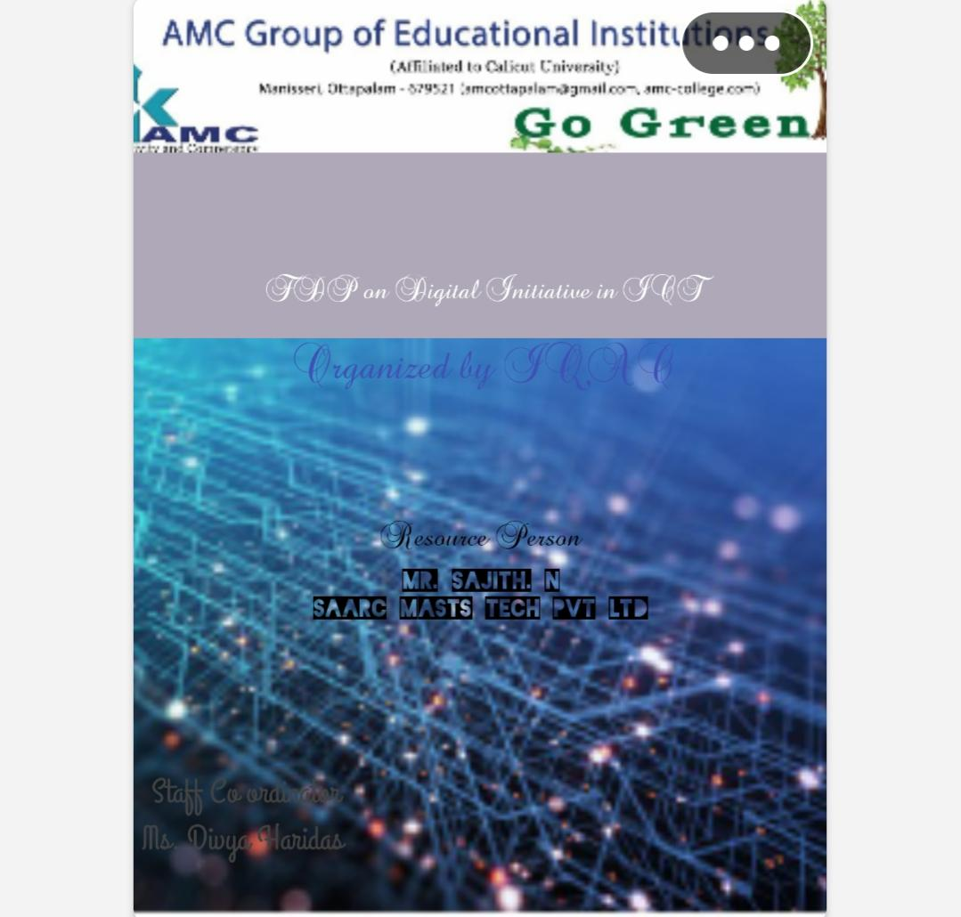
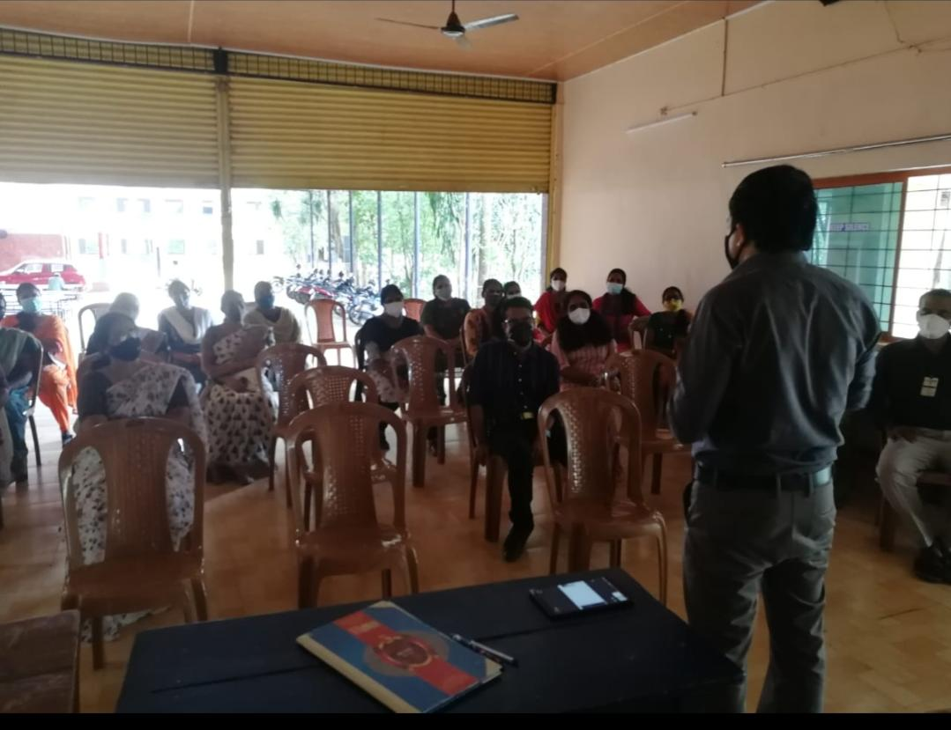
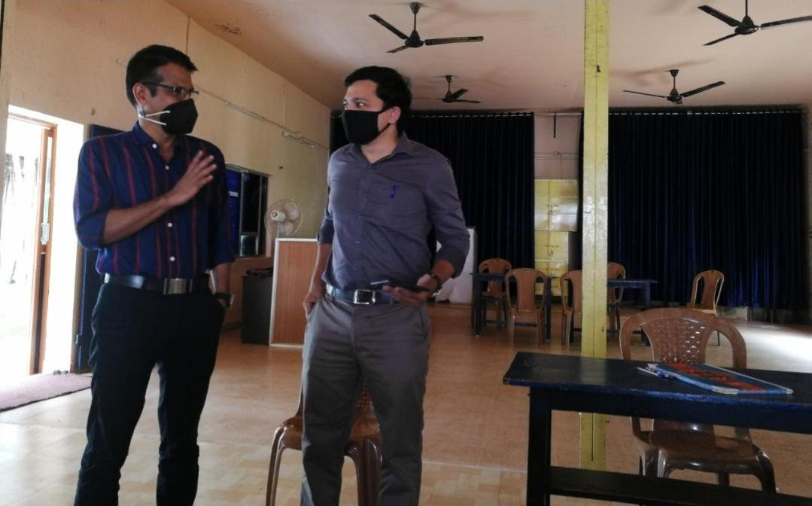
Programme Chart

1.Silent Prayer
2.Welcome Speech: Ms. Vasanthi. P, Head Department of Economics
3.Inauguration : Dr. Byju. K, Principal
4.Resource Person : Mr. Sajith. N, SAARC MASTS Tech Pvt Ltd
5.Vote of thanks : Ms. Divya Haridas, Assistant Professor, Department of English

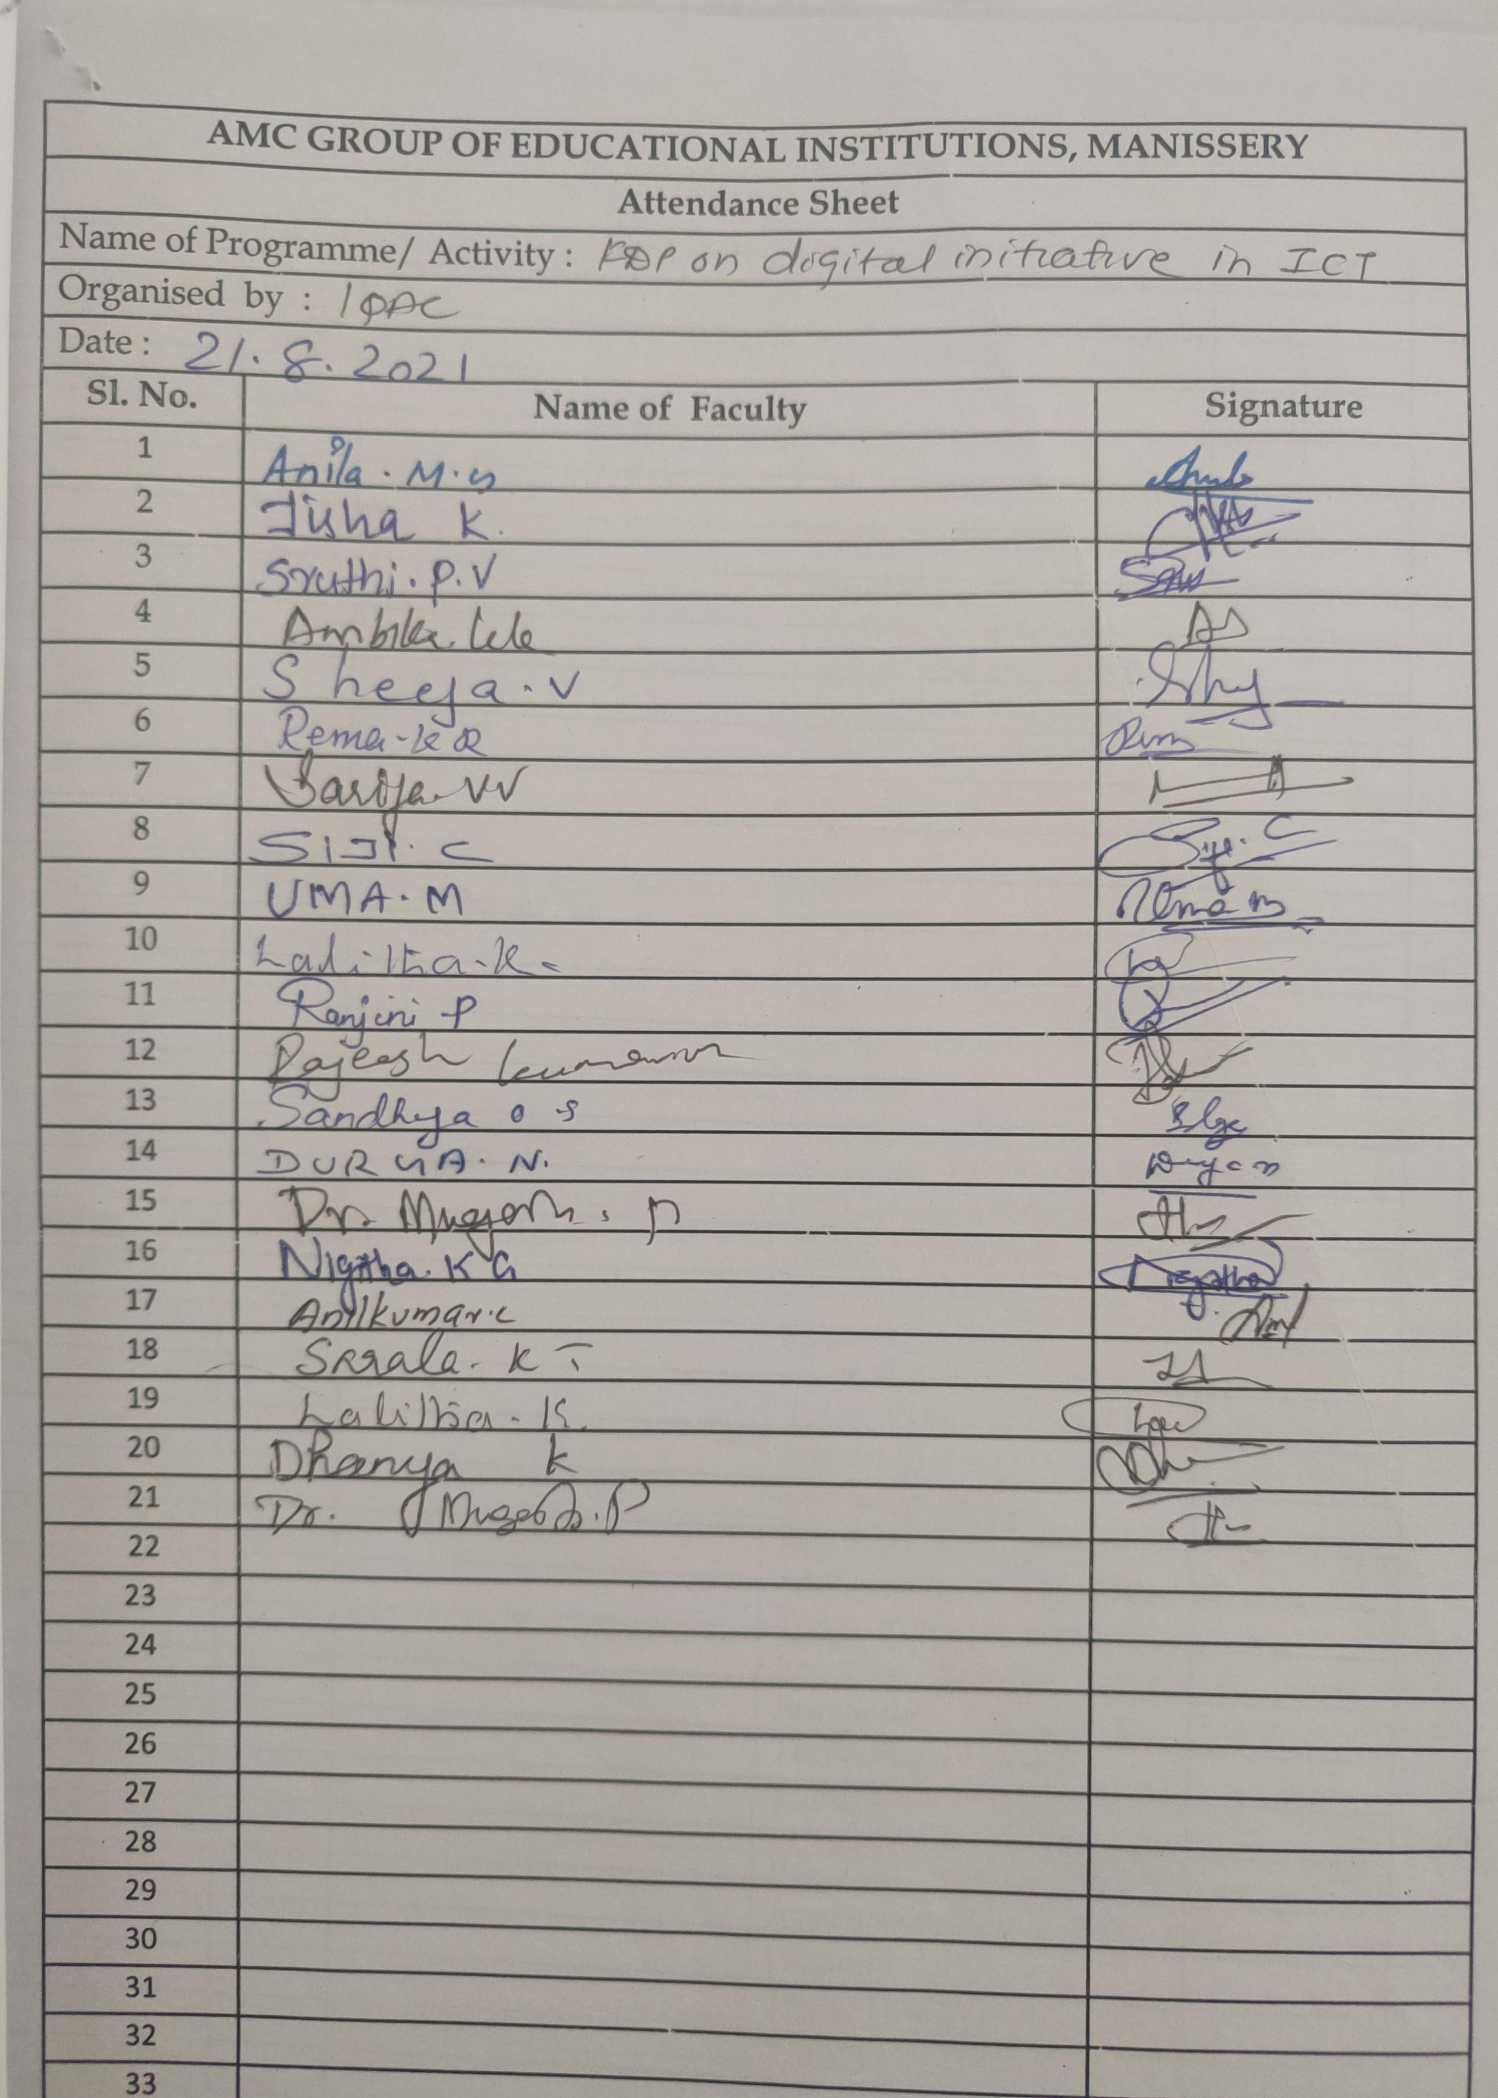

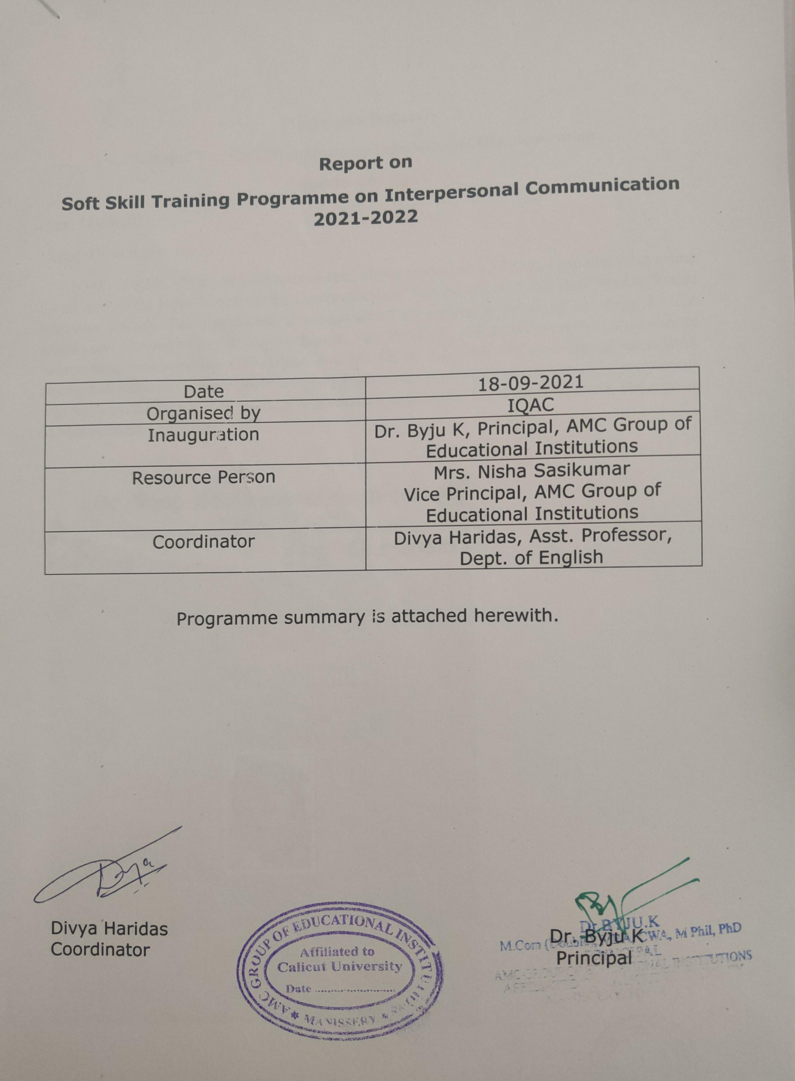

Programme Summary
Soft skill Training Programme on Interpersonal Communication
Organized by IQAC
Date: 18/09/2021
Venue: Open Auditorium
IQAC in AMC Group of Educational Institutions organized a Soft skill training programme for all staff on the topic “Interpersonal Communication” Ms. Sarala. K. T, General Head delivered Welcome Speech. The programme was inaugurated by honorable Principal Dr. Byju. K. The session was handled by Ms. Nisha Sasikumar, Vice Principal. She emphasized the importance of interpersonal communication in day to day life which cultivates the character of team work amongst all staff. The session included many team building activities and games. The programme was really useful for all. The thanks giving speech was given by Ms. Durga. N, Head, Department of Management.

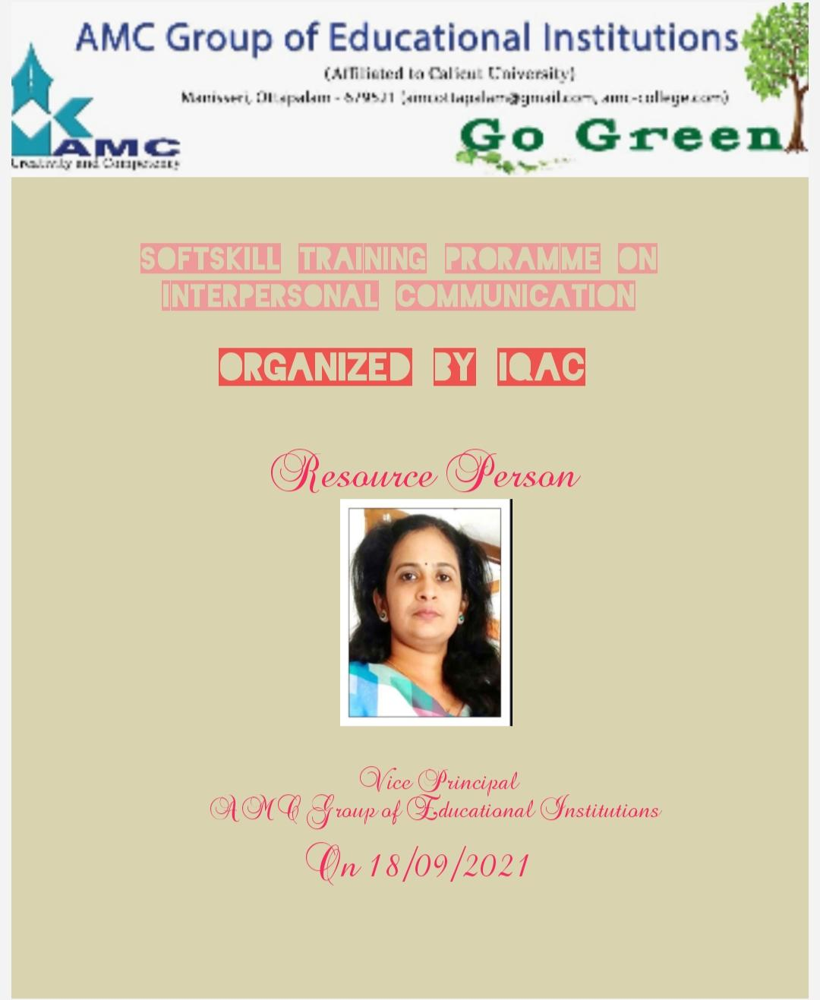
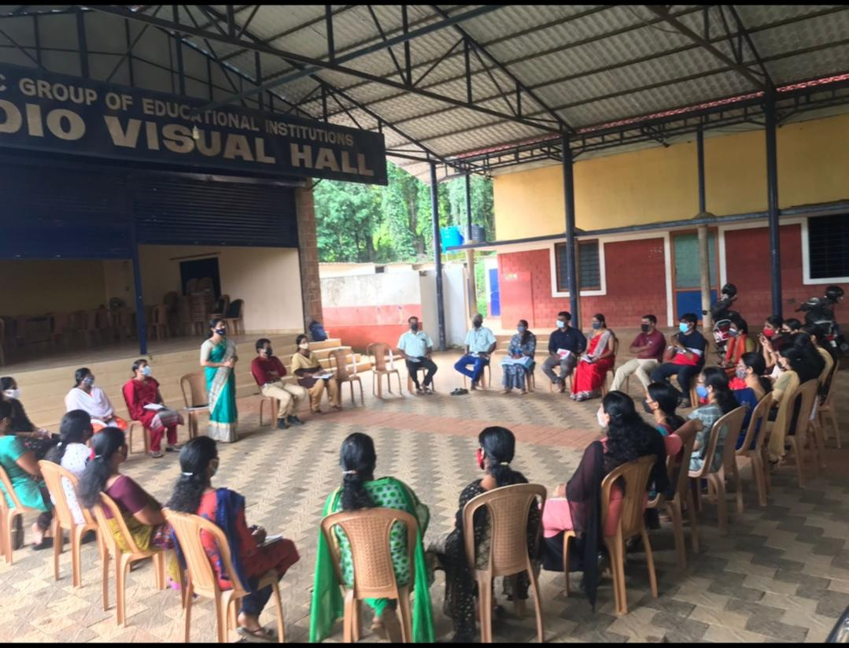

Programme Chart

1.Prayer : Rugmini. T. B
2.Welcome Speech: Ms. Sarala. K. T, General Head
3.Inaugural Address : Dr. Byju. K, Principal
4.Resource Person : Ms. Nisha Sasikumar, Vice Principal
5.Vote of thanks : Ms. Durga. N, Head, Department of Management
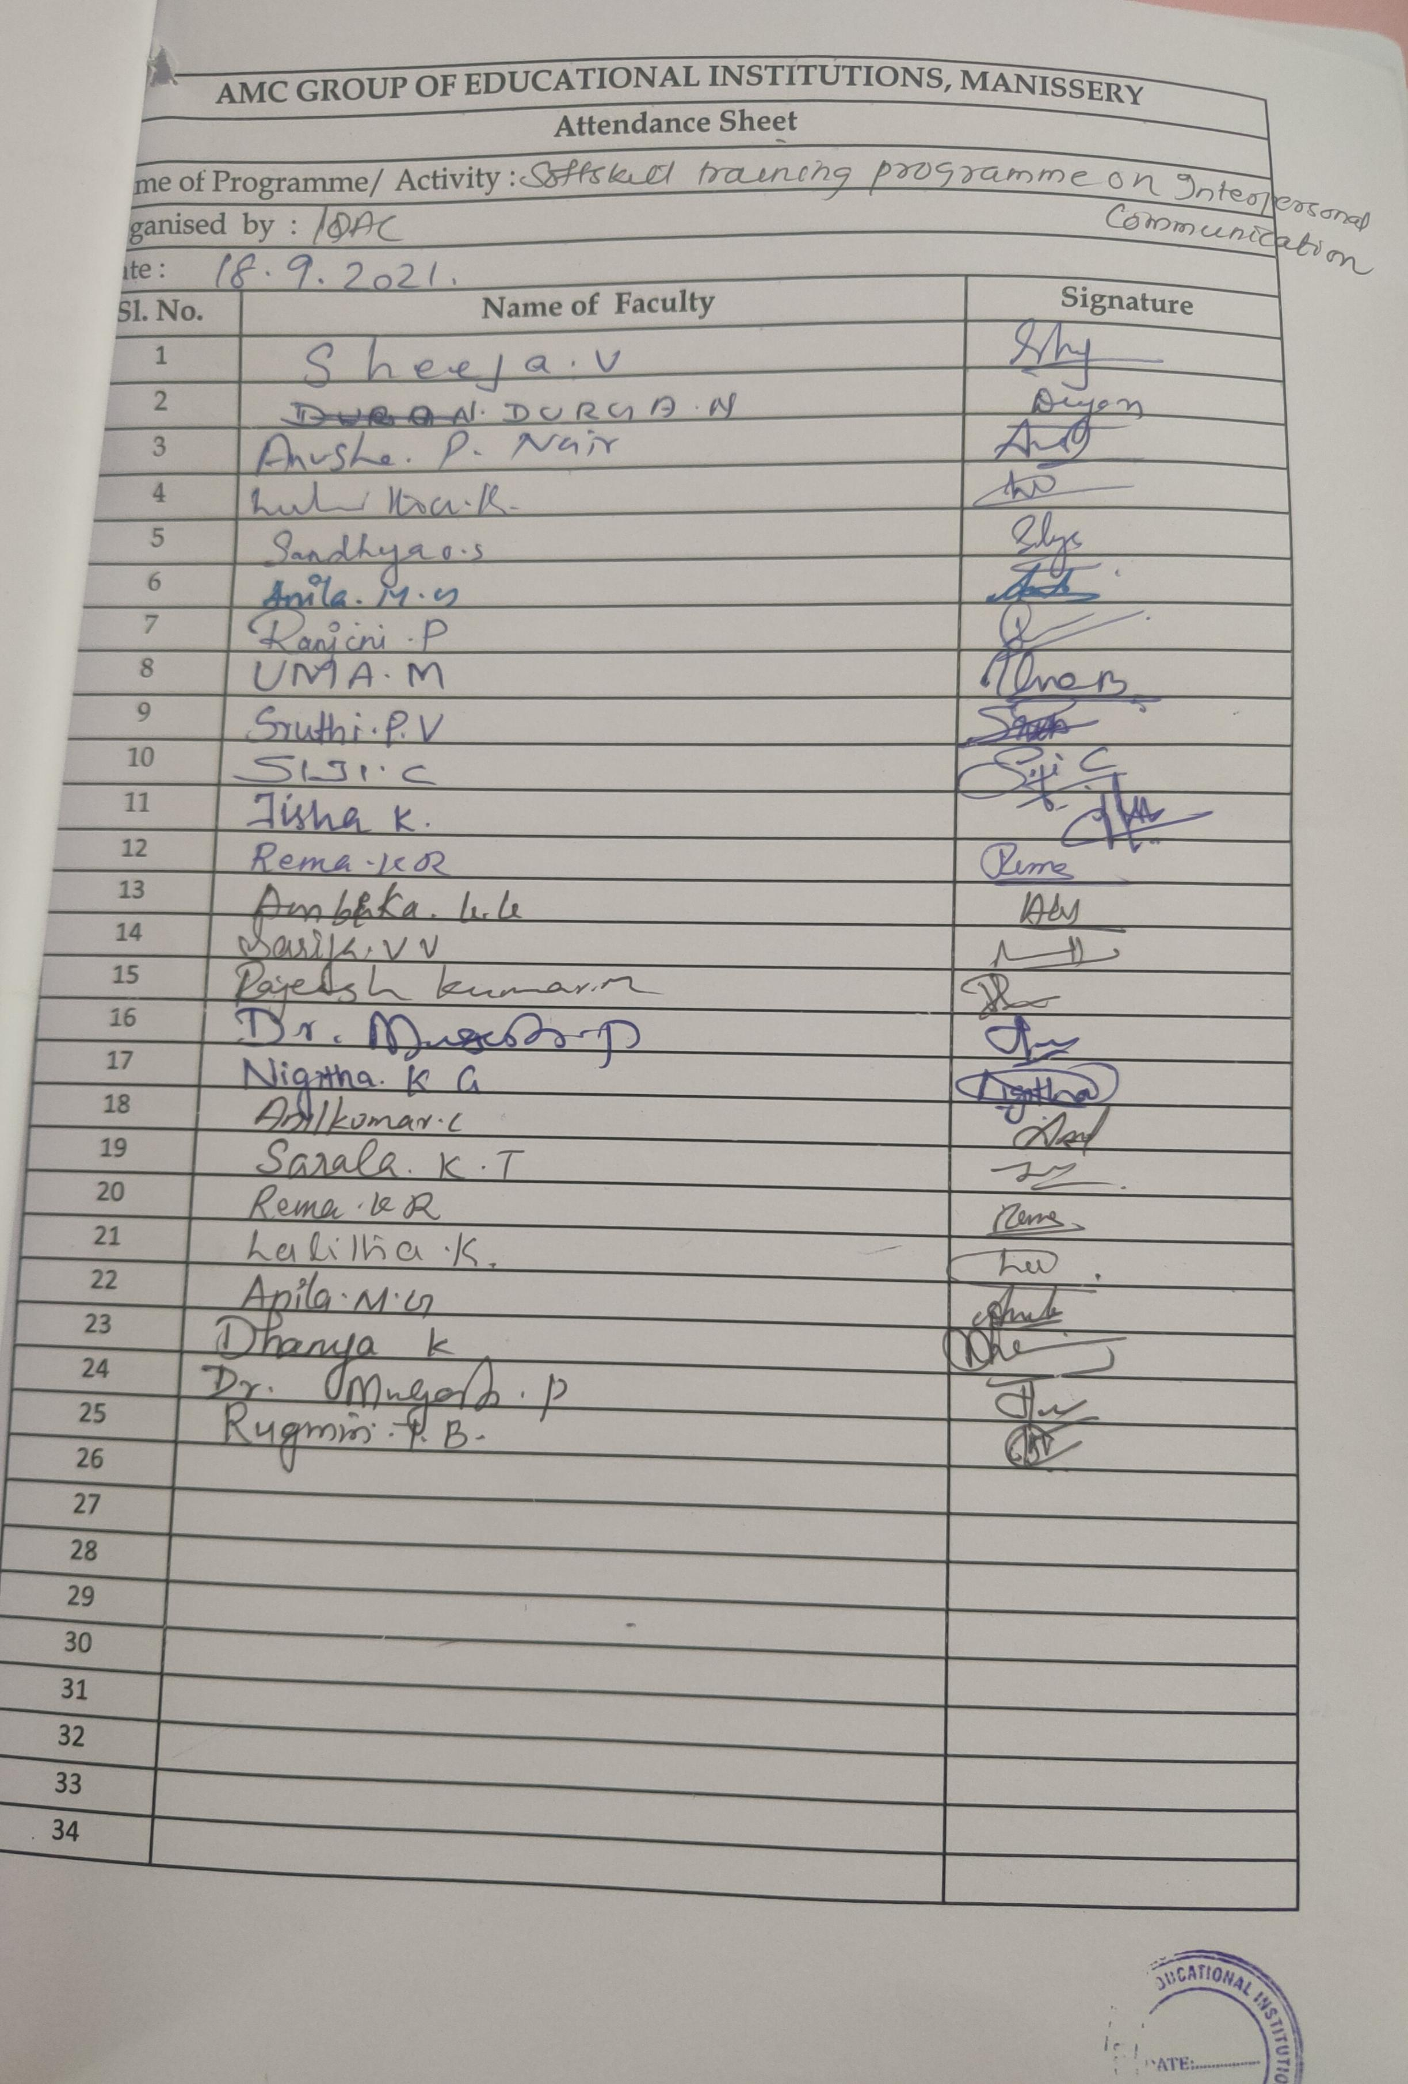

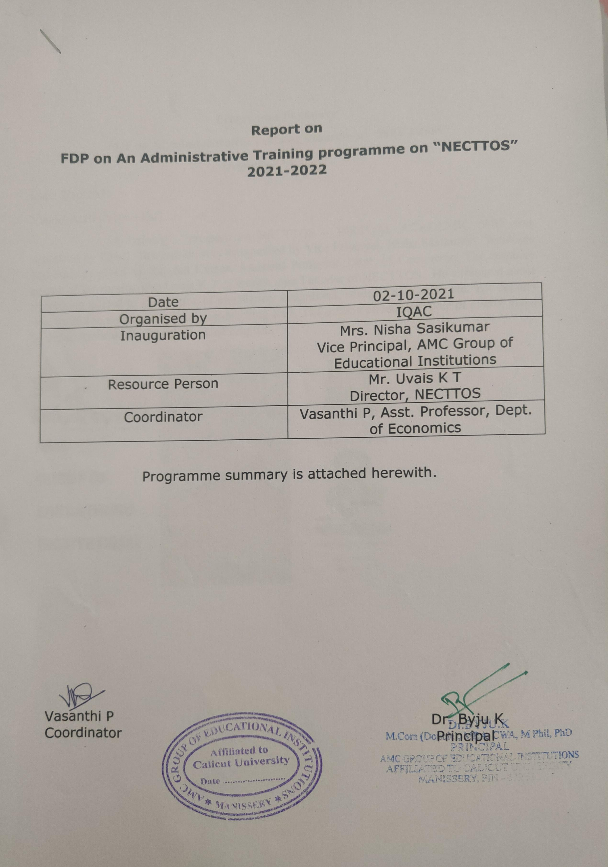

Programme Summary
FDP on An administrative Training program on “NECTTOS”
Organized by IQAC
Date: 2/10/2021
Venue: Audio Visual Hall
A training program on NECTTOS – VIRTUAL ACADEMIC SUIT was organized by IQAC. The session was inaugurated by Vice Principal, Nisha Sasikumar. Welcome address was given by Rajeesh Kumar, Assistant Professor, Dept. of Commerce. The resource person of the session was Uvais K T , Director cum Founder of NECTTOS . He explained about everything related to automation of attendance, assignment, students admission etc. The session was fruitful to both teaching and non-teaching staff. The session ended with vote of thanks given by Jisha, Assistant Professor, Dept. of English.
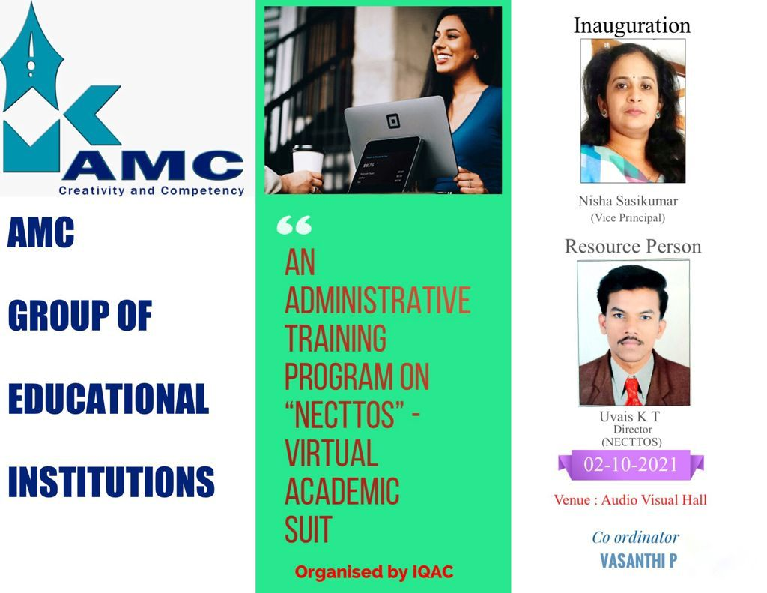

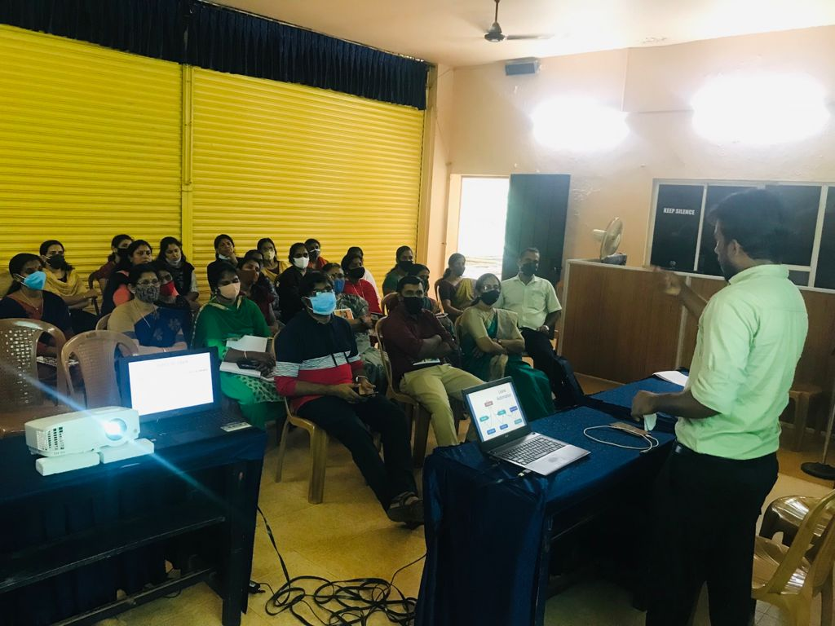

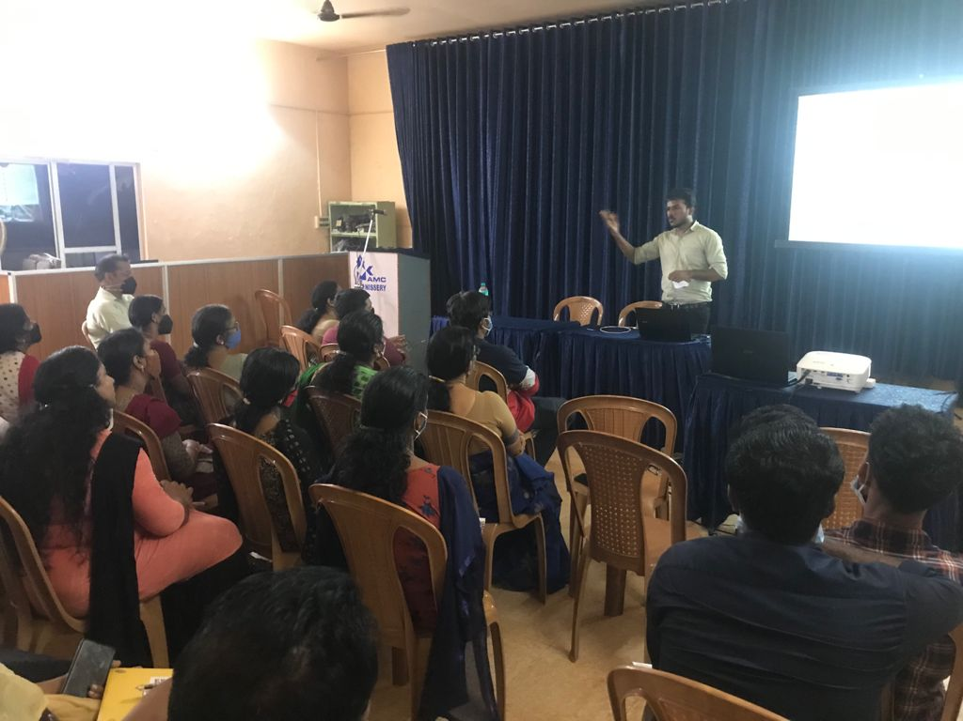

Programme chart
Date: 10/02/21
Time: @3 pm
- Prayer ; Rugmini
- Welcome speech; Rajeesh Kumar P , Assistant Professor , Dept. of Commerce
- Inaugural Address ; Nisha Sasikumar , Vice Principal
- Resource Person : Uvais K T
- Vote of Thanks ; Jisha , Assstant Professor , Dept. of English
- Programme co-ordinator : Vasanthi P ,Head , Dept. of Eonomics

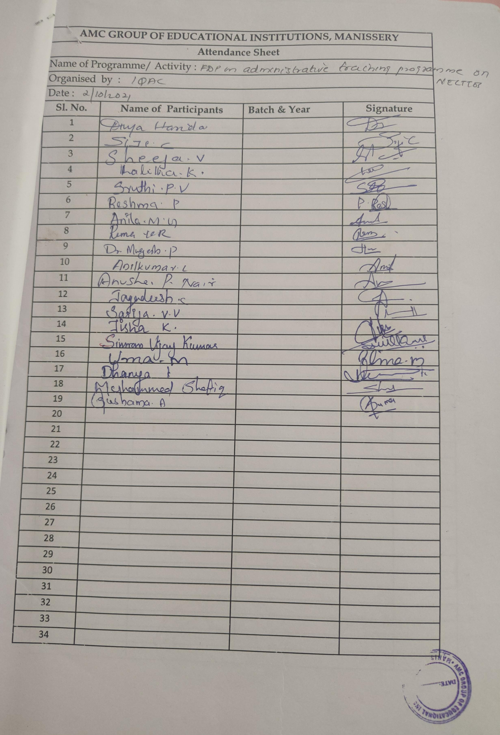

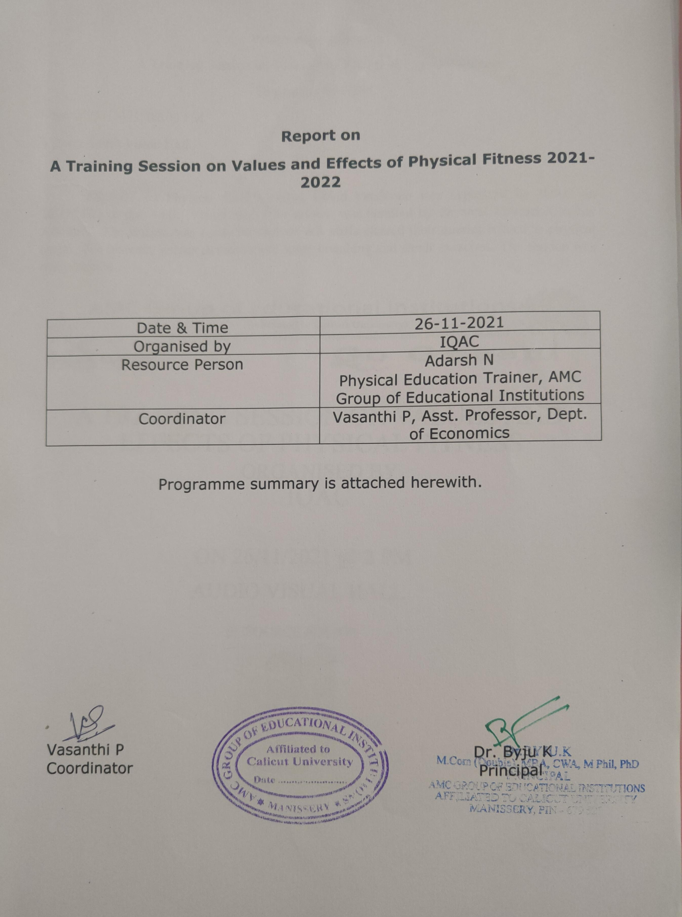

Programme Summary
A Training Session on Values and Effects of Physical Fitness
Organized by IQAC
Date: 26/11/2021, 02:00 PM
Venue: Audio Visual Hall

An FDP on Physical Health during Covid Pandemic was organized by IQAC on 26/11/2021 at the Audio Visual Hall. The session was handled by Physical Education trainer Adarsh.N. The session was really interactive. All staffs cleared their queries related to physical health. The resource person demonstrated some breathing and small exercises. The session was really helpful.
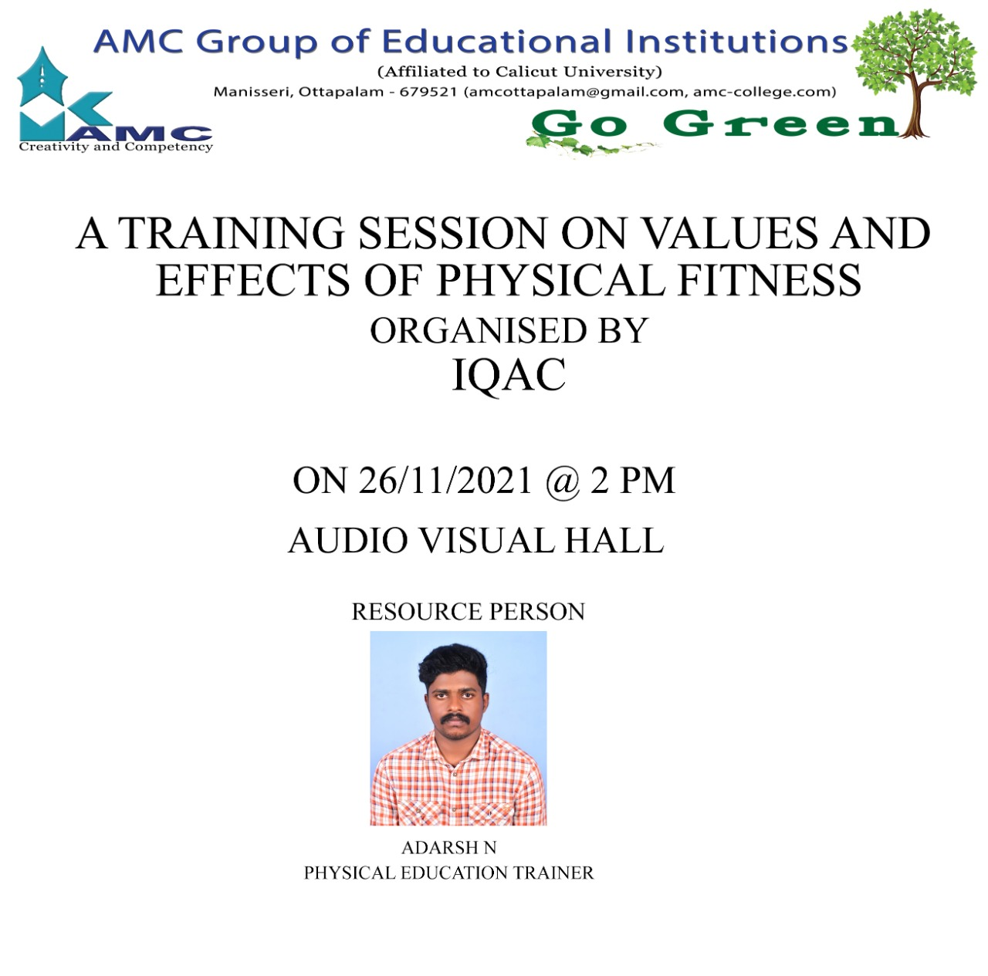

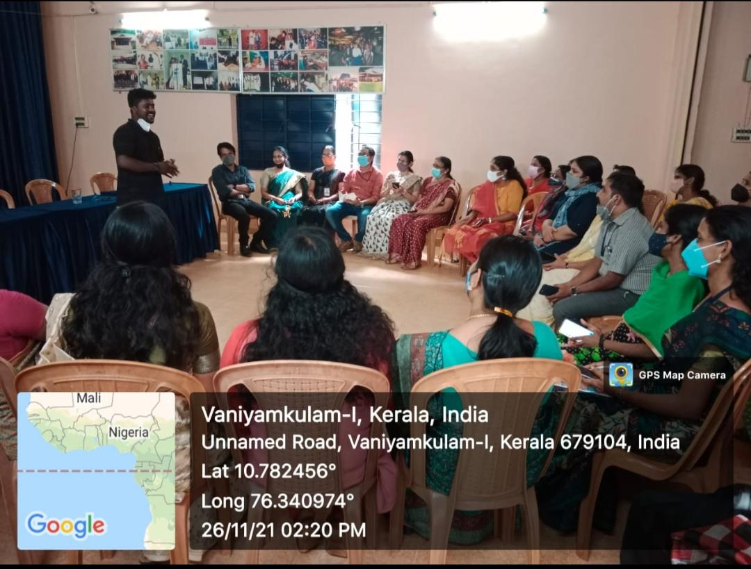

Programme chart
Date: 26/11/21, 2pm
Venue: Audio Visual Hall
- Prayer
- Welcome speech; Rajeesh Kumar P , Assistant Professor , Dept. of Commerce
- Resource Person : Adarsh N, Assistant Professor , Dept. of Physical Education
- Vote of Thanks ; Lalitha K , Assstant Professor , Dept. of English
- Programme co-ordinator : Vasanthi P ,Head , Dept. of Eonomics

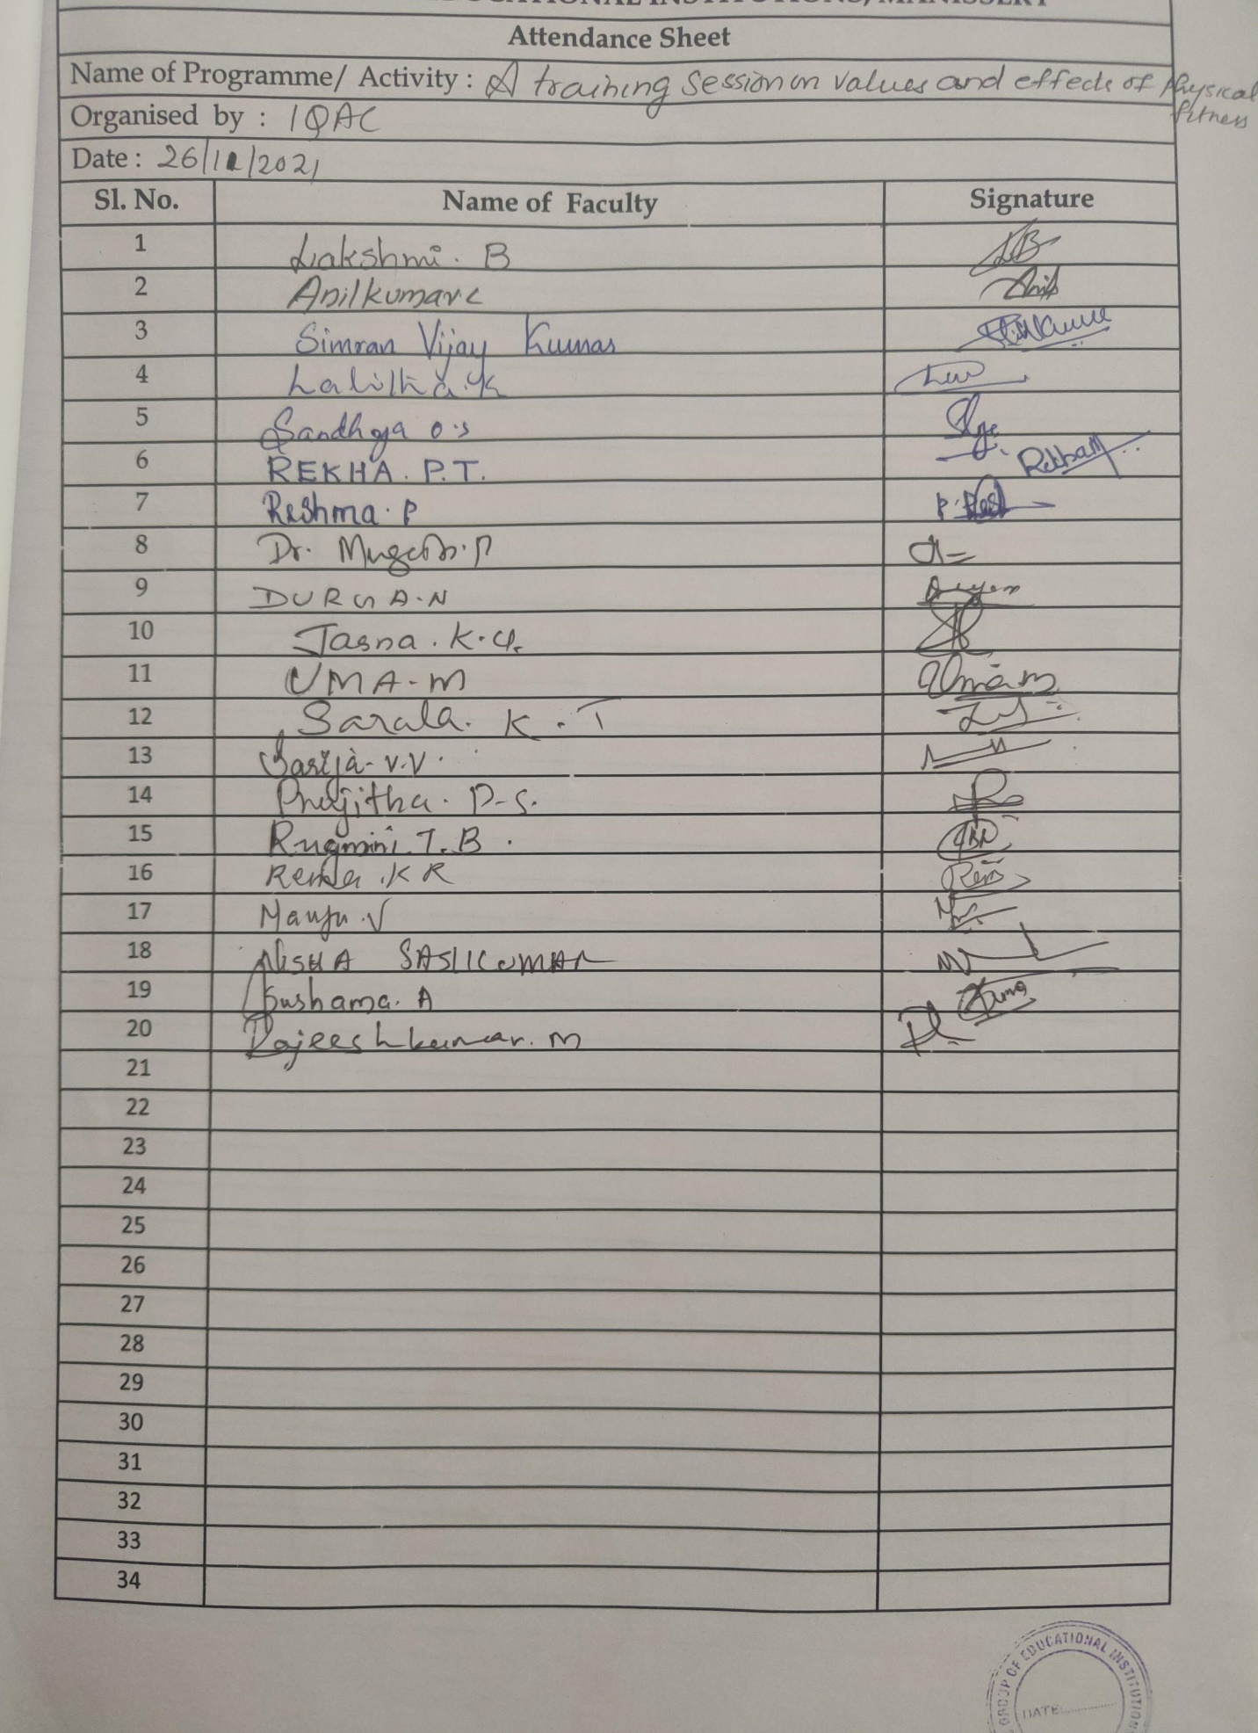

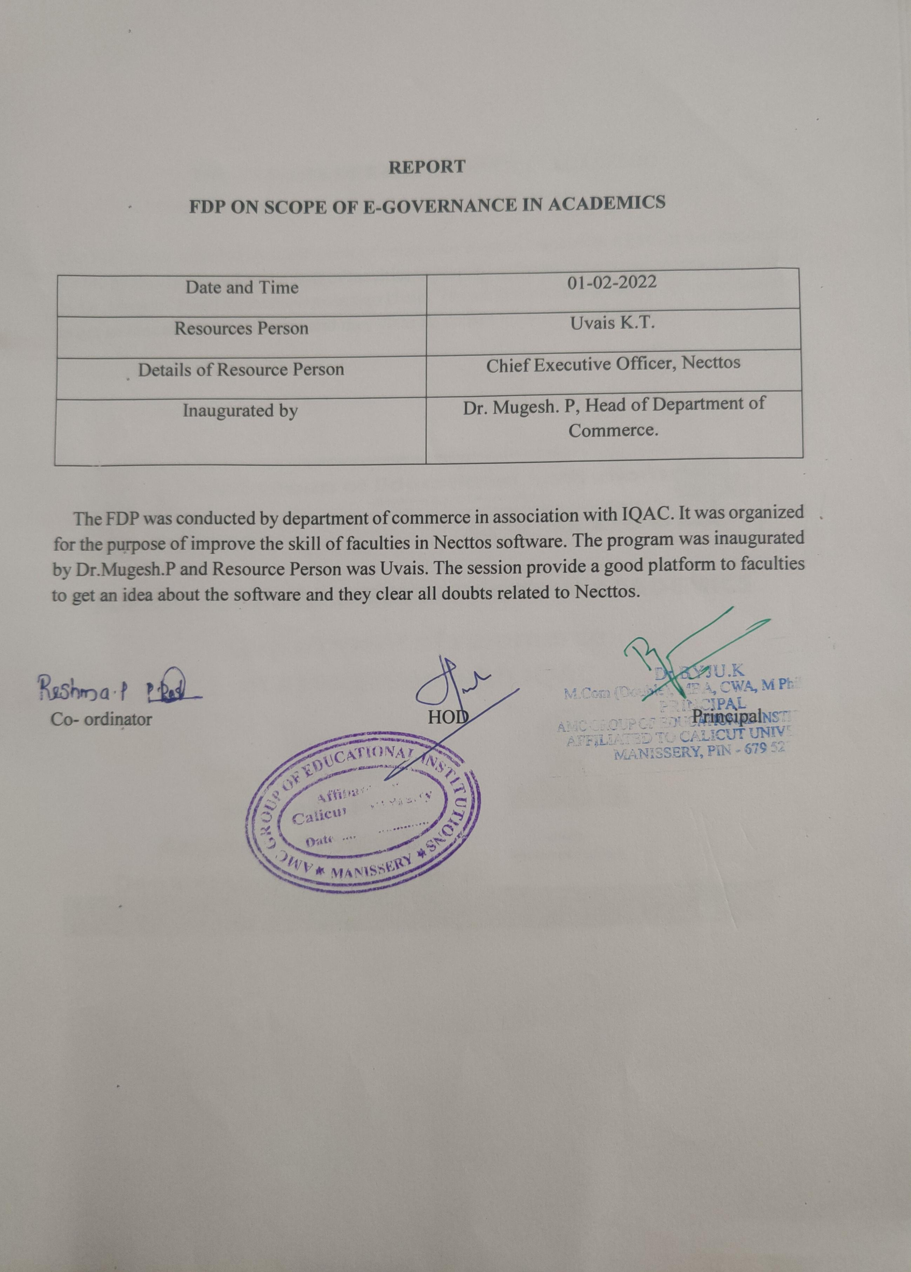

Programme Summary
FDP ON SCOPE OF E-GOVERNANCE IN ACADEMICS
Organized by Department of Commerce in association with IQAC

The FDP was conducted by department of commerce in association with IQAC. It was conducted for the purpose of improving the skills of faculties in Necttos software. The programme was inaugurated by Dr. Mukesh. P and Resource Person was Uvais. The session provide a good platform to faculties to get an idea about the software and they clear all doubts related to Necttos.

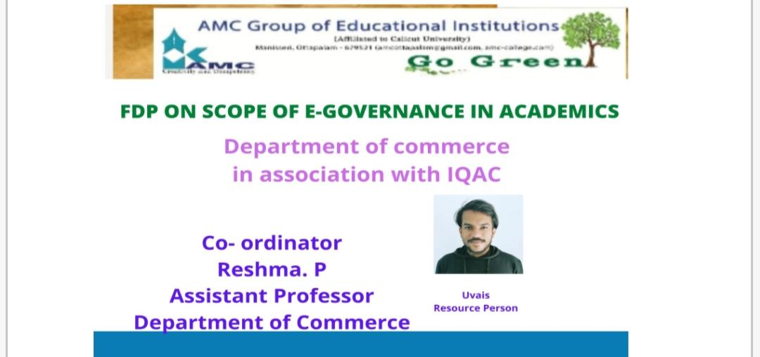

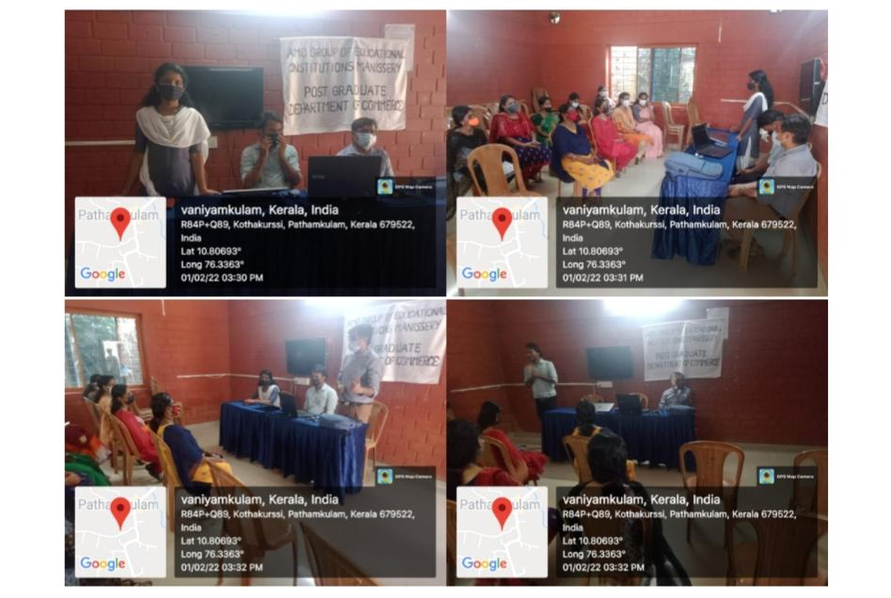

RESHMA.P DR.MUGESH.P
CO-ORDINATOR HOD

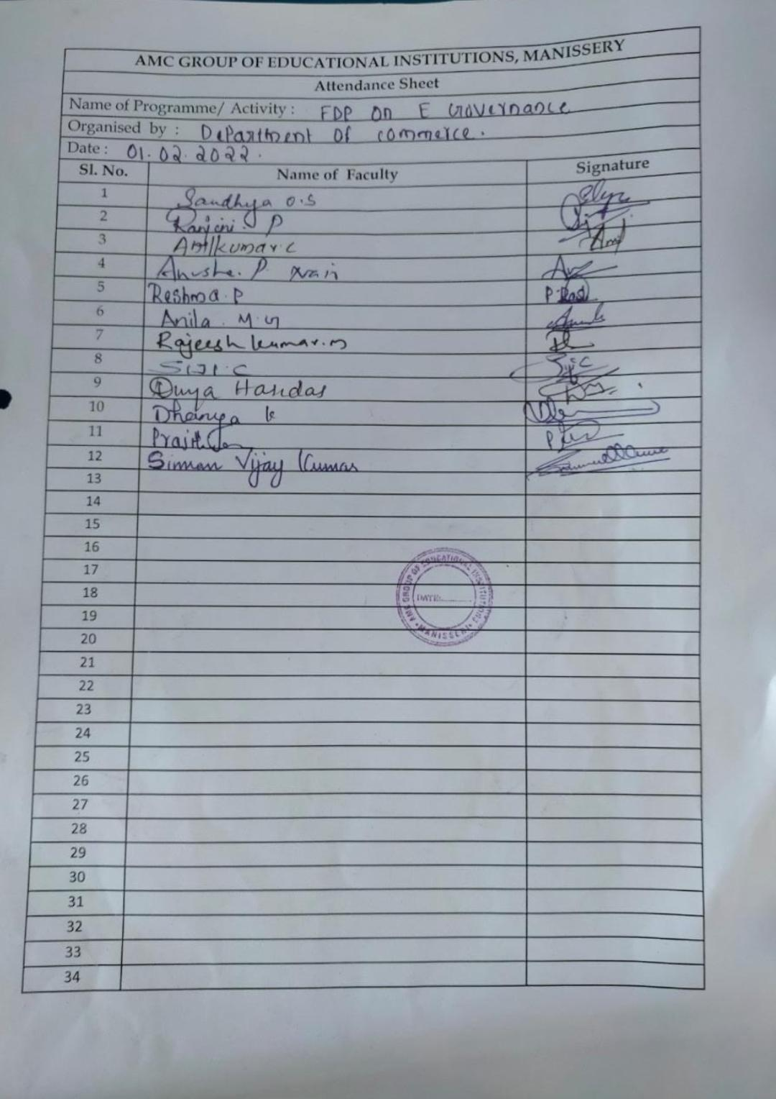

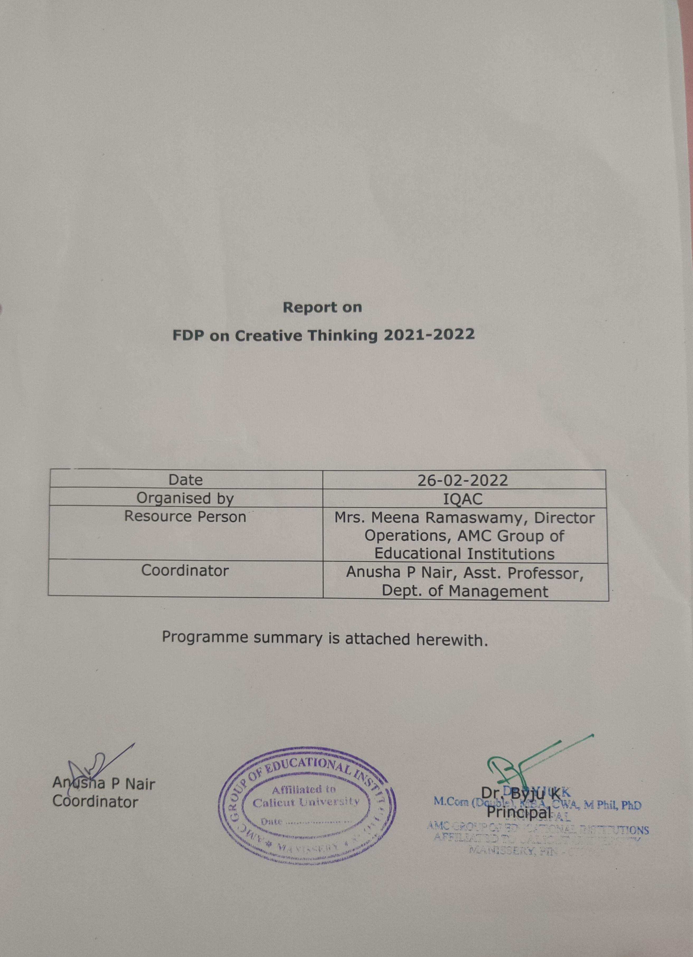

Programme Summary
FDP on Creative Thinking
Organized by IQAC
Date: 26/02/2022
Venue: Presentation Hall
A FDP was coordinated by IQAC on 26/02/2022 in the Presentation Hall of the college campus. The FDP was specially designed to enhance the knowledge and creative thinking of teachers. Creative thinking helps to improve our analytical and problem solving capacities and it will help us to approach various tasks from different angles. The session was handled by Ms. Meena Ramaswamy, Director Operations, AMC Group of Educational Institutions. The session was really very interactive and teachers shared their ideas about creative thinking which can be adopted in the teaching learning process. FDP was coordinated by Ms. Anusha. P. Nair, Assistant Professor, Department of Management.

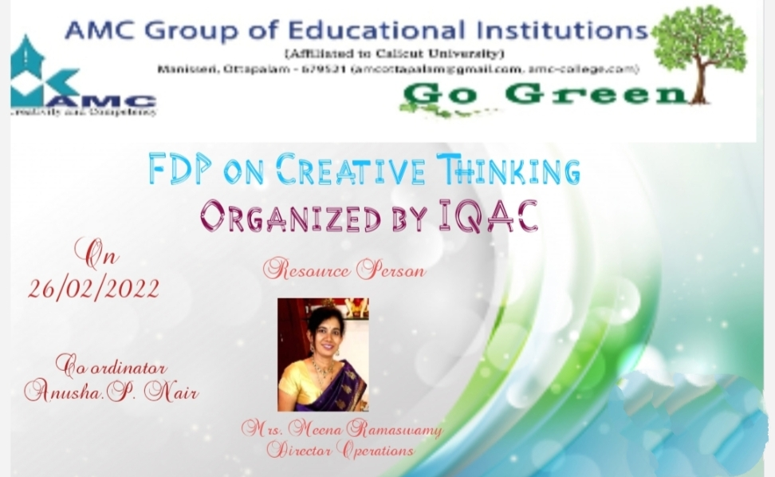

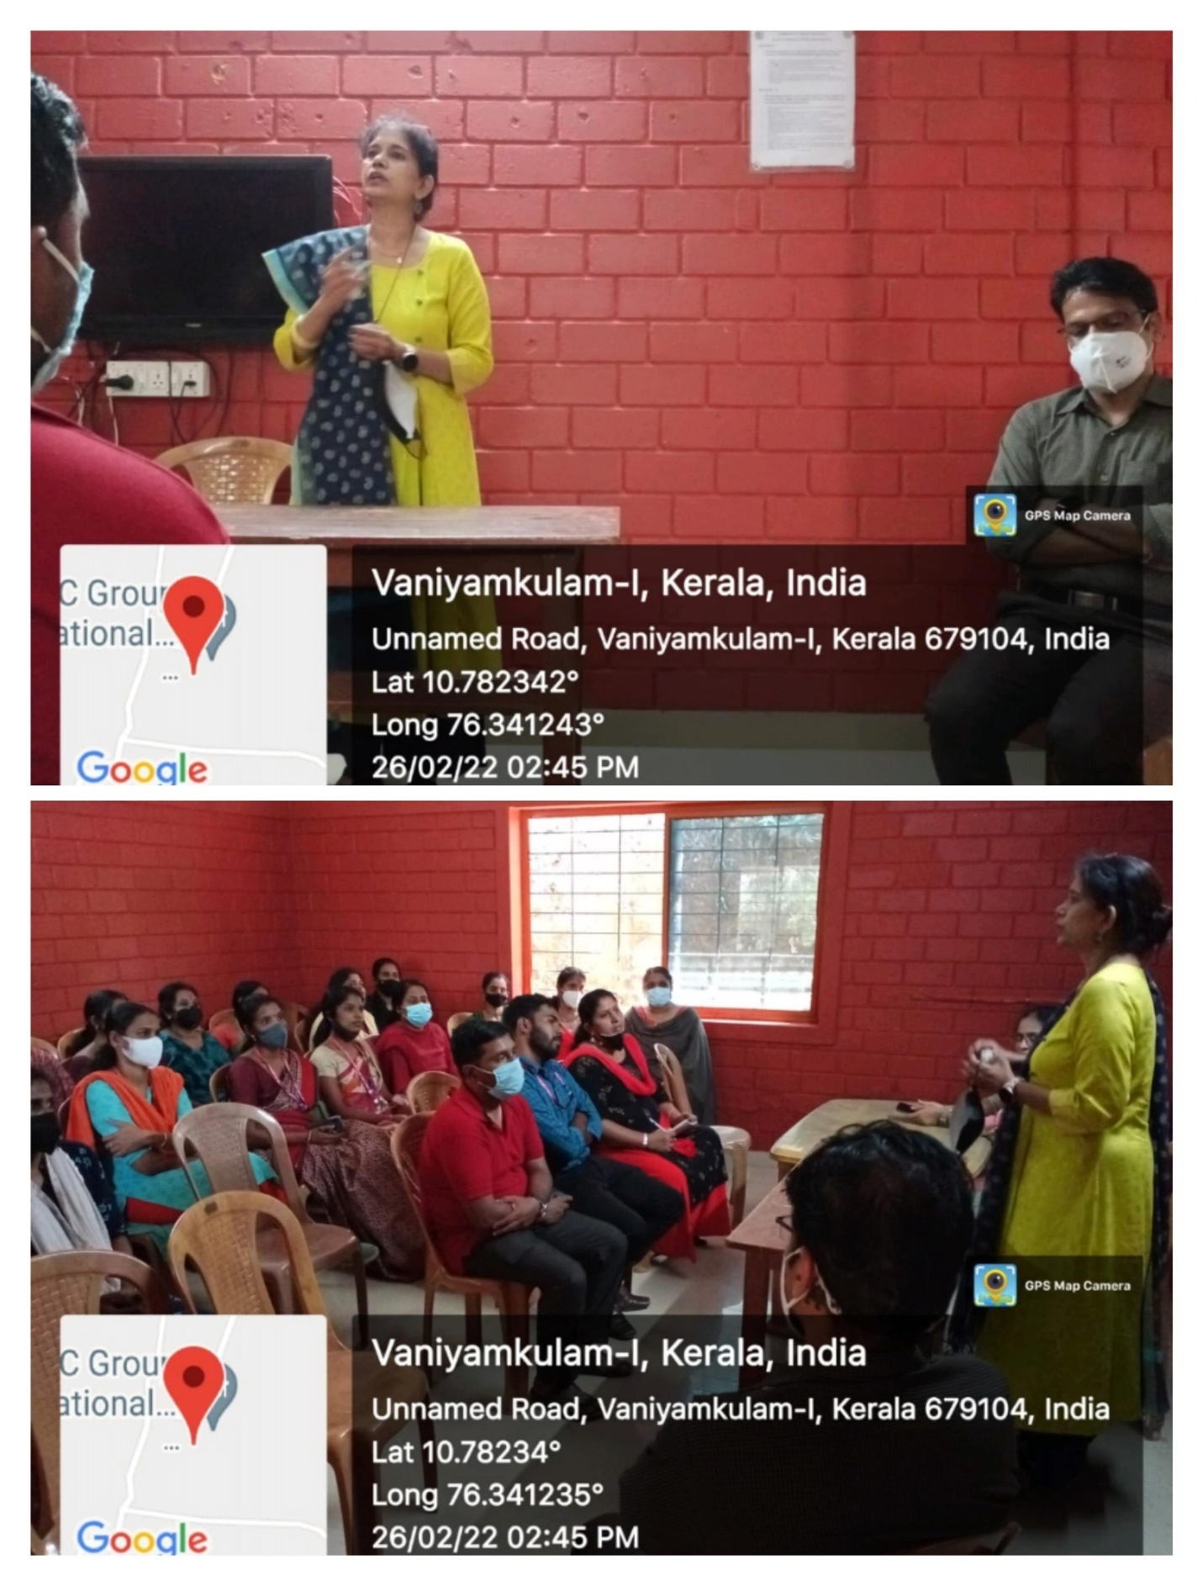

Programme chart

Date: 26/02/22,
Venue: Presentation Hall
- Prayer
- Welcome speech: Nisha Sasikumar , Vice Principal
- Resource Person: Ms. Meena Ramaswamy, Director Operations
- Vote of Thanks : Rajan K , Assistant Professor , Dept. of Economics
- Programme co-ordinator : Vasanthi P ,Head , Dept. of Economics

