ANNUAL REPORT 2016-17
SPORTS DAY
(2016-17)

The Physical Education Department had conducted sports day on 21st February 2017. Our General Captain initiated the program by lighting the camp. Our honorable Principal Byju sir inaugurated the function. We had conducted a march past. We conducted the sports by dividing students into four houses. Many competitions like indoor games, outdoor games and athletics are conducted by Physical Education Department.

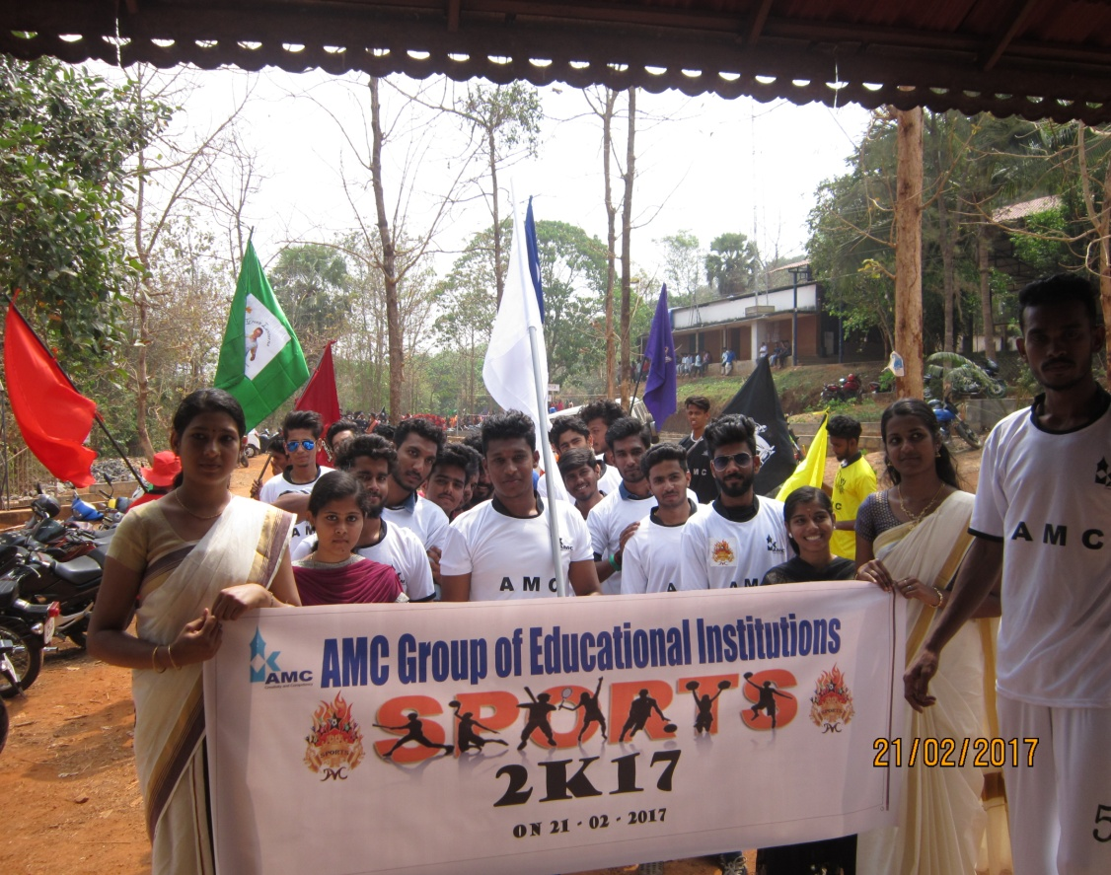

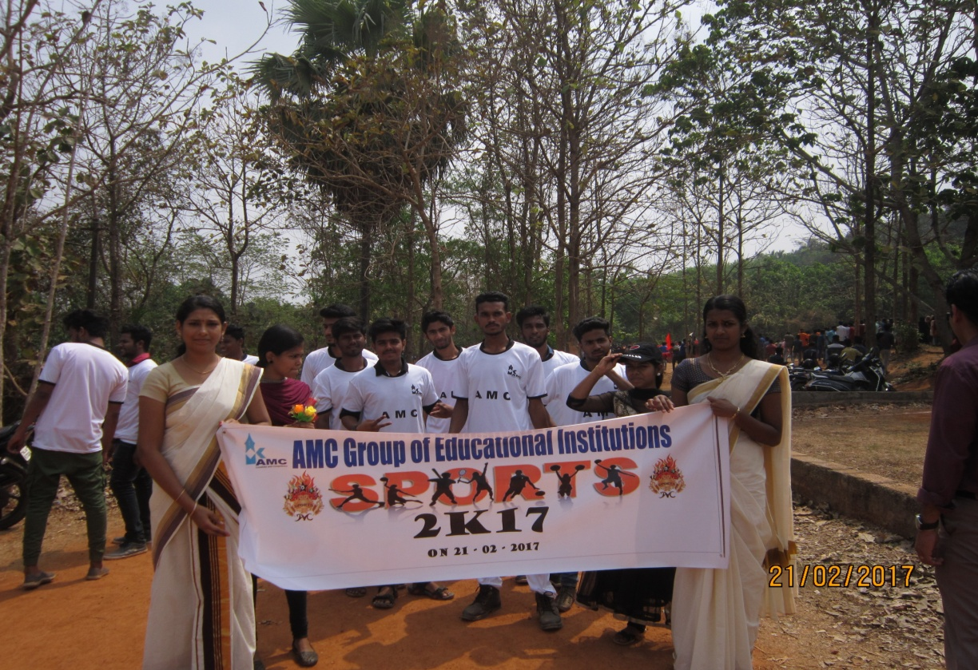

Items | Number of participants
Football | 44
Cricket | 55
Chess | 7
Carroms | 16
Athletics
Running 400m | 17
Running 200m | 22
Running 100m | 30
Relay 400*4 | 24
Shotput | 7

Co-ordinator
Physical Education Department

