ANNUAL REPORT 2018-19
SPORTS DAY
(2018-19)

The Physical Education Department had conducted sports day on 17th January 2019.. Our General Captain initiated the program by lighting the camp. Our honourable Principal Byju sir inaugurated the function. We had conducted a march past. We conducted the sports by dividing students into four houses. Many competitions like indoor games, outdoor games and athletics are conducted by Physical Education Department.

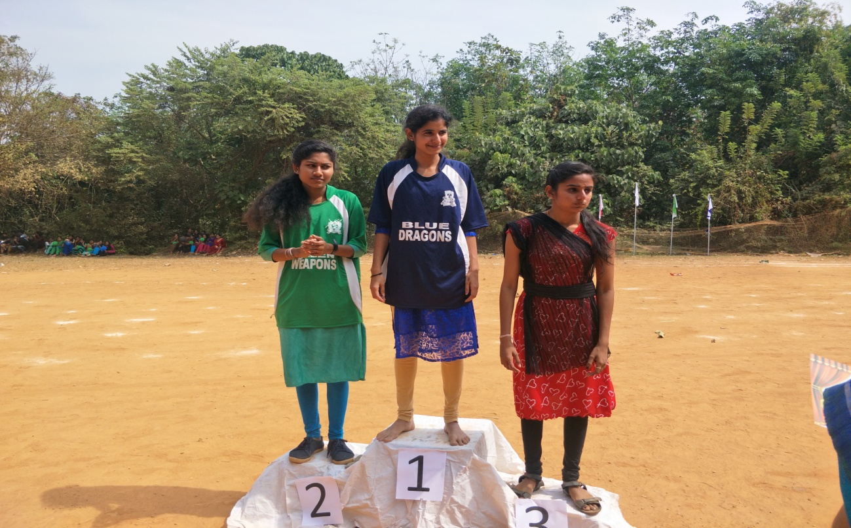

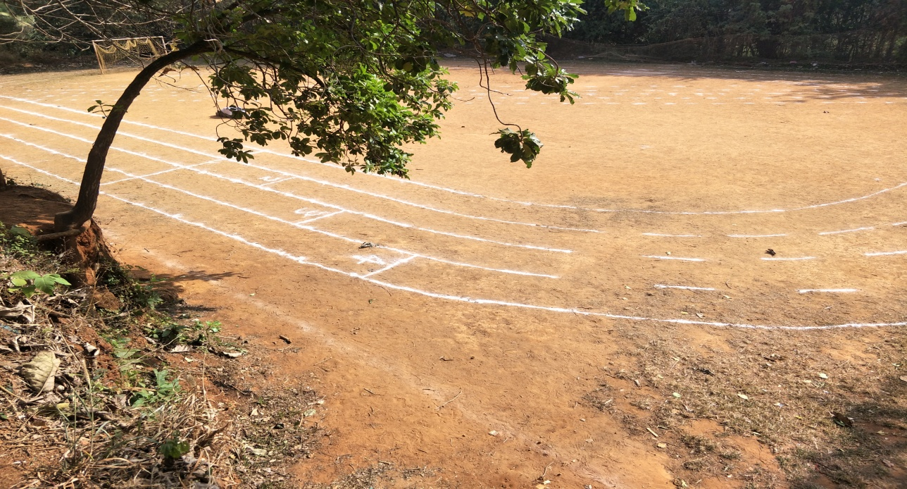

Co-ordinator
Physical Education Department

Items | Number of participants
Football | 55
Cricket | 55
Volley Ball Men | 30
Badminton Men | 36
Badminton Women | 16
Chess | 9
Carroms | 16
Athletics
Running 400m | 18
Running 200m | 30
Running 100m | 43
Relay 400*4 | 36
Shotput | 13

