PHYSICAL EDUCATION REPORT
Physical Education
Annual report 2019- 2020
Department of Physical Education of AMC Group of Educational Institutions Manissery has done a series of activities for the benefit of students in this academic year.

- Penalty shootout contest in Association with Coppa America Tournment leading by the students are first year, second year and third year. The whole students of the college divided into 2 teams Brazil and Argentina on July 2.

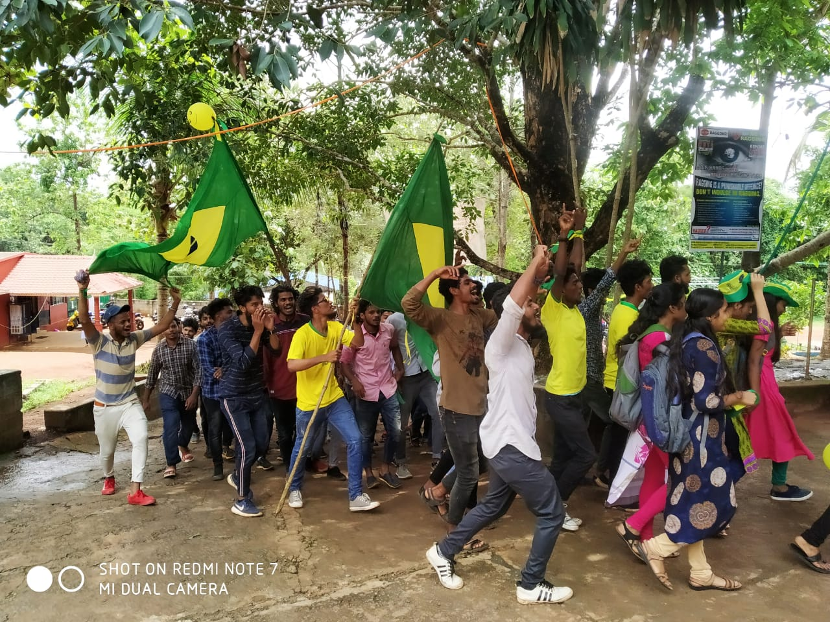

- Our Football team participated friendly match with TRK HSS on August 21.
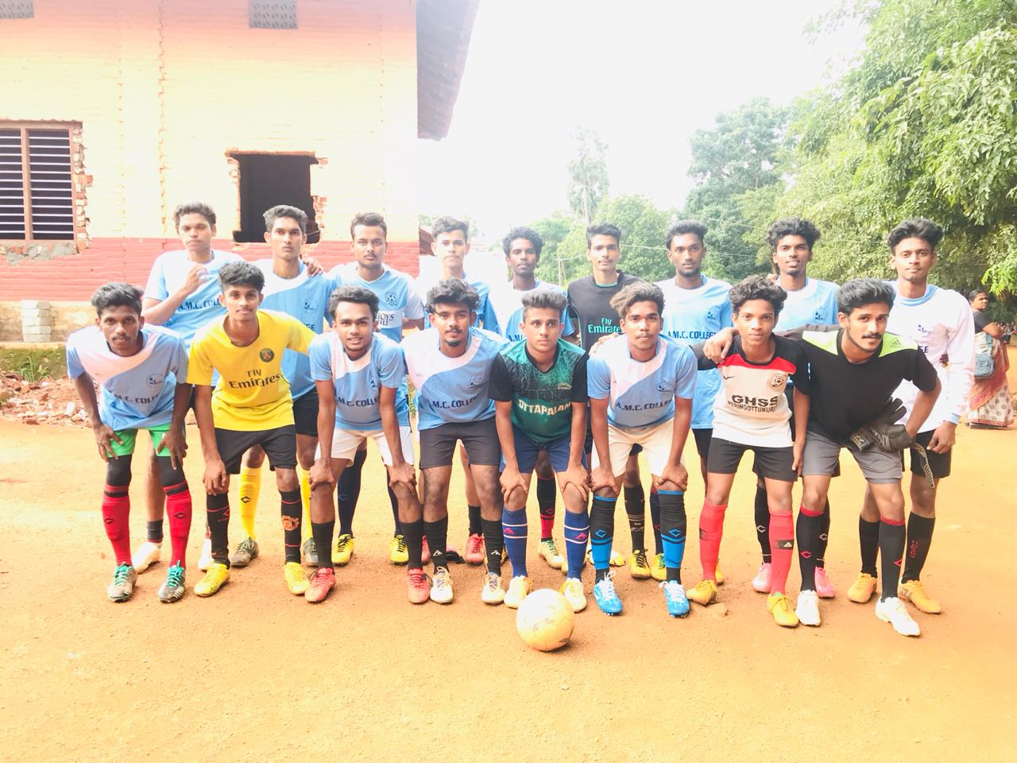
- Prasanth 5th semester BBA student has been elected as general captain of college union election 2019-2020
C-ZONE PARTICIPATION
- Our Football Team qualified in C-Zone first round and second round at SNGS, Pattambi on 4/10/2019 and we entered in quarter final.
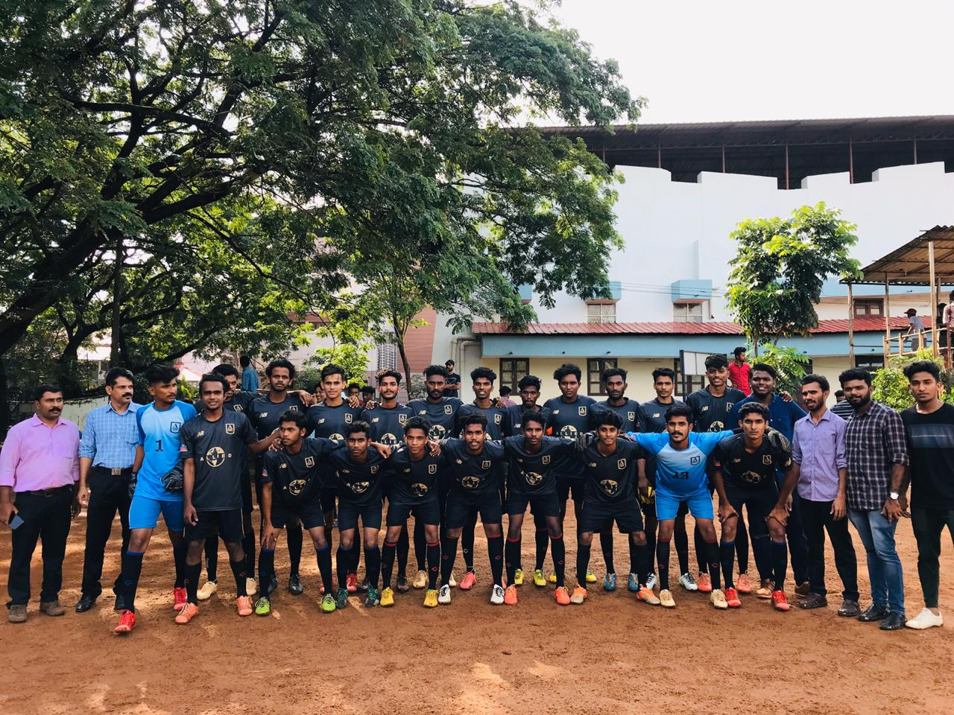
- Our football team participated in C-Zone quarter final at Govt. Victoria College, Palakkad on 5/10/2019.
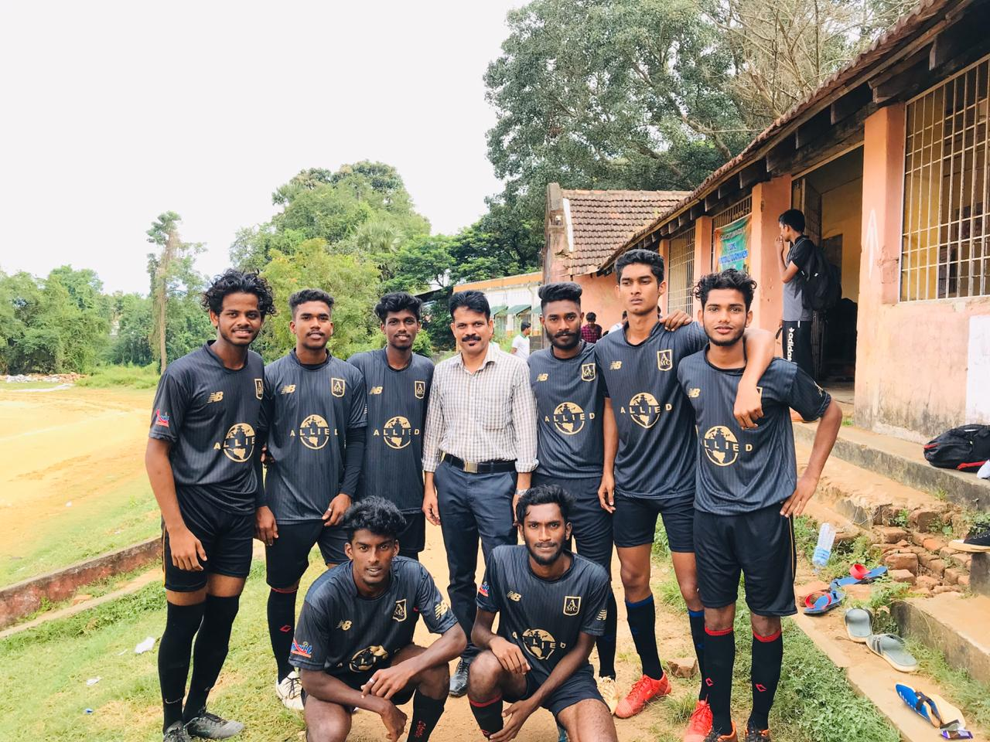
- Our Cricket Team participated in C-Zone first round at MES Mannarkkad on 13/10/2019.
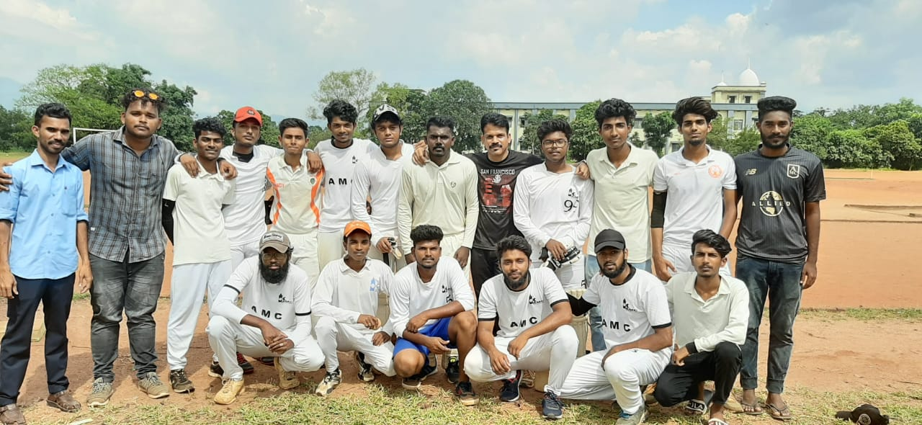
- Our Volley ball team participated in C-Zone first round at Arts and Science College, Kozhinjampara on 29/10/2019.
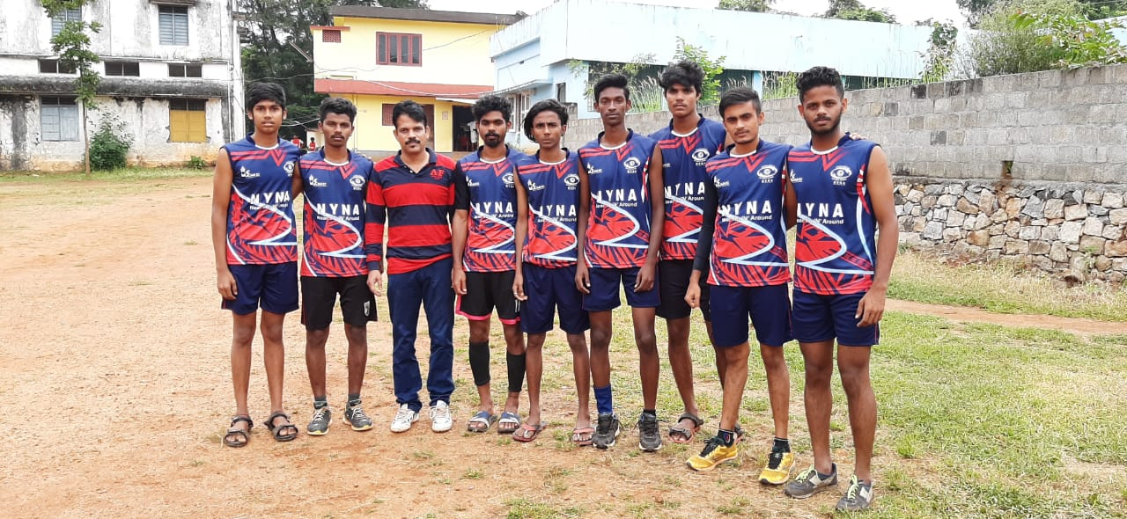

INTERZONE PARTICIPATION
- Our handball girl’s team participated in interzone tournament at Vimala College, Thrissur on 17/10/2019.
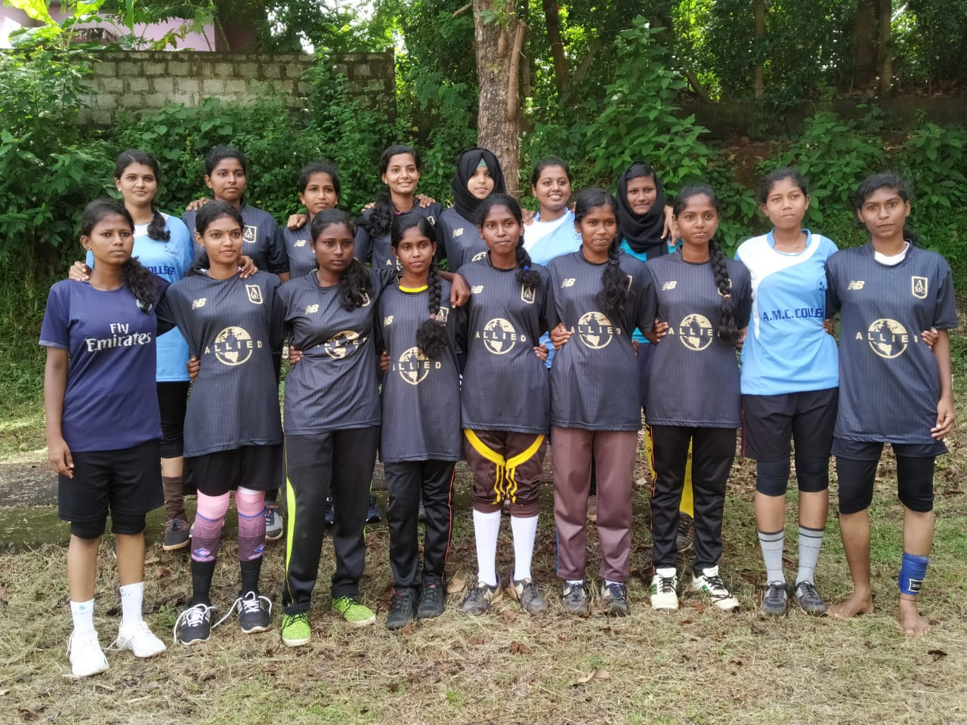
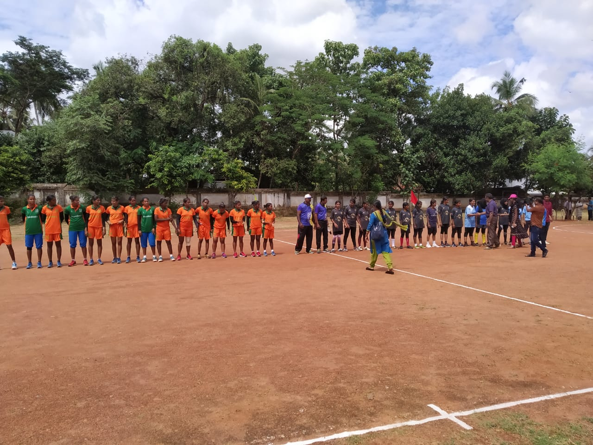

INTERCLASS PARTICIPATION
- An inter class Volley ball tournament was conducted on 1/10/2019 and third BA won the match.
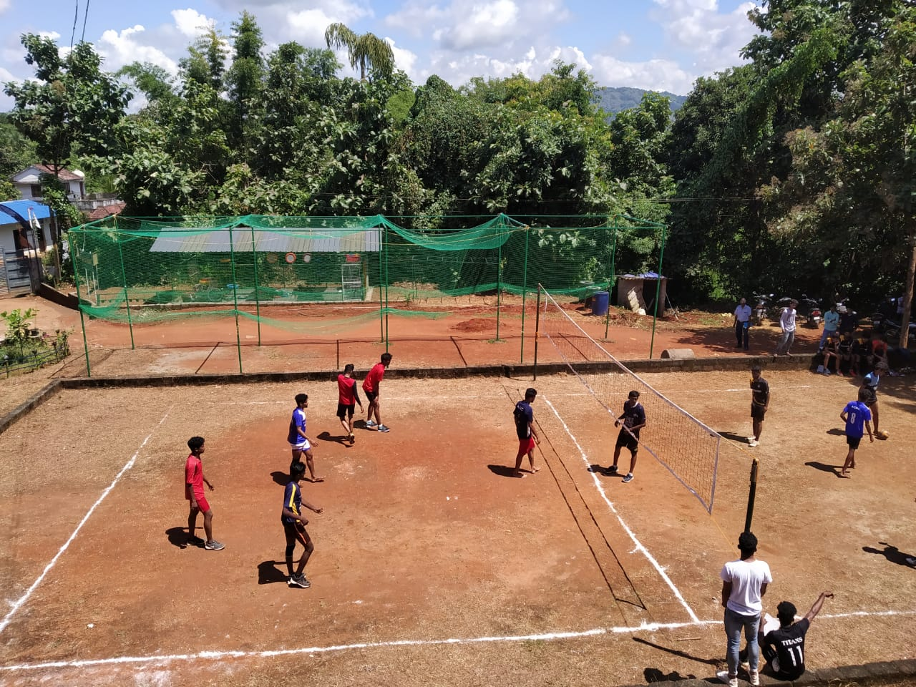
- An inter class Football match was conducted on 5/12/2019. There are 23 teams participated and third BA won the match.
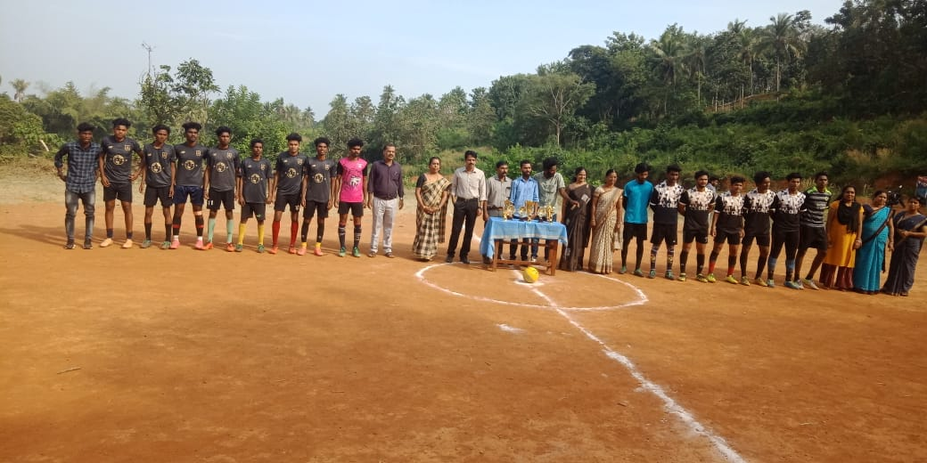
- An inter class Cricket match was conducted on 15/12/2019. Each class have one team. Third CA won the match.
SPORTS DAY
- Our Sports day was celebrated in a great manner on 23-01-2020 in the early morning all the students and teachers assembled at the school ground. About 1200 students gathered in AMC ground conducted a grand parade. Students participated in different games and athletics represents four houses, Blue, Green, Red and Yellow houses. Blue house won the overall championship and participants of other houses ensured individual prizes. Trophy and medals were distributed to the winners of various athletics events.