ANNUAL REPORT 2020-21
PHYSICAL EDUCATION DEPARTMENT

Hereby I submitted the annual report on 2020-21.
ACTION PLAN
SL NO | ACTIVITY | DESCRIPTION | PLANNED ON (MONTH) | RESOURCE PERSON (YES/NO) | TARGETTED STUDENTS NUMBER | FUND REQUIRED (YES/NO)
1 | FOOTBAL L CLASS WISE |  | SEPTEMBER |  | EACH CLASS ONE TEAM
2 | CRICKET CLASS WISE |  | SEPTEMBER |  | EACH CLASS ONE TEAM
3 | HAND BALL FOR GIRLS |  | OCTOBER |  | 2 TEAM
4 | VOLLEYBALL |  | OCTOBER |  | EACH CLASS ONE TEAM
5 | SPORTS DAY |  | NOVEMBER |  |  | YES
6 | ONLINE WEBINAR |  | NOVEMBER | YES |  | YES
7 | ONLINE QUIZ COMPETITION |  | NOVEMBER

The Physical Department conducted the following programs

- A Webinar on Physical activities for Physical and Mental Stress Relief. Resource Person Sri. Moideen.O.A, Assistant Professor and HOD, MES Kalladi. Around 200 students were participated.

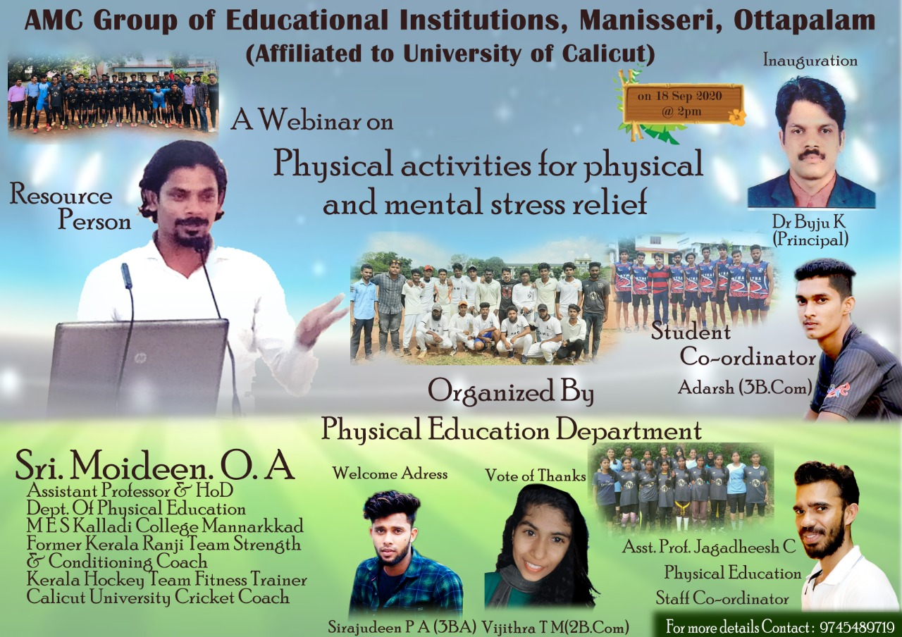

- IPL Prediction Contest 2020, the Prediction was conducted through Google form. Around 50 students were participated and first prize held by MuhammedArshak from I Co-operation, second prize shared by Sreerag. P.P (I Co-op), Vismaya T.S (II finance) and VarshaT.P(II BBA).

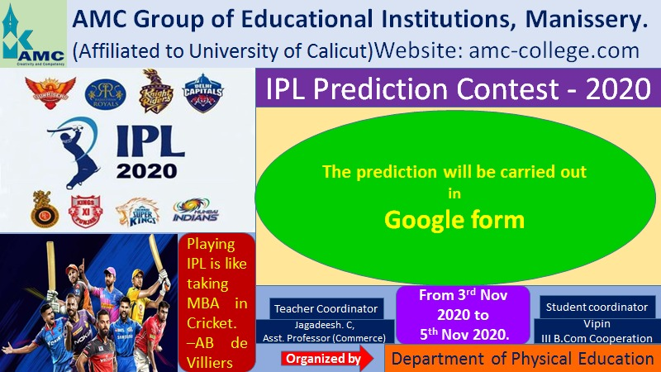

FOOTBALL SELECTION CAMP
Physical education department was conducted a football selection camp at collage ground on 11/1/2021 Monday at 3.30. For the camp selection 50 students are registered through Google form and 22 students are participated. The camp selection was done by ANSHAD K (D LEVEL licence holder)

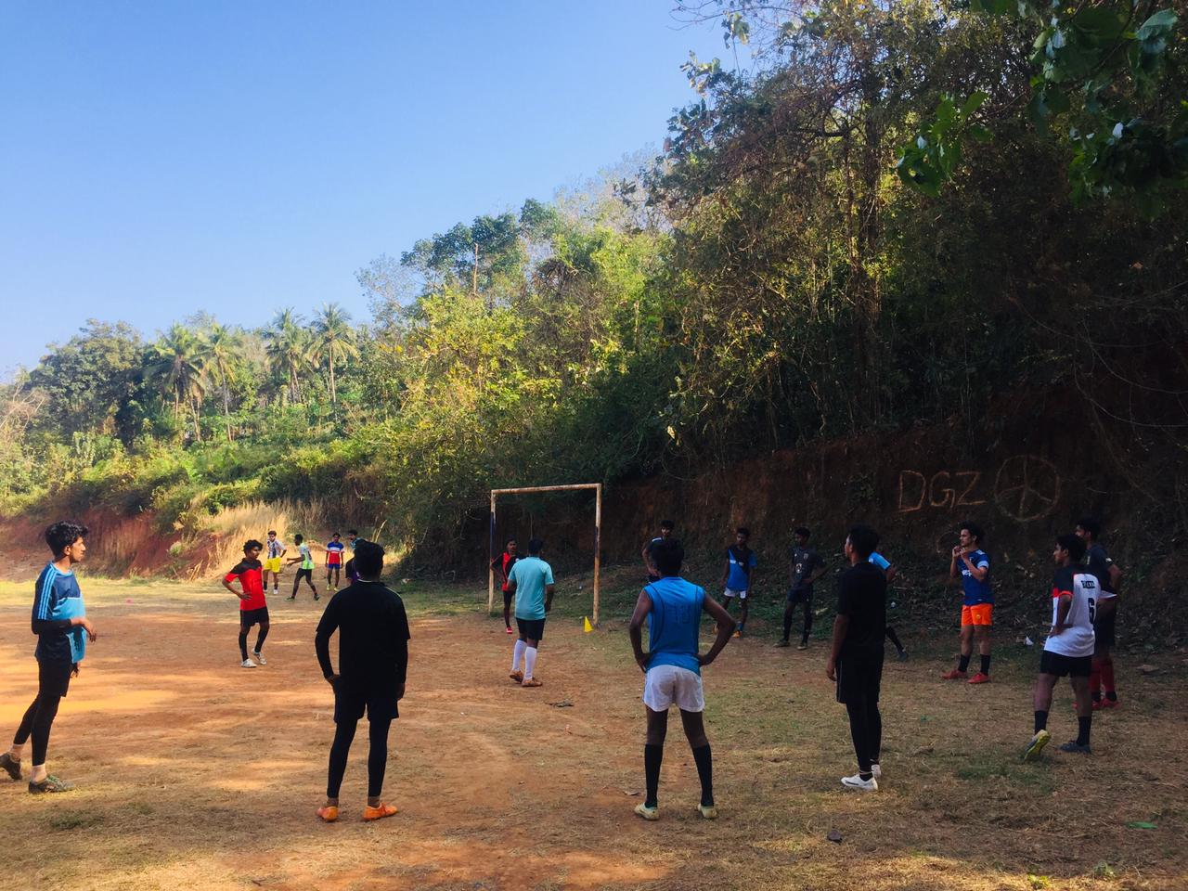

CRICKET CAMP SELECTION
Physical education department was conducted a selection camp for cricket at collage ground on 12/1/2021 Tuesday at 2.30 pm. The selection was only for first years and second year students. For the camp 18 students are registered and 12 students are participated. MUZAMMIL (OLD STUDENT) was the selector.

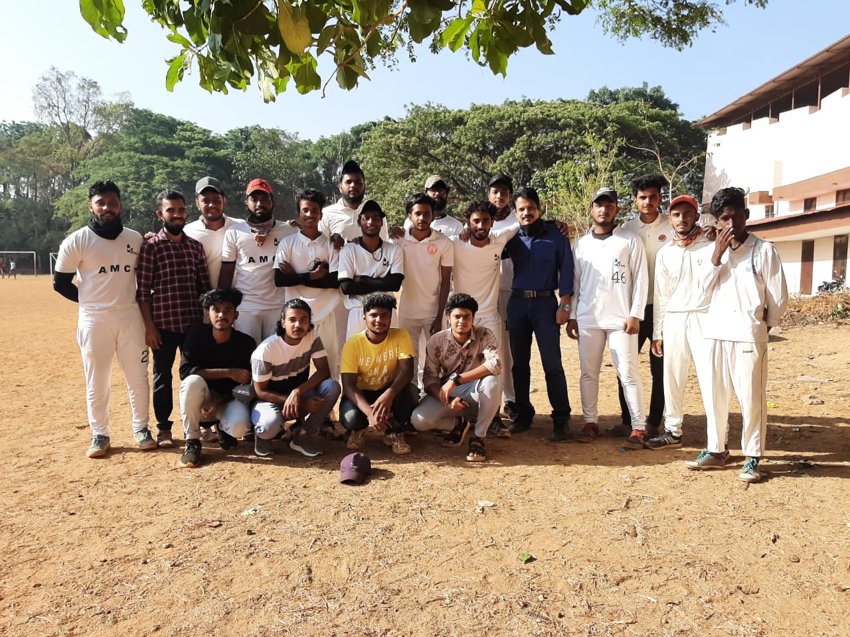

VOLLEYBALL CAMP SELECTION
Physical education department was conducted a selection camp for volleyball at collage ground on 26/2/2021 Friday at 2.30 pm. The selection was only for first years and second year students. For the camp 19 students are participated. Final year students were conducted the selection procedure.

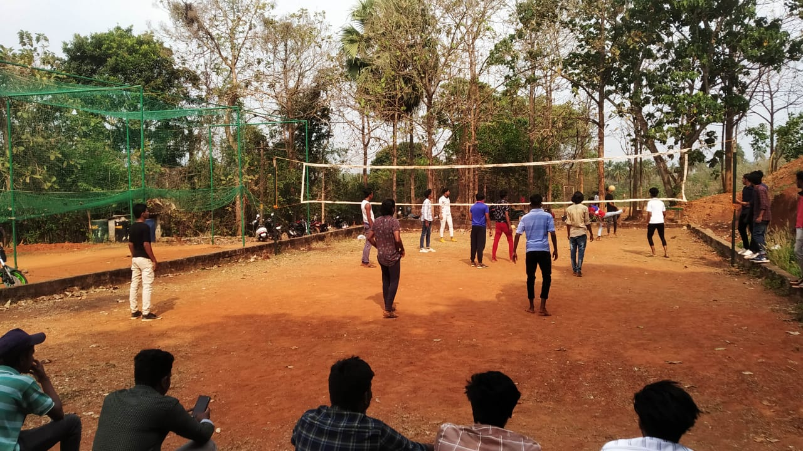

- Our Cricket Team were participated in C-Zone Cricket on 05.03.2021 at S.N.GS Pattambi.
They won first two rounds. Around 18 students were participated.

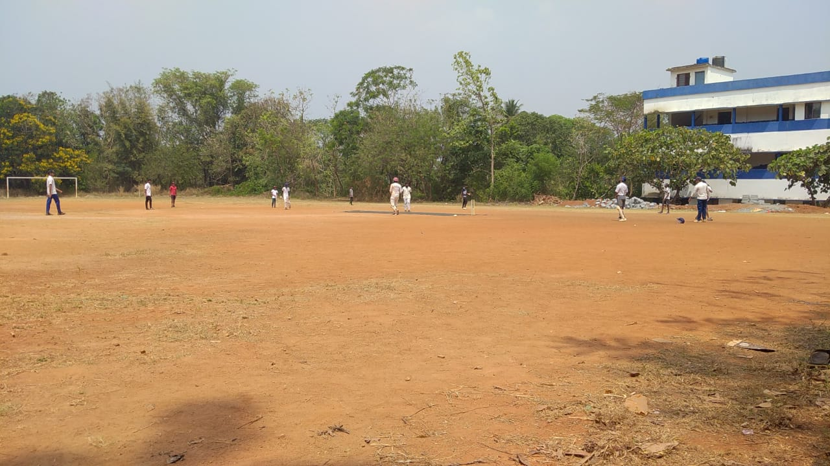

- Our Badminton team were participated in C-Zone on 24.03.2021. Around 6 students were participated.

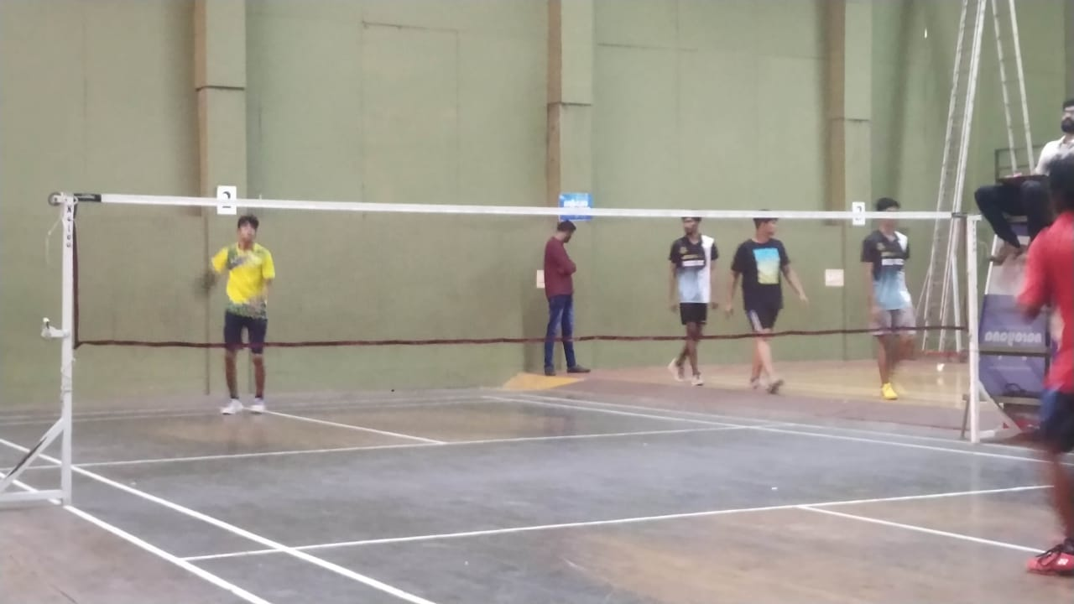

- Our Volley ball team were participated in C-Zone on 07.04.2021 at Yuvakshethra College, Mundoor. Around 12 students were participated.

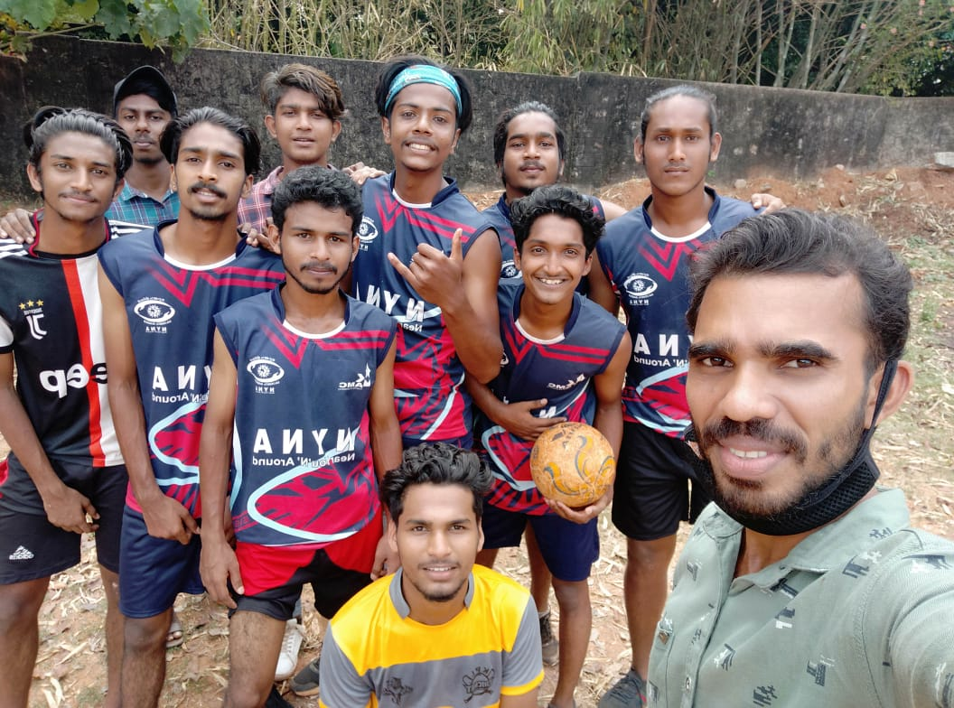

- Our Football Team were participated in C-Zone on 08.04.2021 at MES Kalladi. Around 22 students were participated.
