Coronado Soil and Water Conservation District

Saturday, April 22, 2023
San Antonio de las Huertas Land Grant
1 Camino de la Buena Vista, Placitas
8:30 a.m. to 1:30 p.m.
______________________________________________
Be firewise! Clear around your house and property for a safe perimeter and to prevent fire danger

- Bring dry branches no more than 6 inches in diameter
- Align branch ends in same direction
- No construction waste or barbed wire
- Take wood chips home for mulch or leave for others

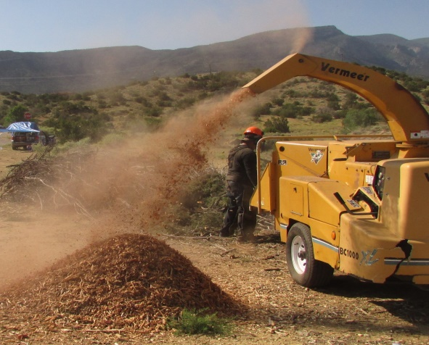

Also Supported by
Las Acequias de Placitas
Las Huertas Community Ditch

www.coronadoswcd.org • info@coronadoswcd.org

