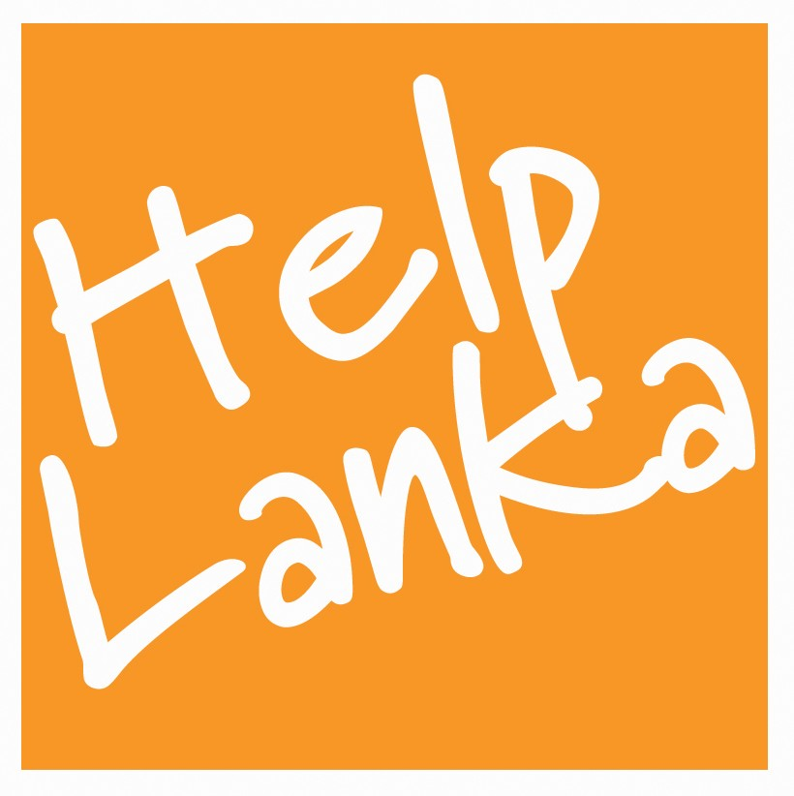

PRESS RELEASE

For Immediate Release: 30/07/13

Helplanka UK volunteer programme fecilitated by Sri Lanka Parliament

Organised annually by Helplanka ( a UK and Sri Lanka registered charity) a group of volunteers including 2 teachers from Barry South Wales visited Sri Lanka in July to teach English, music, drama and sport at Ihalayagoda Vidyalaya Gampaha , St Joseph’s Deaf School Ragama, BS Jayawardene Boy’s Orphanage Ja Ela, Children’s Convalscent Home Ragama and Leonard Cheshire Home Katana Negombo. The programmes led by Sam Goonetillake, Chief Executive, included face painting , bouncy castle and balloon modelling and the group also visited the Children’s ward of the National Cancer Hospital Maharagama. During the 3 week visit to Sri Lanka a number of hearing aids , sports and educational equipment, books and toys were distributed..

The highlight of the visit was taking tea with The Rt Honourable Deputy Speaker Chandima Weerakody MP at the Sri Lanka Parliament who thanked the teachers and pupils of Barry Comprehensive School for their contribution to the development of education in Sri Lanka. The Honourable Deputy Speaker also presented the Helplanka volunteers with their certificates of recognition.

Commenting on this year’s programme which is the 8th annual visit by Helplanka Sam Goonetillake said: “I would like to thank Barry Comprehensive School for their unique contribution and hard work and dedication in helping so many children once again. Heplanka can only continue its work with special needs children in rural areas by receiving funding from UK and Sri Lanka donors . Please support us as so many children rely on Helplanka to change their lives. “

www.helplanka.co.uk

ENDS

Press Enquiries
Sam Goonetillake
Chief Executive
Helplanka
www.helplanka.co.uk
07963 331138
E mail sam@helplanka.co.uk

ABOUT HELPLANKA

HelpLanka is a UK Registered charity (Reg no 1110306) which was formed in January 2005 to specifically help children affected by poverty and disaster in Sri Lanka. Helplanka is also registered as a non profit making organisation in Sri Lanka ( HELPLANKA CHILDREN’S GUARANTEE LTD GL2021)

For further information, please visit: www.helplanka.co.uk

