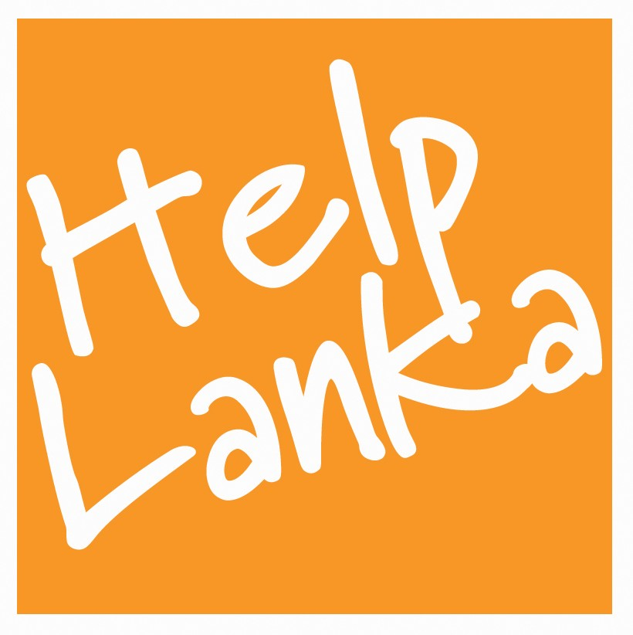

PRESS RELEASE

For Immediate Release: 1/09/17

British High Commission Colombo applauds Helplanka !

Each year, UK Charity Helplanka , that helps children through education in Sri Lanka, conducts a successful Volunteer Programme ,organised and led by Chief Executive Sam Goonetillake to the country. This year’s team of 18 including teachers and pupils from Barry Comprehensive School Wales raised over £20,000 and were hosted to a reception at The British High Commission in Colombo where Tom Burns, Deputy High Commissioner, presented the Helplanka Volunteers certificates of recognition and praised the charity for their longstanding efforts to help children in Sri Lanka for over 12 years.

The group, who raised funds throughout the year, taught English, Geography and Maths and participated in games at St Xavier’s College Marawila NWP, Diyagala Boy’s Town Kandana WP , Siviraja Deaf and Blind School Mahawewa, Samata Sarana Mutwal and Kindigoda and Mabodala Vidyalaya WP. Helplanka also raised funds to assist a school affected by the floods in Mapalagama, Elpitiya District and distributed school uniforms and books themselves and visited the school to assess the impact of the floods. Helplanka donated a number of English and Sinhala language books, equipment , sports goods and arts and crafts materials to the children at all of the projects . As part of the trip to Sri Lanka Helplanka organised a tour of the island to include visits to Sigiriya, Negombo , Habarana, Colombo Dambulla Galle & Kandy.

Sam Goonetillake commented “ I would like to thank Barry Comprehensive School Staff and pupils and parents for their continued support of the work of the charity and The British High Commission for recognising their hard work, dedication and commitment to helping children in Sri Lanka . We rely heavily on donations to continue our work both in the UK and also in Sri Lanka and hope that their work will inspire others to come forward to support us. “

HELP US HELP THEM HELP LANKA
www.helpanka.org.uk

ENDS

Press Enquiries
Sam Goonetillake
Chief Executive
Helplanka
07963 331138
E mail sam.goonetillake@gmail.com
www.helplanka.org.uk

ABOUT HELPLANKA

HelpLanka is a UK Registered charity (Reg no 1110306) which was formed in January 2005 to specifically help children affected by poverty and disaster in Sri Lanka. Helplanka is also registered as a non profit making organisation in Sri Lanka ( HELPLANKA CHILDREN’S GUARANTEE LTD GL2021) Patrons include HE Mrs Amari Wijewardene High Commissioner for Sri Lanka in the UK, Tom Brake MP and David Swallow OBE. The charity runs a volunteer programme , Child Sponsorship and educational programmes assisting schools in rural areas and support for Special Needs Children.

