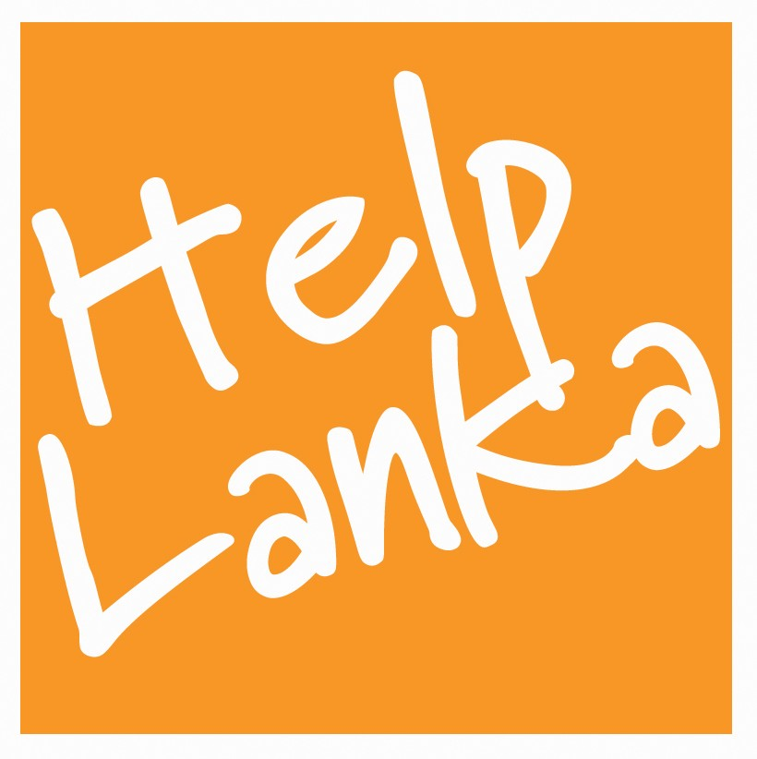

PRESS RELEASE

For Immediate Release: 5/09/18

Helplanka’s Volunteers thanked at Parliament !

UK Registered Charity Helplanka , has helped children through education in Sri Lanka for 14 years and conducts an annual Volunteer Programme ,organised and led by Chief Executive Sam Goonetillake to Sri Lanka . This year, 2 groups participated in the Helplanka Volunteer Experience from 2 schools in Wales UK. 30 students and teachers from St Michael’s School Llanelli and Barry Comprehensive Barry , together with the charity raised funds to teach English sport and drama at 2 rural schools as well as orphanages, children’s centres and conducted programmes for Deaf and Blind children and special needs children .

The group were invited for tea at Parliament by Honourable Deshabandu Karu Jayasuriya Speaker of Parliament. Certificates of recognition were presented by Hon Navin Dissanayake MP Minister of Plantation Industries who thanked the group for their work in Sri Lanka and spent time himself answering questions and organising a tour of Parliament. “ It was a great pleasure and privilege to meet the group from Helplanka: their contribution is a great memento of Sri Lanka – UK Friendship said Navin Dissanayake.

Helplanka donated a number of English and Sinhala language books, equipment , sports goods and arts and crafts materials to the children at all of the projects . As part of the trip to Sri Lanka Helplanka organised a tour of the island to include visits to Sigiriya, Negombo , Colombo, Dambulla, Galle & Kandy.

Sam Goonetillake commented “ I would like to especially thank Hon Navin Dissanayake and Honourable Speaker for their time and support for Helplanka and would like to take this opportunity to applaud the fantastic efforts of the 2 UK schools who have made a lasting difference to children’s lives in Sri Lanka. We rely heavily on donations to continue our work both in the UK and also in Sri Lanka and hope that their work will inspire others to come forward to support us. “

HELP US HELP THEM HELP LANKA

ENDS

Press Enquiries
Sam Goonetillake
Chief Executive
Helplanka
07963 331138
E mail sam.goonetillake@gmail.com

ABOUT HELPLANKA

HelpLanka is a UK Registered charity (Reg no 1110306) which was formed in January 2005 to specifically help children affected by poverty and disaster in Sri Lanka. Helplanka is also registered as a non profit making organisation in Sri Lanka ( HELPLANKA CHILDREN’S GUARANTEE LTD GL2021) Patrons : Tom Brake MP and David Swallow OBE. The charity runs a volunteer programme , Child Sponsorship and educational programmes assisting schools in rural areas and support for Special Needs Children.

