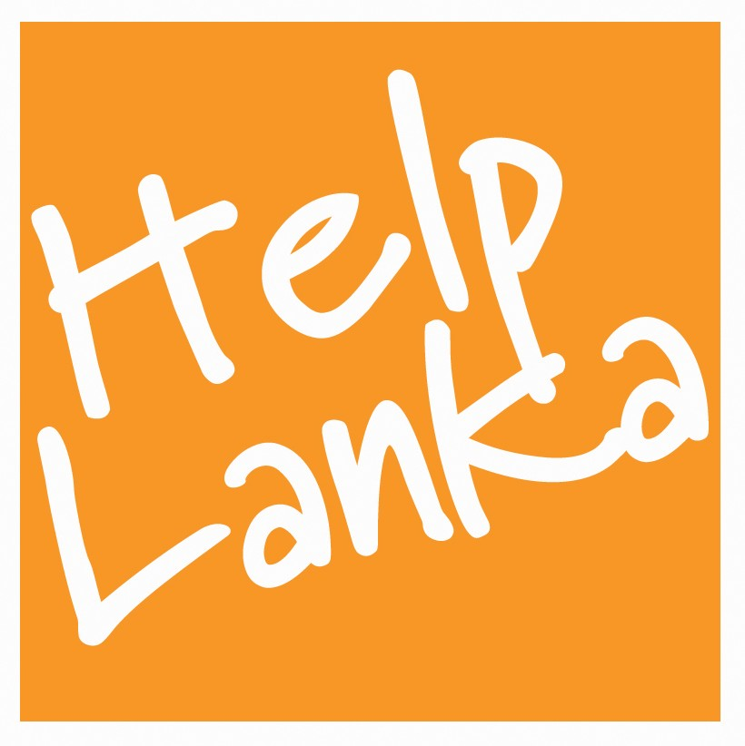
PRESS RELEASE

For Immediate Release:

IRAJ continues to support Helplanka’s work for rural Children in Sri Lanka

Superstar and Pop icon Iraj Weeraratne visited Horawala Vidyalaya in Bentota recently . The surprise visit was organized by UK based charity Helplanka active in Sri Lanka and who also brought 10 students from a school in Wales who have twinned with Horawala school and together with Iraj donated books and held a special music and quiz programme for the children of local schools.

Commenting on Iraj’s visit, Sam Goonetillake, Chief Executive of Helplanka who also attended , said “ this is the third time Iraj has actively supported Helplanka and we are very grateful once again for his support and for taking time out of his busy schedule to connect with rural children in Sri Lanka. “

Ends

Press Enquiries
UK
Kate Moore
E mail kate@helplanka.co.uk

Sam Goonetillake
Chief Executive
Helplanka
07963 331138
E mail sam@helplanka.co.uk

ABOUT HELPLANKA

HelpLanka is a charity (Reg no 1110306) which was formed in January 2005 to specifically help children affected by the tsunami. Chief Executive, Sam Goonetillake and 6 other Trustees, all Sri Lankan living in the UK, have sent aid to affected areas and have started a programme of educational assistance and rebuilding.

For further information, please visit: www.helplanka.co.uk

