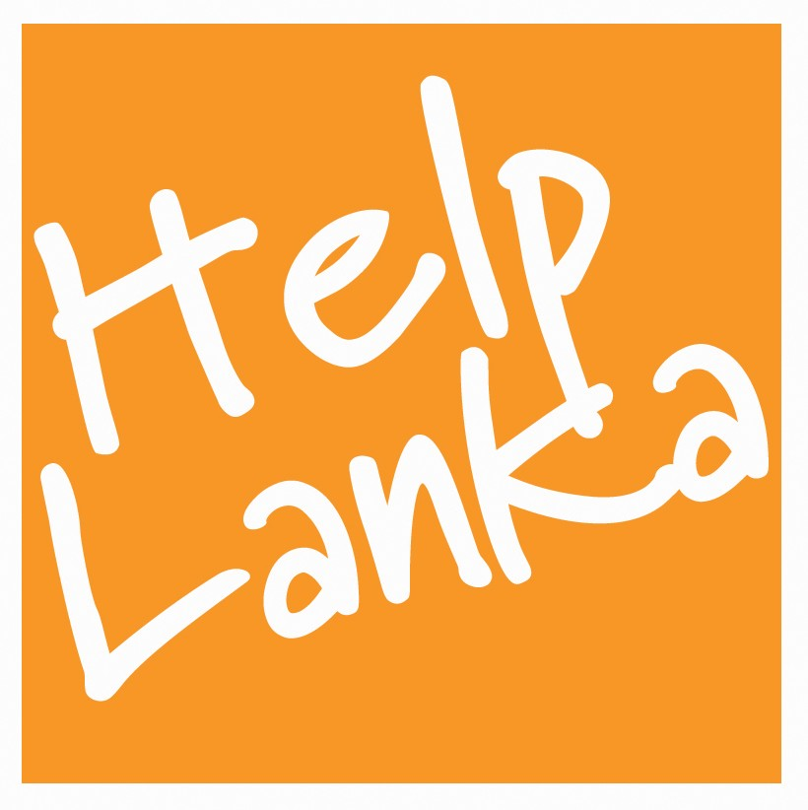

PRESS RELEASE

For Immediate Release: 29/07/11

Helplanka successfully continues to help more rural school children and special needs children with UK volunteer Programme in Sri Lanka July 2011.

Organised by Helplanka UK annually a group of 13 volunteers including 3 teachers from Barry South Wales visited Sri Lanka in July to teach English, music, drama and sport at Siviraja Deaf and Blind School Mahawewa NWP, Ragama Convalescent Home for Children, Leonard Cheshire Home Katana Negombo and also at Ihala Yagoda Vidyalaya Gampaha The highlights for the group were visiting the special needs centres where parties were organised, face painting and games were the order of the day and toys, educational equipment , computers , books ,cuddly toys electric organs , hearing aids and school bags were distributed.

Commenting on this year’s programme Sam Goonetillake said: “I would like to thank Barry Comprehensive School for their hard work and dedication in helping so many children once again. It is a wonderful achievement that despite the economic recession the people of Wales have managed to fundraise a substantial amount to assist these important childrens’ projects in Sri Lanka who rely on our help to survive “

ENDS

Press Enquiries
Sam Goonetillake
Chief Executive
Helplanka
www.helplanka.co.uk
07963 331138
E mail sam@helplanka.co.uk

ABOUT HELPLANKA

HelpLanka is a UK Registered charity (Reg no 1110306) which was formed in January 2005 to specifically help children affected by poverty and disaster in Sri Lanka. Helplanka is also registered as a non profit making organisation in Sri Lanka ( HELPLANKA CHILDREN’S GUARANTEE LTD GL2021)

For further information, please visit: www.helplanka.co.uk

