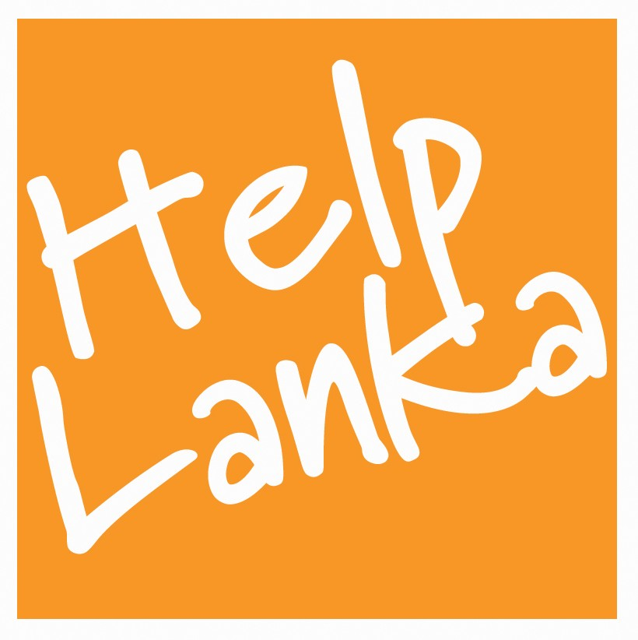

PRESS RELEASE

For Immediate Release: 30/12/10

Helplanka and Mackwoods host Christmas Programme for Deaf and Blind Children in Jaffna
.

Equipped with 55 analogue hearing aids donated by St Helier Hospital in Carshalton Surrey UK, Sam Goonetillake and the Helplanka Team arranged a Christmas party with a difference at The Nuffield School for Deaf and Blind in Jaffna Northern Sri Lanka on December 9th 2010. Funded by donations from UK donors and supported by UK MPs Tom Brake and Stephen Hammond the Charity also gave out 250 caps generously donated by Mackwoods.

Commenting on this special programme, Sam Goonetillake Chief Executive of Helplanka said: “I would like to thank Dr Chris Nonis CEO of Mackwoods for their generous contribution all the children loved their caps! This was a very special Christmas celebration made possible by the hard work and generosity of UK donors and St Helier Hospital, The Sri Lanka Helplanka Team and the work of Stephen and Tom. Indeed their contribution has made a valuable long term difference in the lives of these children and we hope that we can continue to support these projects in the future We will be asking all Hospital Trusts in the UK to donate any unwanted hearing aids to Helplanka and will be writing to the UK Health Minister and to David Cameron urging their support in this campaign.”

ENDS

Press Enquiries
Sam Goonetillake
Chief Executive
Helplanka
07963 331138
E mail sam@helplanka.co.uk

ABOUT HELPLANKA

HelpLanka is a UK Registered charity (Reg no 1110306) which was formed in January 2005 to specifically help children affected by poverty and disaster in Sri Lanka.

For further information, please visit: www.helplanka.co.uk

