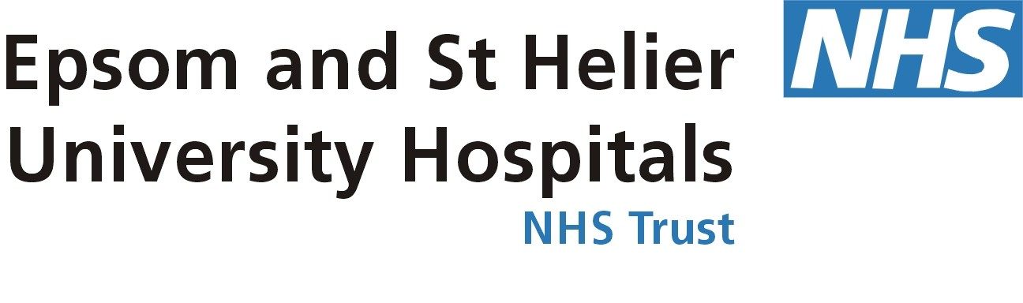

PRESS RELEASE Issued: xx August 2012

St Helier Hospital hearing aids Helplanka campaign
A bumper donation of 50 hearing aids from doctors and audiologists at St Helier Hospital are now helping hearing impaired children in Sri Lanka, thanks to a Carshalton-based charity.
The hearing aids, which belonged to patients who now have newer models, were donated to Helplanka – a charity that has been helping children in Sri Lanka since 2005.

And now, the team of volunteers from Helplanka have made the 5,454 mile trip to St Joseph’s Deaf School in Ragama, Sri Lanka and dropped off the hearing aids, as well as other vital supplies including food, books and toys.
This is the second contribution from the department and forms part of a nation-wide appeal supported by local MPs Paul Burstow (MP for Sutton and Cheam and Minister of State for Care Services and Tom Brake (MP for Carshalton and Wallington),

Steve Hyer, the Trust’s joint clinical director said: “We are delighted that our small donation is making such a big difference to these children in Sri Lanka. This fruitful partnership is bearing fantastic results.”

Sam Goonetillake, Chief Executive of Helplanka, said: As a resident of Carshalton I am particularly proud of the generosity and partnership with St Helier , local people and also our MP’s in organising this donation which has enabled Helplanka to continue its work with special needs children in Sri Lanka. I hope that other NHS trusts in the UK will follow the lead of St Helier with donations of unwanted hearing aids and batteries.
Paul Burstow MP said: "This is an excellent model for co-operation between the NHS and charities. Making sure that discarded hearing aids are put to good use in SriLanka rather than being thrown away."

Tom Brake MP said: ”Yet again, young people in Sri Lanka will benefit from discarded hearing aids. The partnership between Helplanka and the audiology department at St Helier Hospital who are delivering these vital aids, should be replicated across the whole of the country.”

The visit formed part of a number of Helplanka projects helping to improve the lives of children affected by poverty and disaster in Sri Lanka.

Receiving the donation on the school’s behalf, Audiologist, Sister Charmaine said: “It is wonderful that our friends in Carlshalton have generously donated these very valuable hearing aids to the needy in Sri Lanka. We are also delighted that Helplanka has visited our school again.
“Thank you St Helier for this kind donation, it will transform the lives of so many.”

For further information about the work of the charity, visit www.helplanka.co.uk.

For more information about our hospitals, visit www.epsom-sthelier.nhs.uk. You can also join our 2,500 followers on Twitter (twitter.com/epsom_sthelier) or find us on Facebook (facebook.com/epsomsthelier).
Ends
It's 'Your hospital': be one in a 1,000. We are looking for 1,000 people to join a
special panel of patients and local residents to give feedback about the work of our
hospitals: from the care our doctors and nurses provide to the quality of our food and cost of car parking. It's easy to join and all we ask is for you to be brutally honest. Join now – www.epsom-sthelier.nhs.uk/yourhospital.

Note for Editors

- For more information, please contact Femi Adedeji in the Trust’s communications department on tel: 020 8296 2406 or email femi.adedeji@esth.nhs.uk. Out of hours, please call 07975 232 380.

- Epsom and St Helier University Hospitals NHS Trust is a large acute trust serving South West London and Surrey. The Trust is made up of Epsom, St Helier and Sutton hospitals and provides around 700,000 patient contacts every year. The Trust is one of the largest employers locally, with around 5,000 staff.

- The Trust offers an extensive range of services, including cancer, immunology, sexual health, women’s and dermatology services. St Helier Hospital is also home to the South West Thames Renal and Transplantation Unit and the Queen Mary’s Hospital for Children, whilst Epsom Hospital is home to the Elective Orthopaedic Centre (EOC). Both Epsom and St Helier hospitals have Accident & Emergency departments.

- As teaching hospitals, the Trust plays a key role in the education and training of tomorrow's doctors, nurses and other health professionals. We work in partnership with St George’s Hospital and St George’s Medical School in south London to deliver high quality education and research. Outside St George’s Hospital, Epsom and St Helier University Hospitals NHS Trust supports the education of the greatest number of medical students than any other teaching hospital in south London.

- The Trust’s website features a wealth of information for the public and patients, as well as journalists and the media. Designated sections include: latest news, the Trust’s strategy for the future, a full A-Z of all clinical services and our performance. Visit www.epsom-sthelier.nhs.uk for more information. You can also follow the Trust on Twitter: twitter.com/epsom_sthelier, and on Facebook: facebook.com/epsomsthelier.

