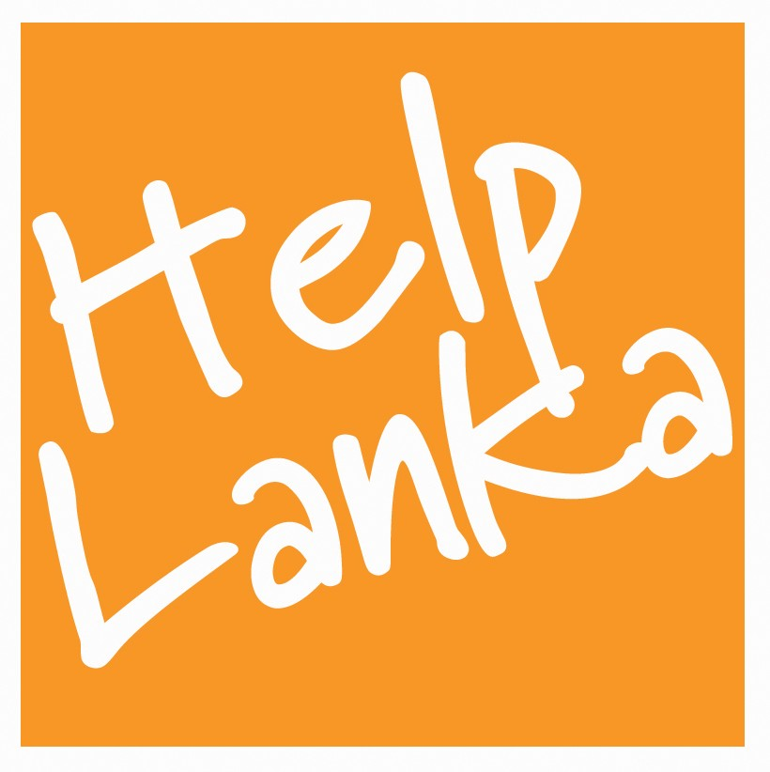

RUN FOR HELPLANKA !

. Dilantha Goonetillake, a Director of Helplanka, UK Registered charity no 1110306, will be running the Windsor Half Marathon again on Sunday 26 September 2010 with all sponsorship proceeds going to Helplanka. Dilantha has been busy training for some time now and hopes to complete the gruelling 13 mile run which will take place at The Long Walk, The Great Park, Windsor, Berkshire.

All monies raised will be used to finance a special Christmas programme for deaf and blind children and rural orphanages in Sri Lanka in December.
Please complete the sponsorship form on the Helplanka website www.helplanka.co.uk if you would like to sponsor Dilantha. Cheques should be made payable to Helplanka and please state if you wish to donate through gift aid.
Send to: Helplanka, 14 Dalmeny Road, Carshalton-on-the-Hill, Surrey SM5 4PP.

