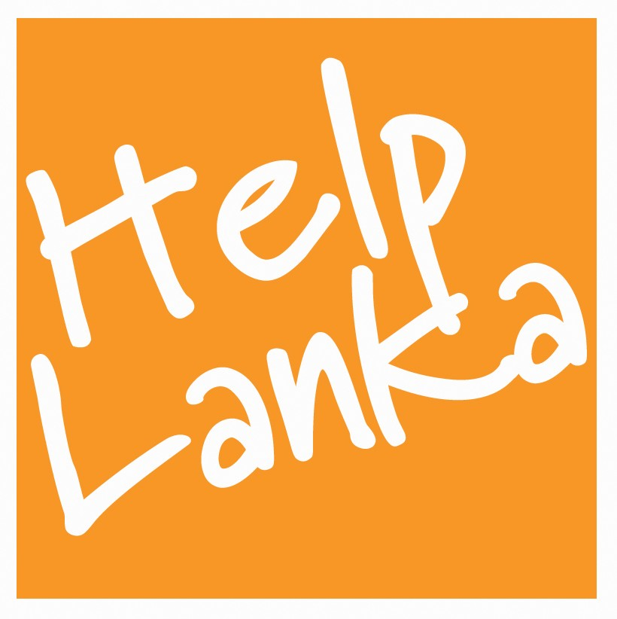
PRESS RELEASE

For Immediate Release: 2/10/07

The Art of Peace – Children’s perspectives through art to Helplanka…

Organised by Helplanka, in association with the Noble Sage Gallery a special art exhibition featuring art from children depicting the theme of Peace will be held at The Noble Sage Gallery Fortis Green Finchley London N29EL on Wednesday November 28 2007 from 8 pm.

Tickets priced at only 5 pounds will include refreshments and all art sold will be used to fund a special Christmas programme for schools and orphanages in Sri Lanka this December.

Hand made gifts from Sri Lanka will also be available for sale and there will also be an auction of 6 works by commercial Sri Lankan Artists with profits going to Helplanka.

Ticket price : £5 in advance including refreshments.

Sam Goonetillake, Chief Executive of Helplanka, said “ This event will capture children’s views of peace and we have ensured that there is representation of young artists from all communities of Sri Lanka. We will also give a review of Helplanka’s work this year and hope to raise enough funds through the sales of the art to bring a little happiness to children at Christmas in Sri Lanka.”

Ticket sales and Information:

Sam tel: 07963 331138 Dinesha : 07949 483376 www.helplanka.co.uk

Ends

Press Enquiries
UK
Kate Moore
0208 773 0484
E mail kate@helplanka.co.uk

Sam Goonetillake
Chief Executive
Helplanka
07963 331138
E mail sam@helplanka.co.uk

ABOUT HELPLANKA

HelpLanka is a charity (Reg no 1110306) which was formed in January 2005 to specifically help children affected by the tsunami. Chief Executive, Sam Goonetillake and 6 other Trustees, all Sri Lankan living in the UK, have sent aid to affected areas and have started a programme of educational assistance and rebuilding.

For further information, please visit: www.helplanka.co.uk

