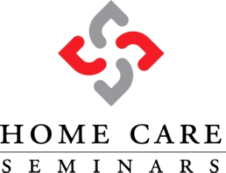
North Carolina Home Care Licensure Applicant Training

The following will be addressed in the training: The current law requiring training; how to apply for your Home Care license; home care licensure rule review; overview of pertinent laws; sample policies and forms. A certificate of completion will be provided to each agency that completes the class.
Instructors:
Connie Wilson, RN, currently serves as the VP of Nursing for At Home Eldercare. Connie has 35years of Home Care experience, in addition to years of both classroom and Aide instructional experience.
Gavin Densmore, MBA, founded Helping Hands of America 23 years ago and currently serves as President of both Home Care Seminar as well as At Home Eldercare. He has sat through both the licensing process for the state of North Carolina, as well as five audits conducted by the DHSR.
Registration: The registration fee is $600 per agency. This allows attendance for up to 2 agency representatives. The agency owner is required to attend. Additional individuals from your agency may attend for $325. Registrations are not confirmed until payment has been received. Forms must be faxed to (833) 244-0471. Please call 919-632-8891 to confirm receipt of your registration form. Walk- ins will not be accepted. Registrations are accepted on a first-come, first-served basis.
Time: The training is offered every Tuesday from 10:00a to 2:30p. We limit the number of individuals in the class to 10 participants, or roughly 5 potential new agencies.
Payment: Cash day of class, Cashiers Checks and Money Orders made payable to: Home Care Seminar LLC. Visa/MasterCard are accepted as well. Should you choose to pay by credit card, please add an additional 4% to cover the credit card processing fees.
Disclaimer: This class is offered for educational purposes only and does not guarantee that the attendee will be granted a license by the Division of Health Services Regulation. Neither Home Care Seminars nor any of its officers, directors, employees or affiliates shall be liable for any direct, indirect, special, consequential, punitive, exemplary and/or incidental damages of any kind whatsoever (including, but not limited to, loss of profits or attorneys’ fees) in any way due to, resulting from, or arising in connection with Registrant’s acquisition or use of the Materials, or from Registrant’s reliance on any information provided. This limitation applies to all causes of action in the aggregate including, but not limited to, breach of contract, breach of warranty, negligence, strict liability, misrepresentation, and any other tort.

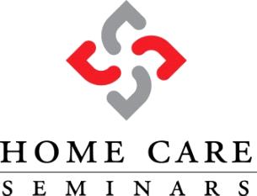
Home Care Licensure Applicant Training
Agency Name:__________________________________________________________________
Agency Owner: (Required attendance)____________________________________________________
E-mail Address (for registration confirmation):________________________________________________
Address:_______________________________________________________________________
City:_________________________________ State:______ ZIP:________________
Desired Class Date:___________ Phone:______________________ Fax: ________________

CLASS FEE: $600.00
HR/New Hire Manual: $2,500.00 Forms: $1,500.00 Policies & Procedures Manual $1,500.00
DISCOUNT!!! Class Registration + Forms + Policies & Procedures all for $3,200.00
Credit Card Charge Authorization
Name on Card: _____________________________________________________________
Billing Address for Card:_______________________________________________________
__________________________________________________________________________
Credit Card #:___________________________________________________________________
Expiration Date:__________________ Last Three Digits on Back of Card:__________________
Card Holder Signature: Date:
___________________________________________ ______________________________

Please fax or e-mail to: Fax: (833) 244-0471 E-Mail: gavin@homecareseminar.com

