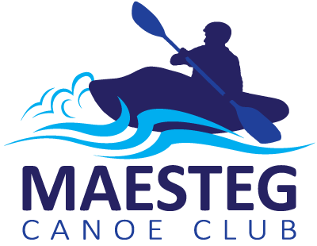
Affiliated to

Membership Application & Renewal Form

Please complete this form on joining the club and at each renewal.
Please inform us if any of the details below change.
Completion of this membership form provides consent for you or your child to participate in the activities of Maesteg Canoe Club in relation to its constitution and the codes of practice of Canoe Wales.

Name of member:

Contact address:

Postcode: Date of birth:
Email address:
Contact telephone number: Mobile phone number:

Emergency contact name: Relationship to you:

Emergency Contact address (if different from above): Contact telephone number:

Mobile phone number:
Postcode:
Do you have any disabilities, medical conditions or allergies. (Common examples include Asthma, ADHD & Diabetes)
YES / NO If yes please give details:

Please delete as appropriate: I agree / I do not agree to photographs of myself / my child being taken by authorised members of the club for promotional purposes.
Canoeing and Kayaking are “Assumed Risk, Water Contact Sports” that may carry attendant risks. Participants should be aware of and accept these risks and be responsible for their own actions and involvement.
Signature: Date:

For members under 18 years this form must be countersigned here by a parent or guardian.
Signature: Date:
Printed name:

Affiliated to

Thank you for joining Maesteg Canoe Club!
As a community club we rely on the hard work of volunteer coaches and committed members. We are funded entirely through membership fees and occasional grants from local and national sports organisations to purchase our equipment and ensure our coaches are qualified to the highest standard.
Please ensure you complete a membership form and return it to a Coach at your next session. It is essential we have up to date contact details & are aware of any medical conditions you may have. Please also bring along your Canoe Wales for your insurance (£5 for children, £10 for adults).
The club is run for you the members! The committee manages all club activities and are elected at the Annual General Meeting. The key contacts within the club are….
Coaches: Dan, Gary, Chris, Jack & Michael
Club Secretary: Sharon Club Treasurer: Cheryl Chairperson: Emily
Club President: Keith

The membership fees for 2017/2018 are outlined below
Junior session fee: Payable to the Swimming Pool each week, currently £3.60
Senior session fee: £8.00 per session or £15.00 monthly direct debit representing a significant saving for our regular members.
For more information

Don’t forget to visit our website: www.maestegcanoeclub.org
You can email us: mail@maestegcanoeclub.org
Call Em: 078 101 51305 You can also find lots of club info on our facebook page

