**Finding Port Talbot Docks**

As you may be aware, for the duration of the school summer holidays we will be paddling at Port Talbot Docks. Our first week here will be 25th July and we will return to the pool on the 5th September. **These are the following dates we are down the docks: 25th July, 8th August and 22nd August.**

**We will meet at the docks at 6pm… all Juniors and Seniors welcome!**

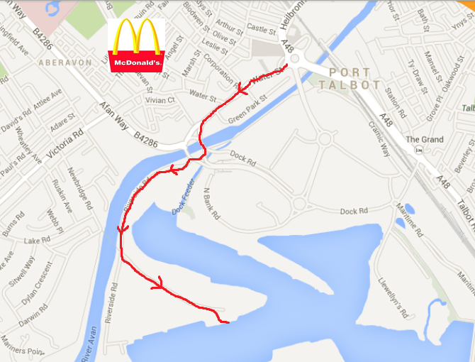

C:\Users\Chilly\AppData\Local\Microsoft\Windows\Temporary Internet Files\Content.IE5\S4OO2C66\MC900212923[1].wmf

**Map © Google Maps 2013**

The nearest reliable postcode is for the McDonald’s restaurant marked here with the black arrow **SA12 6LL**

Go past the McDonald’s and ATS tyre unit. Take the third exit at the roundabout onto Riverside Road then take a left as soon as you have gone through a set of gates.

**Any issues please give us a call…**

**Dan: 07528966436 Em: 07810151305**