Club Merchandise Order Form
Maesteg Canoe Club is branching out into its own club merchandise. If you would like to purchase this merchandise please fill in the order form below and return to either a coach, Cheryl or Em with payment.
Maesteg Canoe Club Committee

Kids T shirt £10.00

Age (Please circle the correct size) 5/6 7/8 9/11 12/13
Child’s name (will go on front of T-shirt):
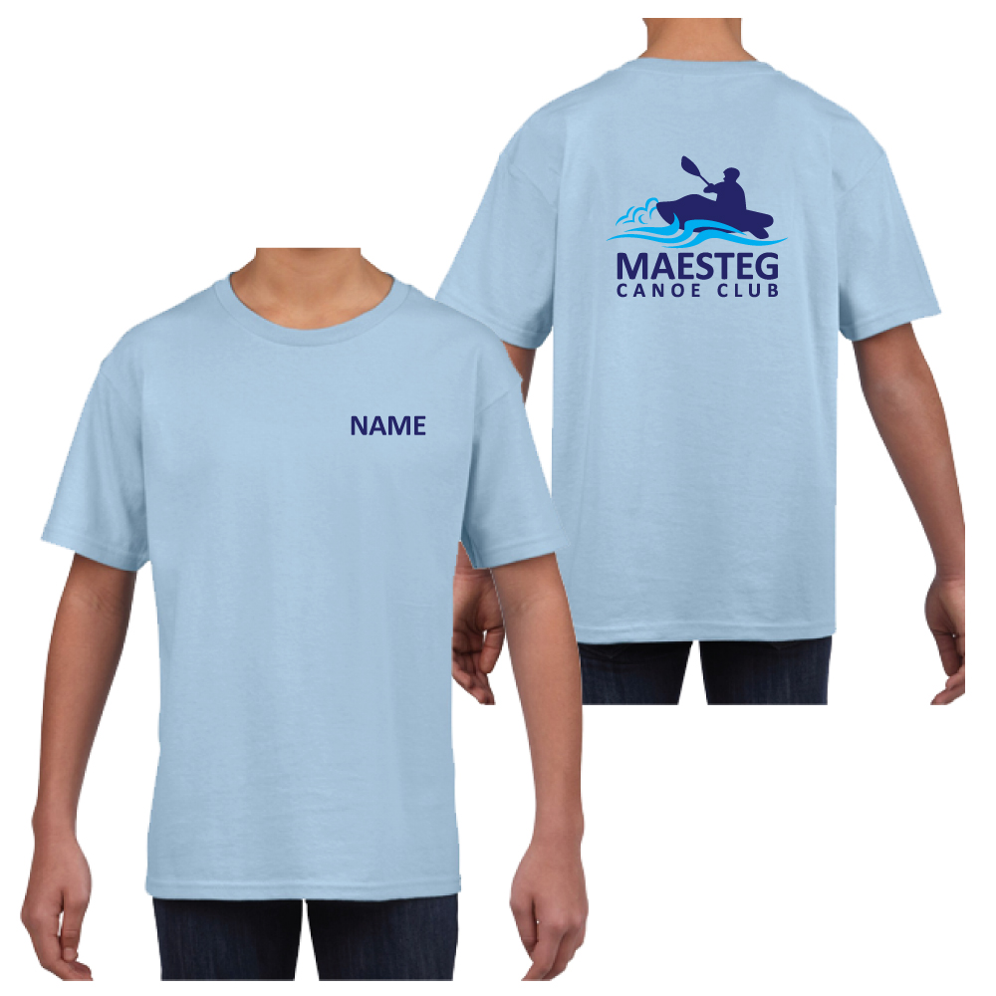

Kids Hoodie £15.00
Age (Please circle the correct size) 5/6 7/8 9/10 11/12 13
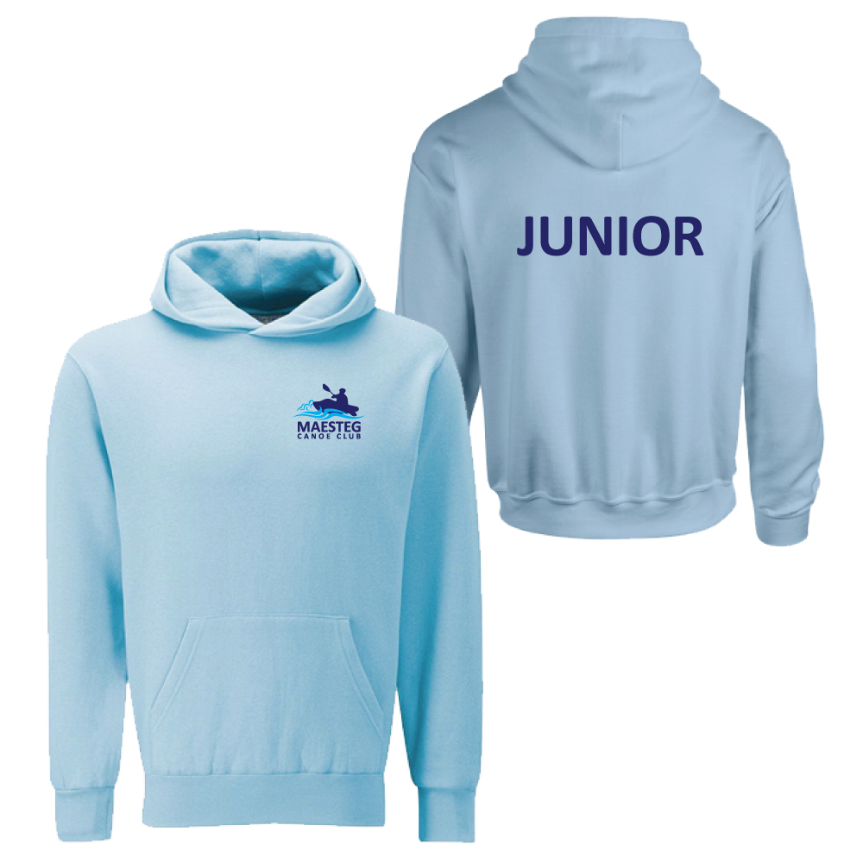

Adult Hoodie £20.00
Unisex Size (Please circle the correct size) S M L XL 2XL

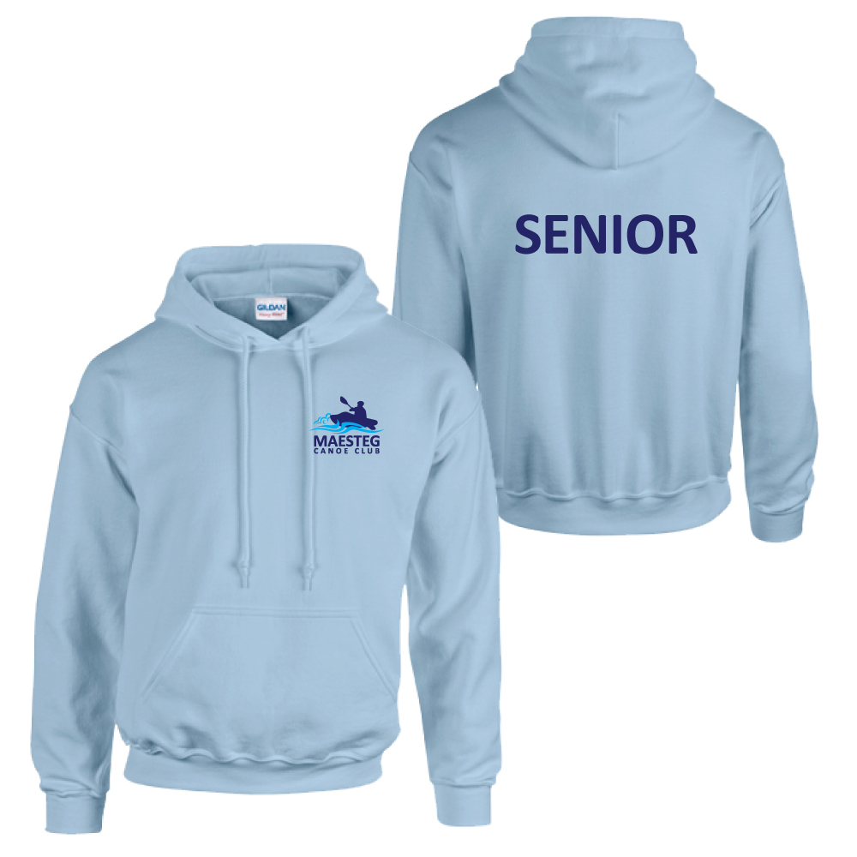
Softshell Jacket £30.00
Unisex Size (Please circle the correct size) S M L XL 2XL 3XL
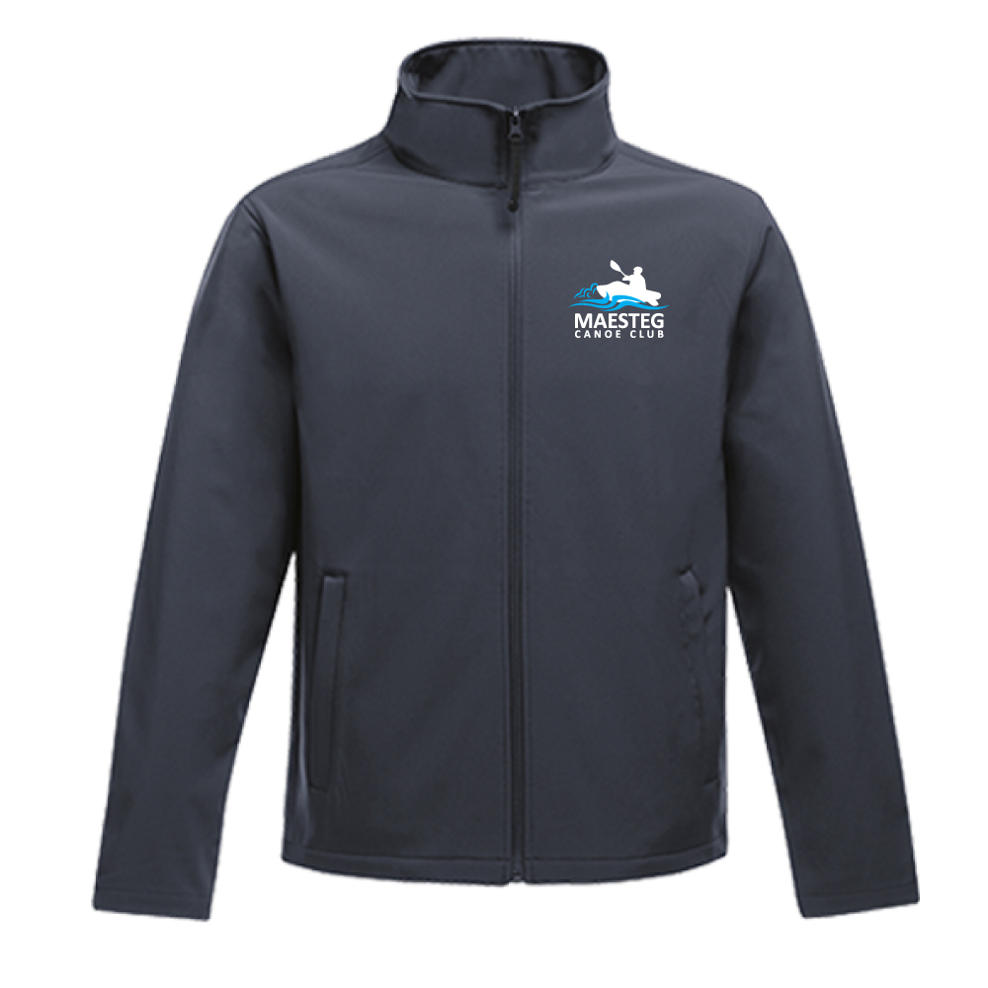

Beanie Hat £6.50
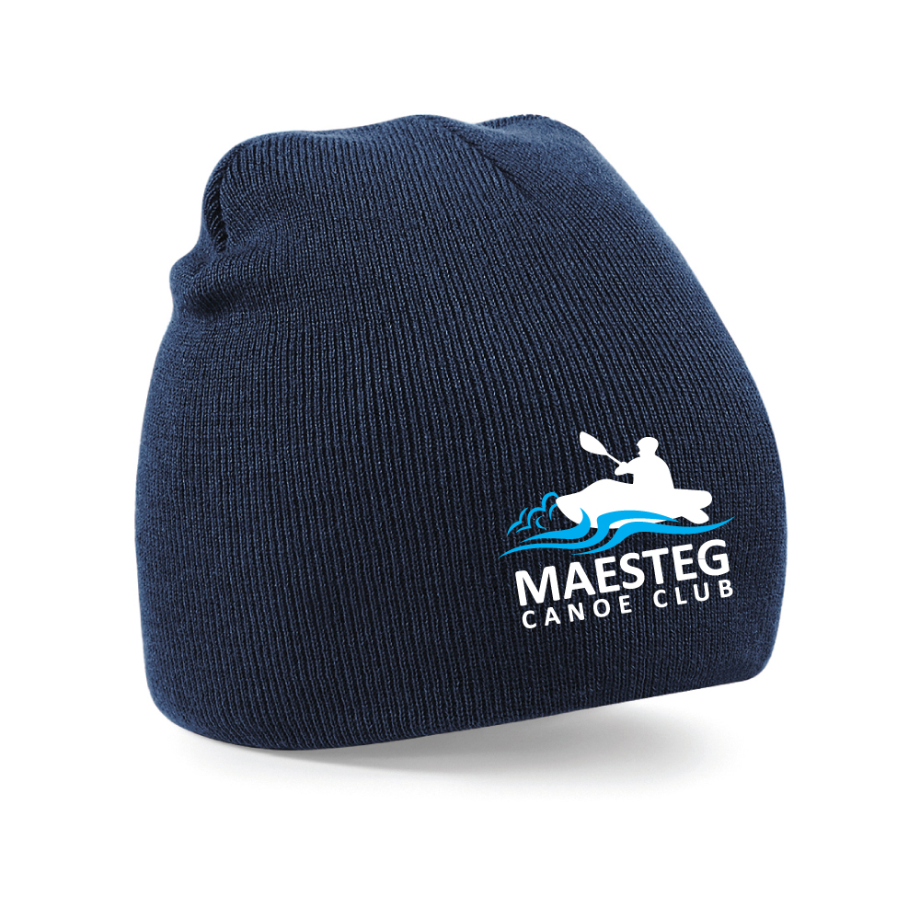
Total amount Payable and enclosed £

