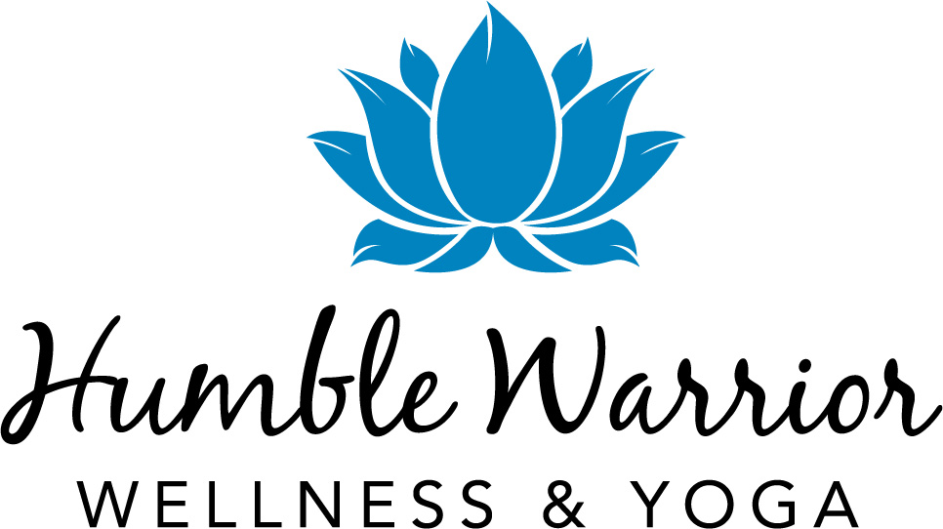

**Humble Warrior Wellness & Yoga, Inc**

**196 Alps Road**

**Suite 2-228**

**Athens, GA 30606**

Thank you for your interest in attending the Humble Warrior Weekend Retreat. You’ve paid the fully refundable $50 registration fee. Now, just a few more steps and you will be fully registered. Please complete this application and return it to [raquel@humblewarrior.org](mailto:raquel@humblewarrior.org) within 7 days.

1. Contact Information.

* Name:
* Phone Number:
* Email Address:
* Mailing Address:
* T-shirt Size:
* Are you signing up to attend a retreat with a buddy? If so, who:

2. What appeals to you about this wellness retreat?

3. How will this retreat help you fulfill your personal goals?

4. Meals and snacks are vegan/vegetarian. How do you feel about holding a plant-based diet throughout the retreat?

5. Please share with us if you have any special wellness skills or resources that that the group would enjoy and benefit from knowing.

6. Do you have any accommodations and/or lifestyle needs you may need to participate in the retreat?

7. Do you foresee a financial hardship in covering the transportation costs to and from the retreat location? If so, please explain.

8. Please identify your emergency point of contact:

* Name:
* Relationship to you:
* Phone Number:

Note: Did you pay the $50 fully refundable registration fee? Yes or No: _______ The fee will be forfeited and considered a donation if you choose not to attend.

Thank you for sharing. We at Humble Warrior look forward to connecting with YOU!

Best,

Diane Flowers

Co-founder & Chairwoman