The MRMS Research Foundation Board Meeting Agenda
Date: Sunday, September 21, 2025
Time: 11:30 AM - 2:00 PM
Location: Ferney SD
Attendance:
- Dr. Tracy Diefenbach: CEO/President
- Darcy Wood: Vice President
- Gail Rathert: Secretary/Treasurer/SD Registered Agent
- Jessical Cihak: Director of Family Services and Engagement
- Dr. Martin Vick: Director of Medical Practice and Consultation
- Marcia Punt: Director of Education and Curriculum Review
- Becky Burdick: Director of Development and Operations
- Joseph Tewksbury: Director of Veteran Outreach and Youth Services
- Chris Farrell: Director of Community Engagement and Fundraising (Call-In)
Agenda:
- Call to Order (11:30 AM)
  - Welcome and opening remarks by the CEO
- Approval of Minutes (11:35 AM)
  - Review and approval of the minutes from the previous meeting (In January)
  - Notes: Posted on the website for review.
- Financial Report (11:45 AM)
  - Presentation of financial status by the CEO, discuss Gail’s role as treasurer and Registered Agent for the State of South Dakota
  - Discussed the need for a CPA as we continue to grow.
  - 2025-2026 Budget
  - 2025-2026 Zeffy, Venmo, and Website Donation Portals
  - Discussion and approval of the financial report

- Foundation Updates (12:00 PM)
  - MN and SD Reports (C1, C2, 990N postcard, SD Annual Report)
  - Insurance and Licensing – status with NPI as an organization.
  - Professional Liability Insurance
- New Business (12:30 PM)
  - Just Strong Ambassadorship, Refuel, and Black Rifle Coffee
  - Cumberland NU Documentary
  - Potential for Today Show interview (The Executive Producer has called to do an over-the-phone interview).
  - Sundance Film Festival, Film Festival/Hollywood, MN Film/Music Festival
  - New volunteers for HR and Community Engagement and Fundraising
  - Introduce Chris and Jeff (via zoom)
  - Need a Finance Volunteer
  - Logo Design Change
  - Strategic marketing and campaign manual
  - Website Updates
- Lunch Break (12:30PM)
  - Informal discussion and networking
- Strategic Planning (1:30 PM)
  - Review of the strategic plan
  - Discussion of goals and objectives for the upcoming year
- Other Matters (1:45 PM)
  - Open floor for any additional topics or concerns
- Adjournment (2:00 PM)
  - Closing remarks and adjournment of the meeting


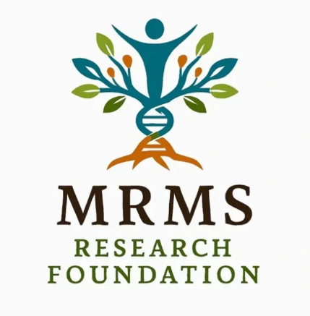

The new MRMS Research Foundation Logo The new Axora Center/Clinic Logo
Institutional Information
Legal Name: The MRMS Research Foundation Date Incorporated: 10/17/2023
Federal EIN: 93-4014294 (Tax Exempt) Federal Status: 501(c)3 Nonprofit
NPI Number: 1033081310 Charitable Organization
Taxonomy Code: 1932000000X Multi-Specialty Group
Member Taxonomy Code: 1744R1102X (Specialist-Research)
Minnesota Business State ID Number: 1420685800028 Certificate of Good Standing: Yes (2025)
South Dakota Business State ID Number: FN309057 Certificate on File: Yes (2025)
Professional Liability Insurance on File: Yes: Private Practitioner, MN, SD
Location of Primary Business: (Remote Office ONLY) Primary Bank: Bank of America
816 2nd St. NE, Business Checking
Fosston, MN 56542
Website: www.mrmsresearchfoundation.org
Email: mrmsfoundation@gmail.com
Primary Contact: CEO/President: Dr. Tracy Diefenbach, CCTP MRMSC 1(218)-637-0399
Registered Agent MN:
LegalZoom (United States Corporation Agents, Inc.)
18202 Minnetonka Boulevard
Deephaven, MN 55391
Registered Agent SD:
Gail Rathert: Secretary Treasurer
3215 Magnolia St N,
Aberdeen, SD 57401
The MRMS Research Foundation Compliance Reporting Dates:
- December 15 of each year: C1 Annual Renewal, Minnesota (Cost: Free)
- April 01 of each year: 990N Tax Forms, or 990 Postcard-card-e-card (if under $50,000.00)
(Cost: TBD)
- July 01 of each year: Minnesota C2 Fiscal Report (Cost: $25.00)
- September 01 of each year: South Dakota Financial Report (Cost: $125.00)
- Certificate of Good Standing: MN: Request each September (Cost: $15.00)
- Certificate of Good Standing: SD: Request each September (Cost: $20.00)
Subscriptions Due:
- Registered Agent: Due October 17 of each year: (Cost: $399.00)
- Website fees: Due January 17 of each year: (Cost: $250.00)
- Personal Liability Insurance for Dr. Diefenbach: Due September of each year: (Cost: $566.00)
- Microsoft Platform: Due January of each year: (Cost: $150.00)

Website Analytics:
September 19, 2025: 747 Site visitors over the last five days.
September 19, 2025: 290 Social Media views (Need to start boosting the feed).
Current Social Media: Facebook, Instagram, and YouTube Channel
Attachments: 2025-2026 Marketing Strategy
JustStrong Marketing Handbook (The Foundation Receives Commission).

