Penmark Village Hall

Booking Information Sheet

**General Information**

The Village Hall consists of the Entrance Hall, Main hall, Kitchen and toilet facilities (Men’s and Women’s), the main hall is shown below

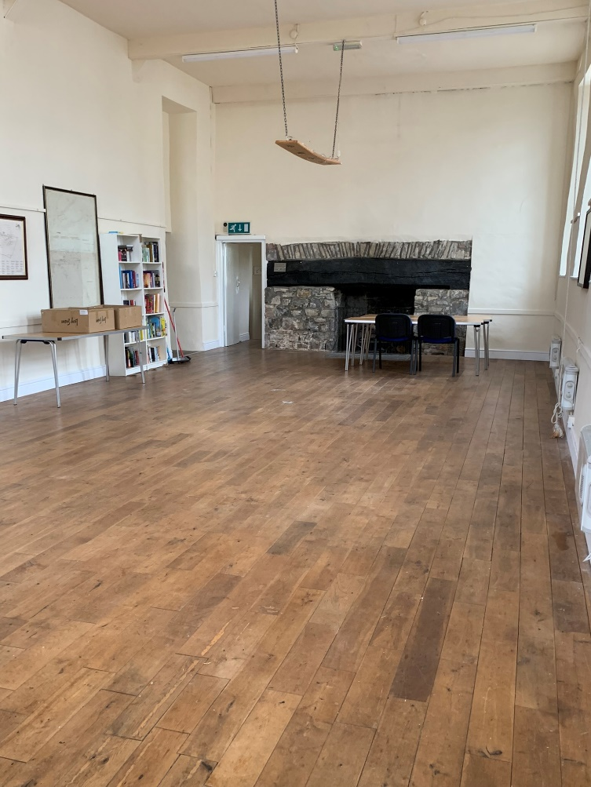

The Kitchen facilities include an oven and hob, water heater, microwave and fridges.

The toilet facilities consist of separate Men’s and Women’s toilets with handbasins.

**Electrics (Main Hall)**

The socket and heater are controlled by two coin meters located in the Main hall as shown below, other switches or breakers should not be altered, it should only be necessary to add to the meters as needed.

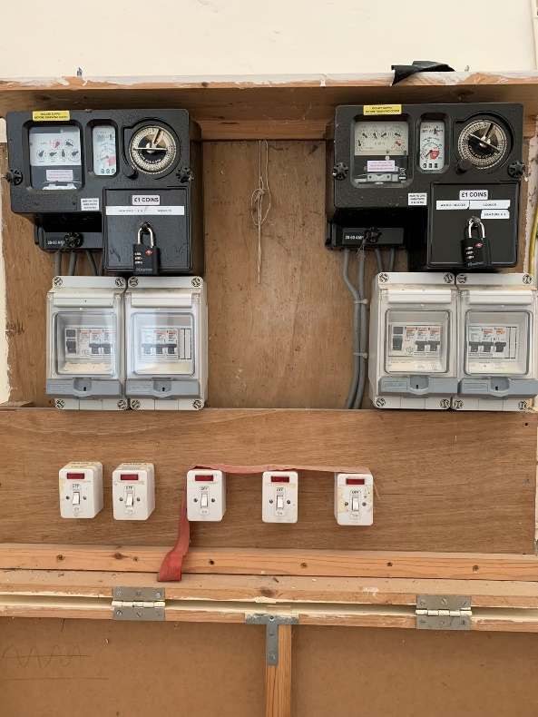

The meters operate different electric circuits as shown the meters, the meters take a new £1 coin.

Wall heater are located in the Main hall, these are all individual controlled and can be turned on/off via the wall sockets switch

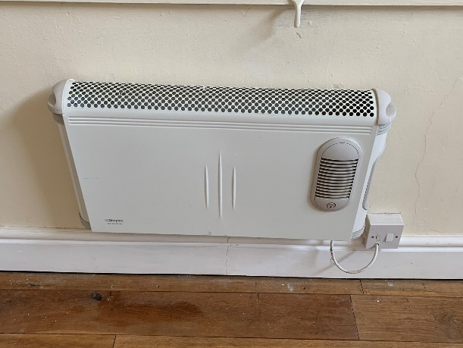

If you use the wall Heaters during you booking,

**Please remember to turnoff all heaters at the wall at the end of your booking.**

**Kitchen and Electrics**

The cooker and Water heater are controlled by switches located inside the kitchen by the entrance door, both have additional switches, for the cooker and socket this is located above the cooker and for the water heater this is in the cupboard under the sink. The cupboard also contains cleaning supplies, additional cleaning equipment (Mop, Bucket, brushes) are located in the entrance hall

Location of Cooker and water heater switches is shown below

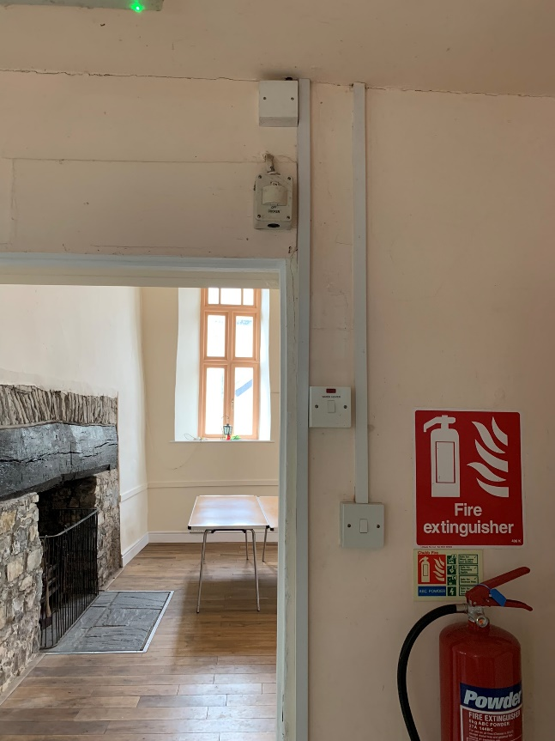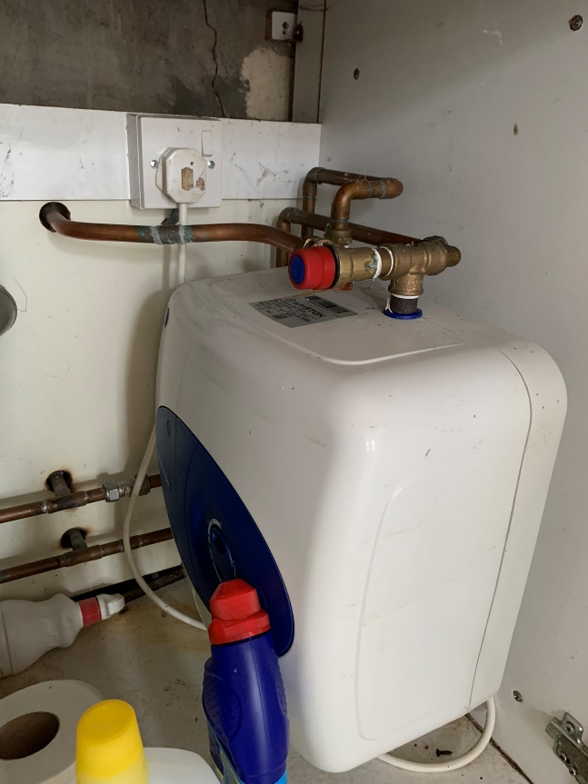

A fire blanket and fire extinguisher are provided in the kitchen. Additional fire extinguishers are in the Main Hall

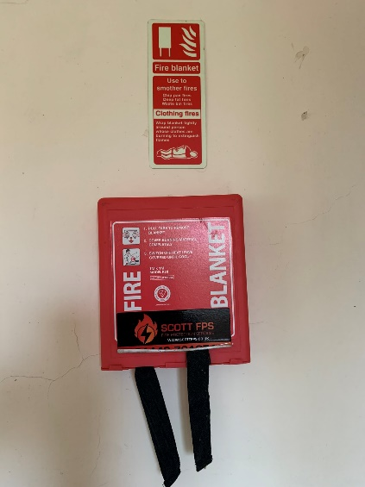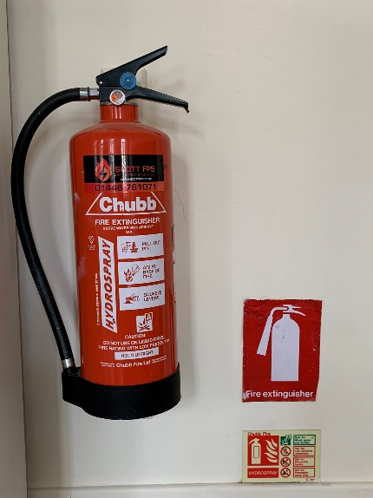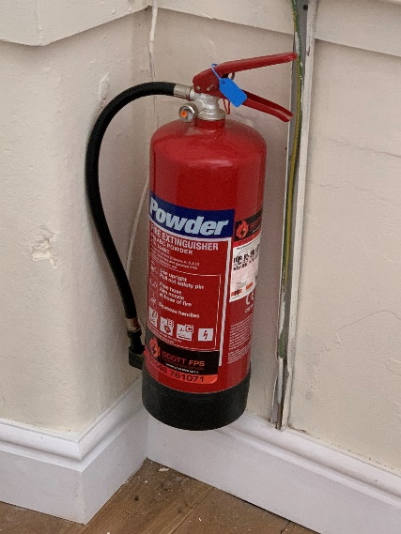

**Please remember to turnoff all Cooker and Water Heater switches at the wall at the end of your booking.**

**Toilet Facilities**

In the men’s toilet the flow of water to the urinals is controlled by a stopcock located inside the Men’s cubicle as shown below

Please turn on the flow during the booking if the facilities are being used and turn off at the end of the booking to conserve water

Booking Checklist

|  |  |
| --- | --- |
| ACTION | COMPLETED |
| Turn off all electric sockets in Main Hall |  |
| Turn off all wall heaters |  |
| Turn off Cooker and clean if used |  |
| Clean any crockery that may have been used |  |
| Turn off water Heater in Kitchen |  |
| Turn Off water flow to Men’s Urinals |  |
| Clean and Tidy Hall, Kitchen and Toilets |  |
| Dispose of rubbish into Black bags, recycling bags and place outside hall entrance |  |