## Pactix can provide a graphics service. Please [contact](mailto:info@pactix.co.nz) us for the latest rates.

## FILE FORMAT

The artwork must be sent in either Adobe Illustrator or PDF, following the specifications listed below.

Name the files in sequence Top/Bottom beginning from the TOP page (01 TOP, 02 BOTTOM).

For PDF multi-page use the same order.

## FILE SOURCE/ORIGIN

### PDF FILE

If possible, send a single file in PDF or multi-page PDF. For orders with multiple projects, send a separate PDF for each project.

PDF files must correspond to PDF 1.7 (ISO 32000-1:2008) standard version.

Please have:

• an output-Intent (print mode indication)

• all texts converted to paths/vectors

• resolution of 300 DPI minimum.

Please do not have:

* comments or form fields
* encryption systems (e.g. password)
* Open Prepress Interface (OPI) comments
* transfer curves
* levels
* paths for die-cutting
* different pages rotated.

It is advisable to convert transparency and gradient in JPG and TIFF before distilling the PDF

### IMAGE FILE

Files created with an image processing program, such as Adobe Photoshop, can be provided in these formats: TIFF, EPS, PSD or PDF.

Files must:

* be saved without any compression function
* have a minimum resolution of 300 DPI

Please do not use:

• Alpha Channels

• clipping paths

### OPEN AND VECTOR FILE

Files can be provided in an open format (EPS). All text must be converted to vector paths.

All images must be included (can be in a separate layer).

## FILE DIMENSIONS AND WAYSIDE TRIM.

•Please create a print document of the exact print size and include a 3 mm bleed area (see diagrams template below). Colours in the bleed area may require an overlaid laminate.

•Please do not:

* insert text (or graphics intended to be read) in the safety margin of 6 mm (along 40 mm edges) & 5 mm (along 80 mm edges) for the Top Film and 3 mm for the Bottom Film.
* Include in the file, crop marks or registers.

## COLOURS

### COLOUR MODE

Specify all colours as:

Pantone Matching System® Coated, OR

CMYK or grayscale, 8 bits / channel; OR

hex triplet (these will be approximated into Pantone).

### FONT COLOURS

Ensure font colours are specified in the file as a Key.

### MINIMUM COLOUR CONTRIBUTION

Colour coverage below 10% can produce a very weak printed output.

### COLOUR PRINTING PROFILE

Coated FOGRA39 (ISO 12647-2:2004)

## FONT SIZE / LINE THICKNESS

Avoid font sizes less than 5 pt (1.3 mm).

Thickness of lines:

• For lines in positive (dark lines on a light background), the thickness must be at least 0.25 pt. (0.09 mm).

• For lines in negative (light lines on dark background), the thickness must be at least 0.5 pt. (0.18 mm).

## FINISHES

An over laid varnish is required when colours are in the sealing area or foils are used.

Any special finishes such as gold and silver hot foil stamping, should be included in the file as a spot colour by renaming the colour channel according to the finish required and agreed upon by the print finisher. Please contact us early in the design process if you are using such finishes.

## IN-LINE PRINTING

Only the Bottom (Rigid) film can have dynamic text data printed in-line during production.

Dynamic data, such as batch, date and packing time, can be printed for unique identification. Limit the number of characters to 50. See examples below. Avoid printing in-line data within ±15 mm of the opening cut line.

## OTHER CONSIDERATIONS

The Top (flexible) film is typically limited to a maximum of four colours but can have up to 10 colours. The more colours the more wastage of plastic during print setup.

The Bottom (rigid) film is strongly recommended to be in one colour and can only be pre-printed in three colours.

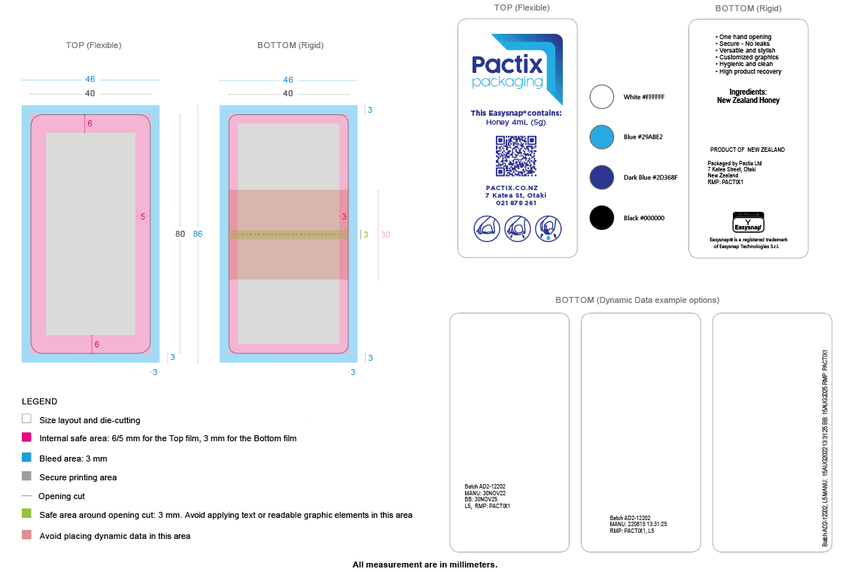

[Set up film graphic.ai](https://pactixconz-my.sharepoint.com/:u:/g/personal/david_stirling_pactix_co_nz/EZwp9ihfujdHihyYJknU4WcBxYdheil1VhAqFBwvu5LzGg?e=VFxNod)

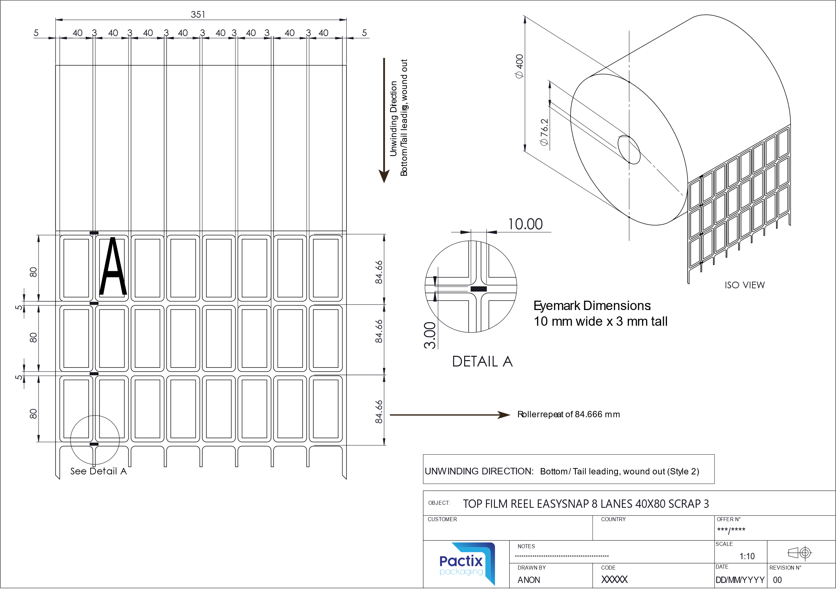

[PULSAR 351 TOP film 40X80 8 Lane.ai](https://pactixconz-my.sharepoint.com/:u:/g/personal/david_stirling_pactix_co_nz/ER6qWQzVDAxCqh3z25lhnzEBUC5zsbT42BJe5wxtrfXIXA?e=1jY7og)

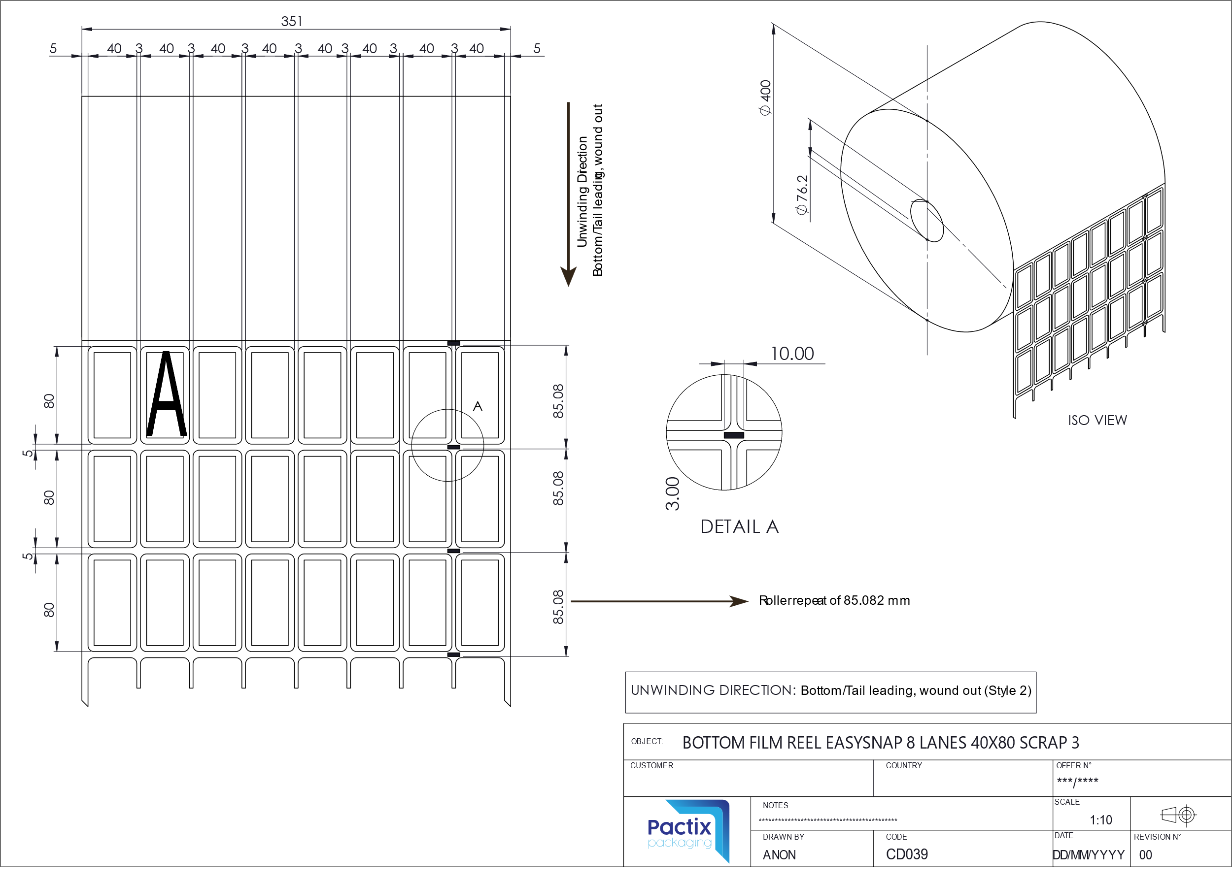

[PULSAR 351 BOTTOM film 40X80 8 Lane.ai](https://pactixconz-my.sharepoint.com/:u:/g/personal/david_stirling_pactix_co_nz/EbjI4OM7ZyxMvyxeEA4vKAIBW3slldXJPduR177jN4QqRQ?e=qn6YVK)