How to assemble pedestal:
- Start with the base (piece with 6 x screw holes) and back piece (rectangular piece with 4 screw holes). Set back piece down flush with base piece and screw in both screws from base piece towards back piece.
- 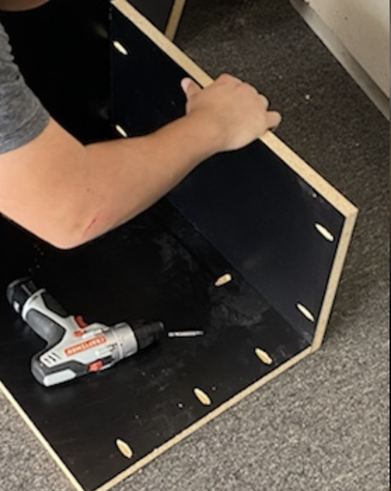
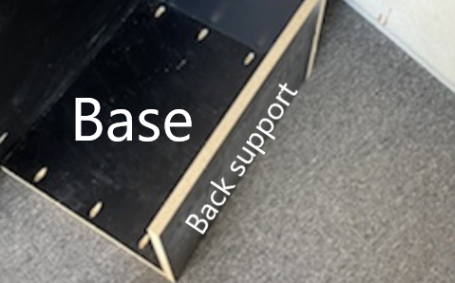
- Next, place left side panel up against the base piece and make sure it is flush with the back piece and screw in both screws from inside towards side panel.
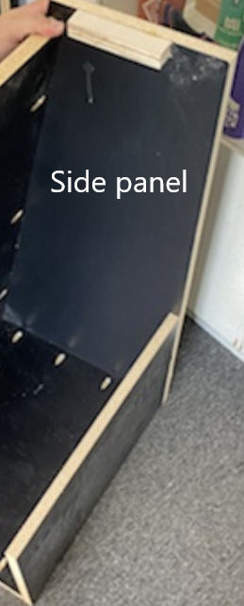
- Next, screw in both screws from back piece to side panel.
- Next, place kick panel (front piece with 6 screw holes) angled from top to bottom and screw in all 3 screw to the left side panel.
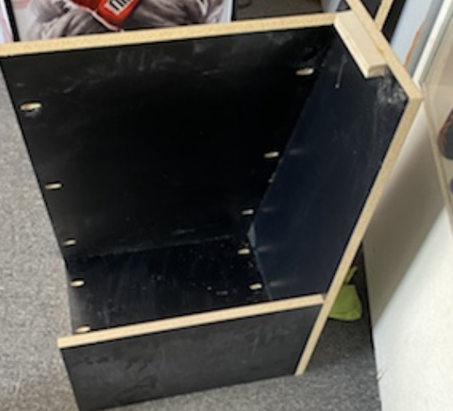
- Next, place right side piece in place and screw in the bottom screws from the base to side panel first and then screw in 3 screws from front kickplate to side panel.
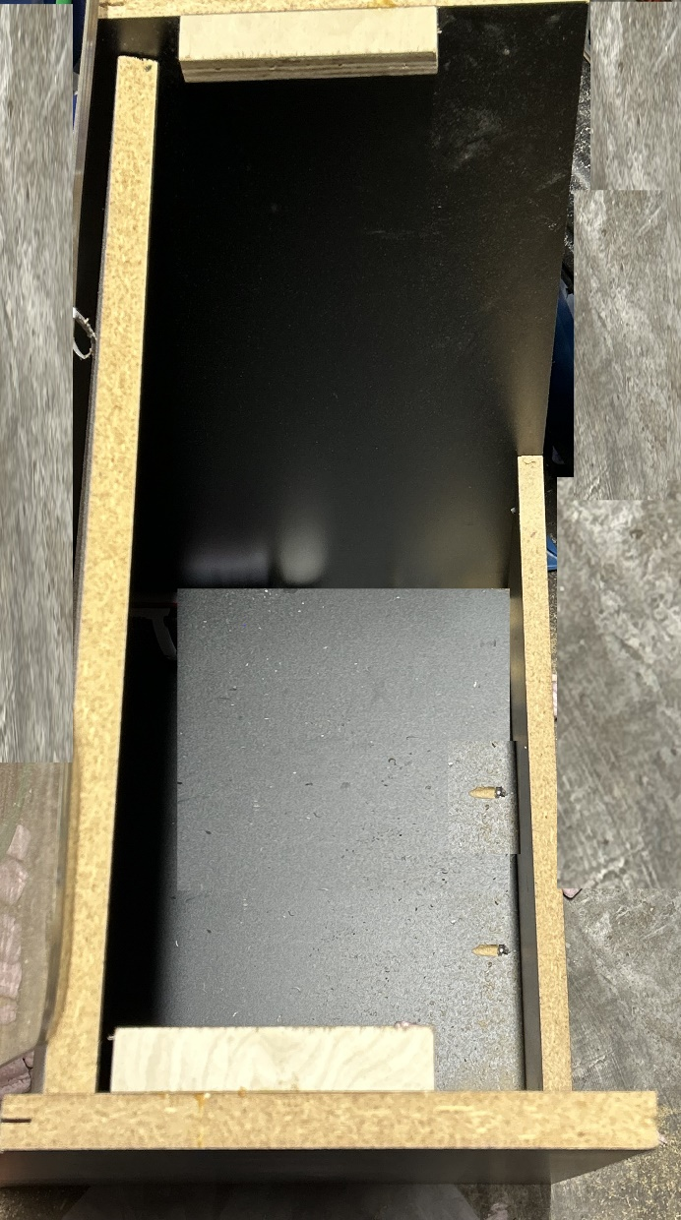

- Next grad control panel mount (this is the bigger piece the control panel will go on top of) and place it on the pedestal stand, make sure the back is flush with the back of the stand and you will screw in 2 screws 12inches inward from the left side and 12 inches inward on the right side. If you prefer you can add 2 extra screws totaling 4 for additional support.
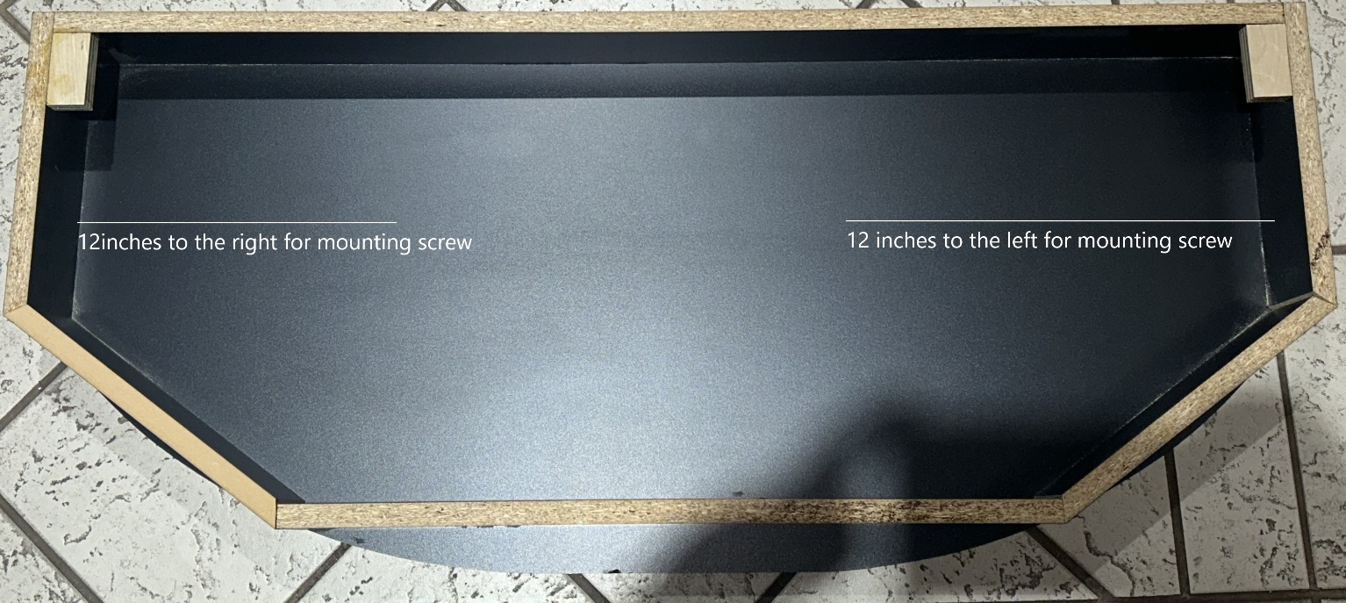

- Lastly, you will place the control panel on top of the control panel mount and there is 2 pre drilled holes that you will screw in to secure the control panel to the control panel mount.

