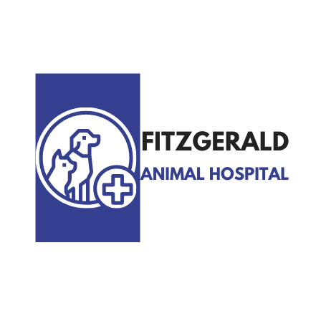
Fitzgerald Animal Hospital
5119 Masonic Dr.
Alexandria, LA 71301
Phone: 318-445-6428 | Fax: 318-442-8309

Human(s) Information
Name:________________________________________________
Spouse's Name:_______________________________________
Address: ___________________________________________________________________
Apt: ____________________________
City: ______________________________________________ State:_________________________
Zip Code:__________________
Cell:__________________________________ Home:_________________________________ Other:_______________________
Spouse Cell: ________________________________ Email:_________________________________________________________

Pet Information

Pet 1 Name:_________________________________ Age or DOB:_________________________ Breed:_____________________
Female | Male Date of last vaccinations:______________________ Neutered or Spayed? Yes | No
Location of Last Vaccinations:___________________________________ City:_______________________ State:________________

Pet 2 Name:_________________________________ Age or DOB:_________________________ Breed:_____________________
Female | Male Date of last vaccinations:______________________ Neutered or Spayed? Yes | No
Location of Last Vaccinations:___________________________________ City:_______________________ State:_______________

Reason for visit: _____________________________________________________________________________________________

