GROWL CLASS

Group Obedience/Behavior Class for Preventing & Handling Aggressive Displays

Limited to 6 Dogs

6:30 p.m. Thursdays (June 7, 14, 28; July 12)

A Rare Opportunity to Gently & Safely Train Nervous or Aggressive Pets Around People & Other Dogs

Using Natural Pack Behavior and Animal Behavior Techniques

Strict Supervision, Management & Equipment Requirements to Protect Handlers & Dogs

Adult handlers only. Family members 16 and older are also welcome to attend.

Aggression is based on fear. The dog fears the approach of strangers, is nervous around children or other dogs, flees or charges when startled, barks incessantly at the neighbors’ pets or growls when the food bowl is approached.

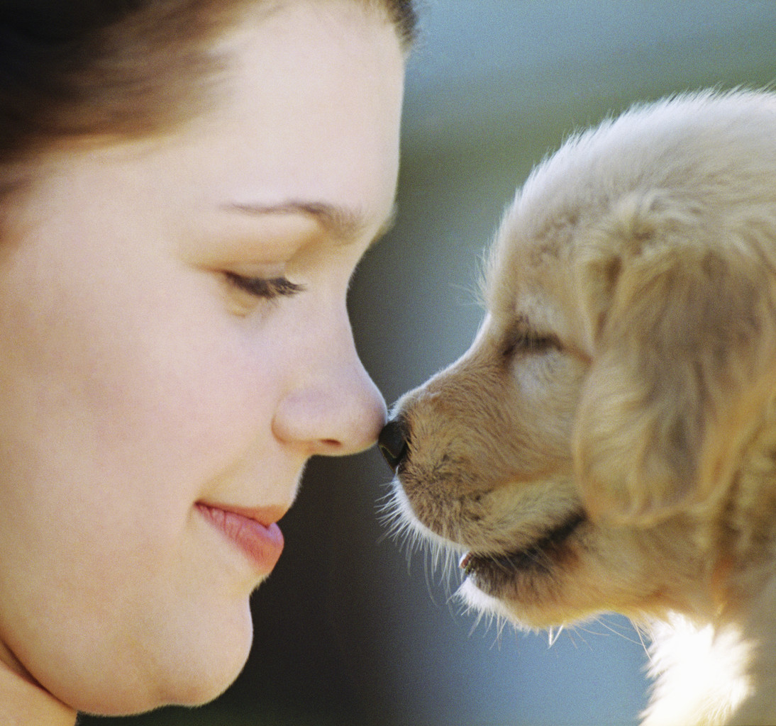

Punishment increases the aggressive reaction in the long run, even if the dog initially seems quieter after being yelled at, admonished or worse. Your dog has to learn to trust you to take care of the scary things, to allow you to decide who enters your home and to be polite to other dogs.

This program offers basic obedience skills in the face of distraction, along with sound proven behavior modification techniques.

Learn gentle, effective ways to conquer or control your dog’s fears. Get back to the fun of living with your dog. He can learn to accept you taking his things and grabbing his collar.

Teach your dog to more calmly accept people and dogs he sees on his walks. Develop realistic expectations for your pets. Not all dogs need to visit classrooms full of children. Some dogs are happiest if they never go near dog parks or group doggie daycare. If your dog has had a bad dog park or day care experience, this is an opportunity to help him conquer his fears.

Encourage your pet to turn to look to you for guidance rather than growling or snapping. Learn to talk dog, reading the information his body language is providing. Use your own body language to help show your dog you are in control of the situation.

**Cost if completed questionnaire and payment are received by June 3: $195.**

**Registration after June 3: $250.**

**$50 discount for those who have completed any of our Detouring Doggie Delinquents private classes or workshops (even if with previous dogs)**

A completed questionnaire must be submitted for approval. Feel free to contact us to chat about the program. Our system for approving dogs for this workshop is understandably cautious and time-consuming, so submit your form now before we fill, especially since we are closed May 20-27 for the flat-coated retriever national specialty. You may pay online after we review the form but no spot is guaranteed until payment is received. Once registration is completed, if you cannot attend for any reason, you may use your class credit toward Best Paw Forward group or private classes or programs through December 2018.

## **\* * * * * * * * * * * * * * * * * * * * * * \***



**Best Paw Forward Inc., 1835 Oak Haven Plantation Road, Osteen FL 32764-8872.**

**This session may be held outdoors under cover to allow maximum space for participants,**

**or may move to our new indoor space if practical.**

## Focus on fun and positive motivation. Clicker Spoken Here; Longest-running group clicker classes in southeast U.S.

**www.bestpaw.com 407-321-1006 bestpaw@bestpaw.com**

P.J. Lacette has been training dogs for more than 40 years and specializes in counseling behavior problems and social issues. Her extensive background in changing behavior problems with a gentle approach has developed into a number of special programs for dogs with social issues.

Please check the web page or contact her about private work for problem pets, or e-mail Best Paw Forward to be added to its events and seminars list.

Member: Association of Professional Dog Trainers (charter member 15), Dog Obedience Clubs of Florida