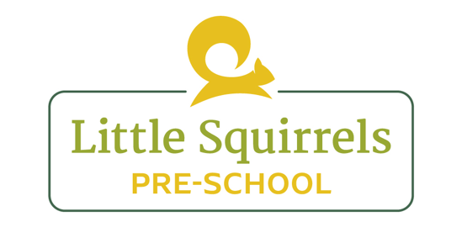

Food Hygiene and Healthy Eating Policy

At Little Squirrels we provide snack for the children in the morning and milk in the afternoon.

Snacks provided are healthy, balanced and varied. We aim to offer children a range of options as well as introducing them to new flavours and teaching children about seasonal fruit and veg.

Individual dietary requirements and preferences are respected and information is gathered from parents to ensure we meet the needs of each child.

Healthy eating is an important value of our pre-school and we promote this regularly with the children; incorporating it within aspects of learning as well as during meal and snack times. This, as well as oral hygiene is embedded into our curriculum.

Advice and information is offered to parents about healthy eating and oral hygiene. We aim to schedule to visit from a dentist to talk to the children regularly and email guidance and tips on cleaning children’s teeth.

Additionally we give packed lunch advice and examples, as well as giving parents individual support with providing healthy options in their child’s packed lunch.

Children who refuse to eat or eat a small amount at lunch time are offered their lunch again later in the day.

Staff eat healthy foods with the children at lunch time and use this time to model positive attitudes and behaviours during meal times.

Fresh drinking water is always available and accessible. It is frequently offered to the children and their intake monitored. In hot weather children are encouraged to drink more water to ensure they stay hydrated.

Food Hygiene

All allergy and intolerances are listed in the food preparation area and all staff are made aware of these upon induction and reminded to refer to the list regularly and before preparing food. Red plates and cups will be used for children with allergies and written procedures for all children with specific dietary requirements are held.

All staff who prepare and handle food practice effective food hygiene and are trained to do so.

When preparing food, we start by washing hands. Surfaces will be cleaned using the the correct antibacterial sprays and left on the surfaces in accordance the products directions.

The correct food preparation equipment will be used when preparing snack and staff will ensure that no cross contamination occurs.

During lunch, designated table clothes are used and cleaned using antibacterial spray.

It is the responsibility of staff to ensure that any and all foods are stored according to safe food handling practises and at the correct temperature in order to prevent the growth and multiplication of food poisoning organisms, to reduce the rate of food spoilage and to ensure that food quality is maintained.

We are a **nut and kiwi** free setting due to allergies.

Parents are permitted to bring in cake for birthday celebrations, however we ensure all food brought in follows the above regulations. We provide an alternative to children with dietary requirements to ensure we are aware of the ingredients.

If we have more than two cases of food poisoning in the setting, we will contact all parents and inform Ofsted as soon as possible.

Reviewed by: Megan Bennett (Manager)

Review Date: July 2025