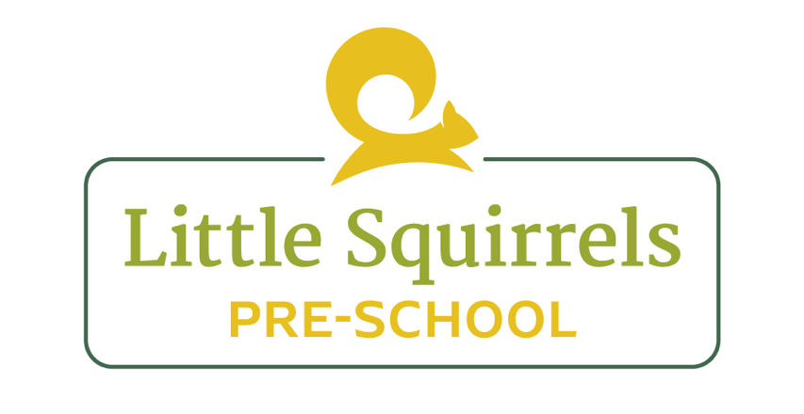

Administering Medication Policy

Calpol

At Little Squirrels, we will only give paracetamol routinely if it has been prescribed by a GP.
If a child needs a "top up" of Calpol, they are usually not well enough to be in Pre-School and parents will be asked to collect their child if they cannot manage without medication.
With parental permission we will give Calpol if necessary before collection, if a child is unwell.
A medication form will be completed on EYlog.

Unable to Contact Parent/Carer and Uncertainty Regarding Previous Calpol Administration

If a child becomes unwell during their time at the setting and develops a high temperature, and staff are unable to contact the parent/carer or emergency contacts, staff will continue to monitor the child’s condition closely and provide appropriate comfort, rest and fluids.

If staff are unable to establish whether the child has received Calpol/paracetamol prior to attending the setting, or are unable to establish the time and dosage of any previous administration, no further Calpol/paracetamol will be administered until the previous administration has been confirmed and it is safe to do so.

Where the child remains unwell and staff are unable to contact the parent/carer, particularly where the child has a high temperature and flu-like symptoms, staff will seek clinical advice from NHS 111. Staff will explain the child’s symptoms, temperature, age, known medical information and the uncertainty regarding any previous Calpol/paracetamol administration, and will follow the clinical advice provided.

All attempts to contact the parent/carer and emergency contacts, the child’s symptoms and temperature, any medication information available, and advice received from NHS 111 will be accurately recorded.

If the child’s condition deteriorates or they develop signs of serious illness, staff will seek emergency medical assistance by calling 999, without waiting for the parent/carer to make contact.

The child’s welfare and safety will remain the priority at all times.

Prescription medication

We are happy to provide prescribed medication. Prescription medicine will only be given to the person named on the bottle for the dosage stated. Medicines must be in their original containers.
Parents of children requiring prescription medication should allow a senior member of staff to note the details of the administration on the appropriate form and another member of staff should check these details are correct.
Parents must give prior written permission for the administration of each and every medication. Parents should notify us IMMEDIATELY if the child's circumstances change, e.g. a dose has been given at home, or a change in strength/dose needs to be given.
A medication form will be completed online once the dose has been given to the child. This will notify parents on the EY log app.

All medication for children must have the child's name clearly written on the original container and kept in a closed box, which is out of reach of all children.
Emergency medication, such as inhalers and epipens, will be within easy reach of staff in case of an immediate need, but will remain out of children's reach and under supervision at all times.

Any antibiotics requiring refrigeration must be kept in an area inaccessible to children and at the correct temperature.

Ongoing medication such as inhalers and allergy medication require a separate medication form to kept on file at all times. This must be updated if doses or medications change. Inhalers to be kept in accessible box in same place and all staff are to be made aware of location. Inhalers to be kept in named bags with dose information.
Epipens must be kept in the same accessible location, out of reach of children.

Reviewed by: Laura Leeds (Manager)
Review date: April 2026

