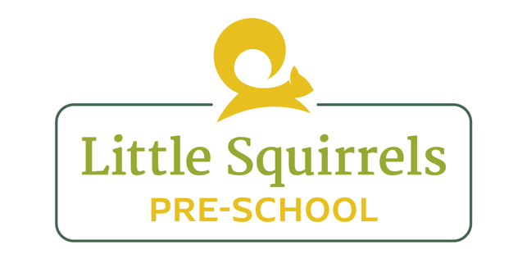 **Managing Behaviour Policy**

We believe that everyone at Little Squirrels should feel valued, respected and safe. We aim to ensure that children follow behaviour guidelines at Pre-School to ensure the safety of everyone.

What staff will do:

* We will make sure we promote communication constantly with the children and encourage them to use their words where they can, to reduce some conflict.

* We will always praise positive behaviour in pre-school.

* We will model kindness at all times, as we strongly believe it is one of the most important traits for a child to have. We will discuss this daily during carpet time.

* We will have golden rules that we will run through every morning before the session starts and explain why these rules are important to keep everyone happy.

* Staff will always speak to children politely and will not shout as a form of discipline. Staff will only raise their voice in order to be heard if the hall gets too loud, or if a child was in danger of hurting themselves.

* We will ensure that children take part in turn taking games regularly, so it becomes natural in their play.

* Staff will never use physical punishment in any way. If a child is ever needed to be restrained, this will be done professionally and parents will be informed. We will also record any events where we have used physical restraint.

* Common unacceptable behaviour includes biting, scratching, hitting, pushing and general fighting with other children or towards an adult.

* If any of the above are happening frequently and causing an issue, we try to find an underlying cause.  Staff will use a record sheet to try and establish any triggers for the behaviour, or patterns such as tiredness or communication difficulties.
* Use kindness hands to promote kindness and reward children for acts of kindness.
* Soothing and direct eye contact, on the child’s level, holding both their hands to gain their attention and a firm, level voice will be used to reprimand the child and explain to them that their behaviour was unacceptable.

If a child shows unwanted behaviour

1. If a child hurts another child, we will immediately remove the child away from the situation and give plenty of cuddles to the hurt child.

1. We will get down to the child’s level and explain their actions. Depending on the child’s age and development, we will act accordingly. For example, a younger child might not respond to a long explanation so a firm “no” and a demonstration of “kind hands” might be more suitable. An older child will be asked to reflect on their actions and to think about why they were in the wrong.

1. We will always acknowledge the feelings of the child and show understanding in their emotions. We will encourage different ways to express their emotions that doesn’t involve hurting their peers.

1. We will encourage the child to apologise, but will not push this if they don’t fully understand the concept of “sorry.” We will work with the child, through role play, modelling kind, positive behaviour.
2. We will continue to make use of our kindness tree and give kindness hands to children who display acts of kindness.
3. Use emotions area to read books and give children opportunities to reflect.
4. Use social stories when appropriate.
5. Personalised behaviour reward charts to be used to encourage positive behaviour.

If the behaviour continues:

Little Squirrels is committed to dealing with negative behaviour in a non-confrontational and constructive manner. Wherever possible, disruptive or challenging behaviour will be tackled collectively between staff, children and parents in the pre-school.

1. If the behaviour continues, staff will continue to communicate this with parents to ensure we have a consistent approach at home and at pre-school. We will use the graduated response to ensure we are doing everything possible to support the child.

1. We will then begin to shadow the child and use ABC charts to see if we can find a trigger in an attempt to limit the negative behaviour.

1. Finally, if the behaviour is not improving, we will ask for support from the Early Years Consultant.

1. There are occasions when such strategies alone will not alter or prevent negative behaviour. In such cases further action will be necessary including reviewing a child’s space at the setting either temporarily or permanently.

1. As a last resort the management has the right to temporarily suspend or exclude a child in the event of persistent, irresolvable unacceptable behaviour.

Reviewed by: Megan Bennett (Manager)

Review Date: July 2025