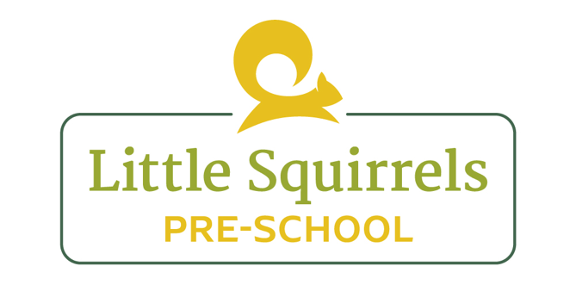

Complaints Policy and Procedure
Little Squirrels are committed to providing high quality care to all children and aim to communicate effectively and regularly with parents. This communication will involve the daily care of their children, the day to day running of the pre-school and any changes made to policies and procedures that will effect the care of their child. However if parents or carers deem it necessary to make a complaint we will deal with it appropriately and efficiently.

- Parents are made aware of our complaints procedure when they register their children.

- If a parent or carer has reason to make a complaint they may voice concerns directly with management. This can be done verbally or in written form.

- If the complaint is made verbally then managers will record the conversation.

- Each complaint will be taken seriously and investigated appropriately.

- If the complaint is serious then we will acknowledge the complaint within 7 days, it will be investigated and a letter of response with an action plan will be given.

- Contact details for Ofsted will be made available for parents if they believe their conflict was not resolved.

- Ofsted will be notified, given details and evidence of all serious complaints and how it was dealt with effectively.

- Changes to policies and procedures will be made if necessary and staff will made aware of any changes.

- Details of all complaints will be kept in a file for Ofsted and managers to access.

- LADO must be contacted if an allegation is made about a member of staff within 24 hours. This will be dealt with appropriately, recorded and followed up in accordance to advice from LADO.

Reviewed by: Megan Bennett (Manager)
Review Date: August 2022

