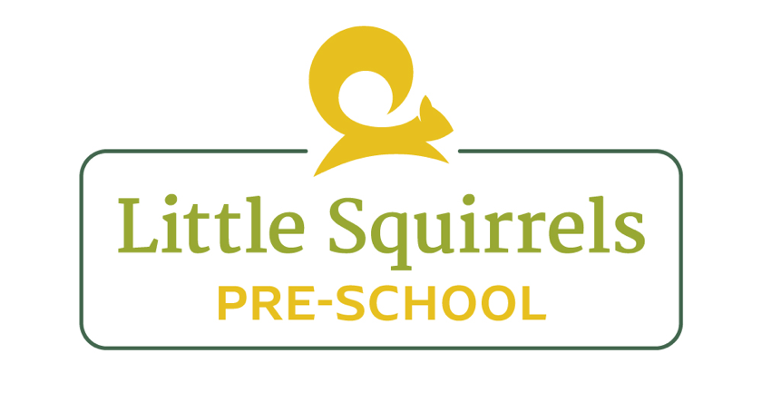

Recruitment Policy

At Little Squirrels, we have a strict recruitment policy.
- We will advertise any vacancies on our website and on the Devon County Council site. We will provide a detailed job description and desirable specification.

- We will ask for an application form and ask for references on the form. Once we have had a reasonable amount of applicants and reached the advertised closing date, we will shortlist people that fit the requirements and invite them for an interview.

- Once the applicants have been interviewed, management will have a meeting to discuss and decide on the new staff member.

- The staff member will be notified and we will explain that they have been offered the job once suitable checks have been completed.

- Management will then contact the references on the application and ask them to return the reference request form, stating if they have any concerns with the member of staff working with children. We will also check the staff member does not have any disciplinary actions against them. If the forms have not been returned within 5 working days, they will be chased.

- Once the forms have been returned, management will call the referee to make sure it was a legitimate reference.

- The applicant will be asked to provide documents so a DBS form can be completed. Once this has come back clear, the member of staff will be asked to come in for an induction. Staff will not be allowed to work alone with the children or provide intimate care until the DBS is completed.

- The Employer will arrange and pay for the Employee’s initial Disclosure and Barring Service (DBS) check where required for the role. Following receipt of the DBS certificate, the Employee shall be responsible for registering with and maintaining the DBS Update Service, including payment of any applicable subscription fees. If the Employee fails to register for, renew, or maintain their DBS Update Service subscription within the required timescales, resulting in the DBS certificate no longer being eligible for the Update Service, the Employee shall be responsible for the cost of obtaining any subsequent DBS check required by the Employer.

- Our induction process will ensure staff understand our ethos and values, learn the day to day running of the pre-school and make them feel welcome.

- Staff will be given a copy of all policies and procedures and will be asked to read through these before they begin work.

- Staff will be put on safeguarding level 2 training within 4 weeks of starting with us, but will be trained in basic safeguarding during their induction.

- Staff are subject to a six month probation period, they will be supported during this period to ensure they work well within the team. If, after the six months is up and the staff member has a higher than average sickness record, performance issues or any disciplinary proceedings, it is under management discrepancy whether their probation period will be extended.

Reviewed by: Laura Leeds (Manager)
Date: July 2026

