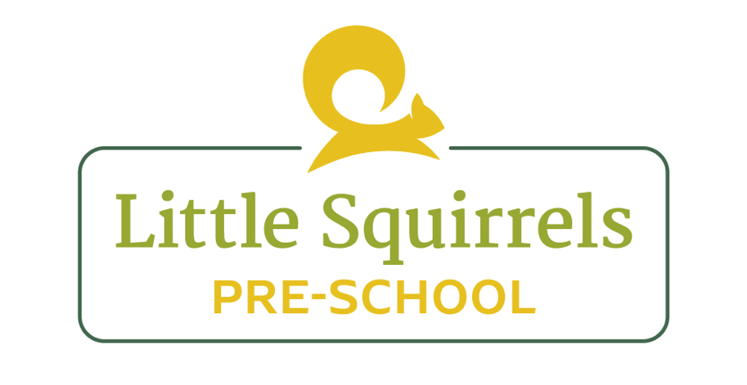
Sickness Policy

Our aim is to ensure that all children remain as healthy as possible in our care. To do this, we have outlined in this policy exclusion periods to keep infectious children away from the pre-school until they are feeling well again.
Incidents of Vomiting & Diarrhoea
Where possible, staff should attempt to ascertain the nature of the child’s illness. After the second bout of diarrhoea or after the first bout of vomiting, the staff member is to inform the child’s parent and to request that the child is collected from the preschool. The parent is asked to keep the child at home for 48 hours after the last bout of vomit or diarrhoea.

High Temperatures
Suspicions of high temperature should be checked using an ear thermometer. If the child’s temperature is above 38°C, the parent is called to advise them of the child’s condition and ask them to collect the child. Staff may attempt to reduce a child’s temperature by:
Stripping the child down to their vest or nappy and removing socks and shoes.
Offering the child a drink of water.
If the child’s temperature reaches 38.5°C or above we can administer emergency calpol if parents have agreed to this on the application form.
We ask that the child remains home until 36 hours after the fever subsides

Allergies
Child allergies are potentially serious and may even be life threatening. Managers are to ensure that the following procedures are followed:
A parent has notified the preschool by letter or via the registration form to inform us that their child has an allergy.
Ensure that the child’s on-line registration documents are annotated with the details of the allergy, including symptoms and emergency treatment.

Little Squirrels Exclusion Policy
At Little Squirrels, we mainly follow the advice from the Public Health “Spotty Book.” However, there are a few conditions that we have our own policy for. These are outlined the table below.
Condition | Exclusion Period
Sickness and diarrhoea | 48 hours after last episode.
Bronchiolitis | Until the child is fully recovered.
Chicken pox | 5 days minimum, all blisters must be completely healed before returning.
Hand, Foot and Mouth | 3 days minimum, all blisters must be completely healed before returning.
Conjunctivitis | 24 hours after receiving eye drops.
Headlice | Until the first course of treatment has been given.
Impetigo | 48 hours after starting treatment.
Scarlett Fever | 24 hours after starting antibiotic treatment.
Fever | 36 hours after fever has subsided

Informing the preschool of Child Sickness
Parents/carers are asked to inform the preschool of the condition affecting the child as soon as possible. Parents of sick children are asked to apply the exclusion policy as detailed in the table above.
Preschool Child Sickness Procedures
If a child is found to have an infectious disease during a preschool session the parent/guardian will be immediately informed and the child will be excluded in accordance with the table above.
If a child becomes unwell whilst they are at the preschool, staff are to ensure that the parents are contacted immediately and the child is offered a suitable resting place, with a member of staff supervising at all times.

Reviewed by: Laura Leeds (pre-school manager)
Date : August 2023

