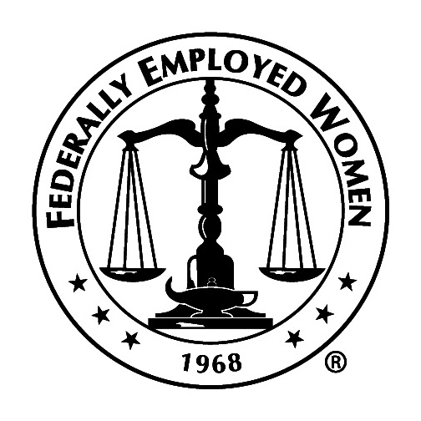 | Northeast Region  Federally Employed Women  REQUEST FOR ELSIE ELWOOD  SCHOLARSHIP FUNDS

Name: ________________________________________________________

Membership ID Number: __________________________________________

Phone Number: _________________________________________________

Membership is current with BOTH National FEW and Chapter: __ Yes __ No

Scholarship Amount Being Requested: _______________________________

Purpose of Scholarship: ________________________________________________

_____________________________________________________________________

_____________________________________________________________________

_____________________________________________________________________

Please outline your active involvement in FEW (e.g., attend Chapter meetings regularly, participate in committee work (please specify name of committee and whether at Chapter, Region, and/or National level), attend local FEW events (please specify Chapter, Region, and/or National level): _____________________________________________________________________

______________________________________________________________________

______________________________________________________________________

If approved, date Scholarship Funds are needed: ________________________

If approved, who should the check be made out to: _______________________

________________________________________________________________

For Internal Use Only:

Date Received by Regional Scholarship Chair: ___ Initials of Regional Scholarship chair: ___

Request: ______ Approved _____ Initials of Regional Scholarship Chair
______ Disapproved _____ Initials of Regional Scholarship Chair

Contact Chapter Treasurer if not known; must be a member in good standing to apply.
If “no,” request will automatically be disapproved.
Enough to cover out-of-pocket tuition, hotel, and transportation to FEW National Training Program
How will the Scholarship funds be used, e.g., RTP, NTP, local training, etc.?
Submit to Dawn Nester, Scholarship Chair @ Histrylady@yahoo.com no later than September 17, 2022.

