SAVE THE DATE

“Springing Into Action for Your Future”
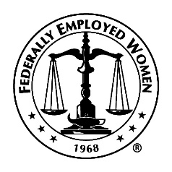
Northeast Region
Federally Employed Women
2nd Virtual
Spring Regional Training Program
May 21, 2022, 9:00 a.m. – 1:00 p.m. EST
Focus on your wellness, diversity, retirement, and FEW, then
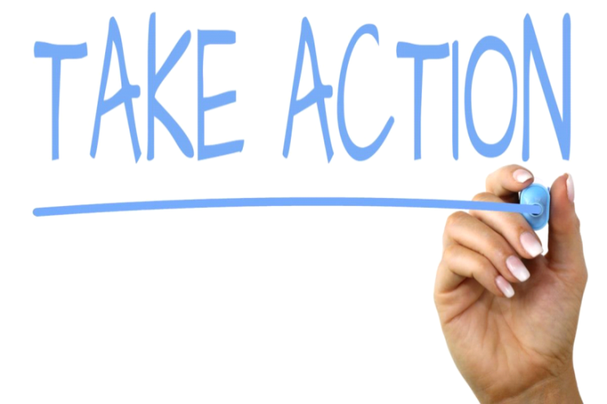

REGISTRATION OPENS SOON!

Working for the Advancement of Women in the Government

