SAVE THE DATE

“Women in History, Women Now”

|  |  |  |
| --- | --- | --- |
| C:\Users\Histrylady\AppData\Local\Microsoft\Windows\Temporary Internet Files\Content.IE5\KNWVW74Q\52_photos_of_women_who_changed_history_forever_-_A_woman_suffrage_activist_protesting_after_The_Night_of_Terror._[1917][1].jpg |  | **C:\Users\Histrylady\AppData\Local\Microsoft\Windows\Temporary Internet Files\Content.IE5\5SGQOG2J\A_Young_Woman_Holds_a_Banner_at_the_Civil_Rights_March_on_Washington,_D.C.,_on_August_28,_1963[1].jpg** |

**Northeast Region**

**Federally Employed Women (FEW)**

**Regional Training Program**

**Seneca Falls, New York**

**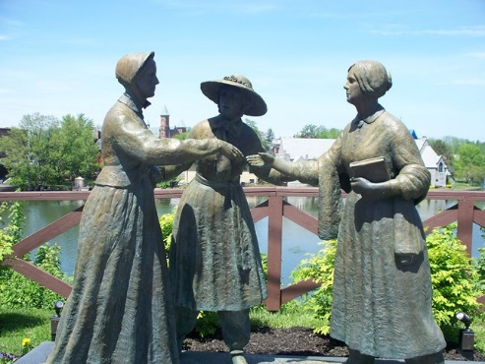**

**Seneca Falls Historical Society Museum**

**September 18-19, 2021, 8:00 a.m. – 12:00 p.m. EST (both days)**

**Both afternoons – Choose local historical sites to visit:**

**National Women’s Hall of Fame, Women’s Rights National Historic Park, Seneca Falls Heritage Area, Seneca Falls Visitor’s Center or Elizabeth Cady Stanton House**

**Working for the Advancement of Women in the Government**