
g

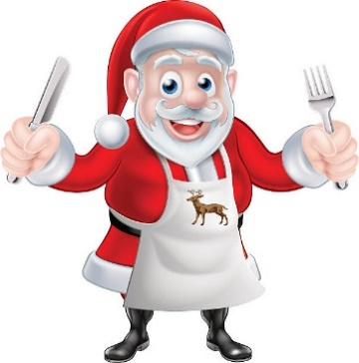
Christmas Meals & CancellationS
Cootamundra Meals on Wheels will be providing a Hot Meal delivery on all public holidays over the Christmas period.

Christmas Day this year is Wednesday the 25th of December, Boxing Day is Thursday the 26th of December and New Years Day is Wednesday the 1st of January 2025.

If you do not usually receive a meal on a Wednesday, a Thursday or a Monday, but would like to receive a meal on Christmas Day, Boxing Day or New Years day, please contact the office to organise a meal delivery.

Alternatively, if you do not require a meal on these days, could you please call to cancel. This will assist the service in organising our volunteers and deliveries ahead of time.

Meals on Wheels Office: (02) 6942 4695 Adina Care Kitchen: (02) 6942 7077
LIONS CLUB CHRISTMAS CAKES

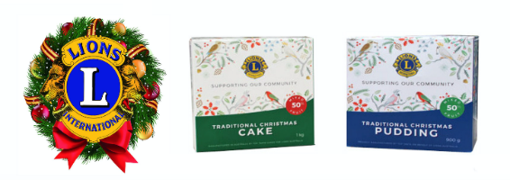

The LIONS CLUB Christmas Cakes are once again available to purchase from the Meals on Wheels Office. First introduced in 1965, the Lions Club Christmas Cake and Pudding program has raised more than $70 million. All proceeds are donated back into the community.

CONSUMER NEWSLETTER DECEMBER 24
Annual Christmas luncheon
Cootamundra Meals on Wheels invites you to join us for the Annual Christmas Luncheon on Tuesday 3rd December at 11am at the Cootamundra Ex-Serviceman’s club.
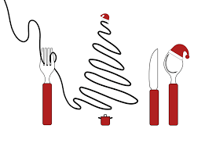
A separate invitation has been sent out, so if you would like to attend, please RSVP with payment by Tuesday the 26th November, to make sure we save you a seat!
It’s a fabulous way to celebrate the end of another year in a relaxed environment.
Our guest speaker for the event will be Leslie Burns – Aged Care specialist officer with Services Australia.
There will be a raffle and lucky door prizes on the day, and the big man in the red suit, Santa Claus will also drop in for a visit and to check who is on the naughty or nice list!! HO, HO, HO
OFFICE HOURS
Monday to Friday – 8.30am to 11.30am
1.00pm to 3pm
CLOSED CHRISTMAS DAY, BOXING DAY, AND NEW YEARS DAY

And have helped such causes as blindness Prevention and Vision improvement projects, Medical Research, Children’s Mobility Foundation, Eye Health Program, Hearing Dogs, Disaster Relief, Aged Care, Drug Awareness and Youth Programs.

There are a variety of sizes available including:
1.5 kg cake - $20 900 g Pudding - $16
1 kg cake - $16 80g Mini Cake - $2


Get into the Festive spirit at the 2024 Sparkling Streets Community Christmas Party.
Home alone on Christmas day?
Want to get out and share a meal with others?
Everyone is invited to this year’s annual
Combined Churches luncheon
Date: Wednesday the 25th of December
Venue: 90 Thompson Street, Cootamundra
Time: 11am to 2pm. Lunch is at 12 noon
Cost: Free
Share nibbles on arrival, a main meal and sweets Takeaway is available.
For further information or to book please contact
Sam on 0418 254 677 or
Sister Kathie on 0400 307 585

Supported by the Cootamundra Gundagai Regional Council, this years’ party will be held on Thursday the 19th of December 2024 between 6pm and 9pm in Parker Street.
Late night shopping means it’s a great chance to pick up some last-minute Christmas gifts. Grab a bite to eat and take in the festive lighting and décor, visit the many market stalls, or sit back and listen to the live entertainment. Whatever you choose, there will be lots to see and do.
Services Australia - kiosk
A Centrelink Help Service Kiosk is now located at the Cootamundra Branch of SWS Bank.
A computer and printer is available to the public to access Centrelink and Medicare accounts, read messages or upload forms. Bank staff are unable to assist with any enquiries, so it’s a good idea to be able to log in to your own My Gov account independently before you head in there.

Christmas Crackles
Social Support – Out and About
The social support outings have been a massive hit this year. It’s been fantastic to see so many people coming on our trips and get-togethers. These are a great way to be active as well as foster new friendships. Our last trip was to Stockinbingal, where lots of our clients not only enjoyed a lovely lunch at 44 Hibernia, but also got to meet a few of the locals!! We are already busy planning the events for 2025,
so as soon as we have our
dates sorted, we will let you
know. That way you can
be sure to mark the dates
in your diary!!

What do you call an
elf who has just won
the lottery?
Welfy
How much did Santa
pay for his sleigh?
Nothing – it was
on the house

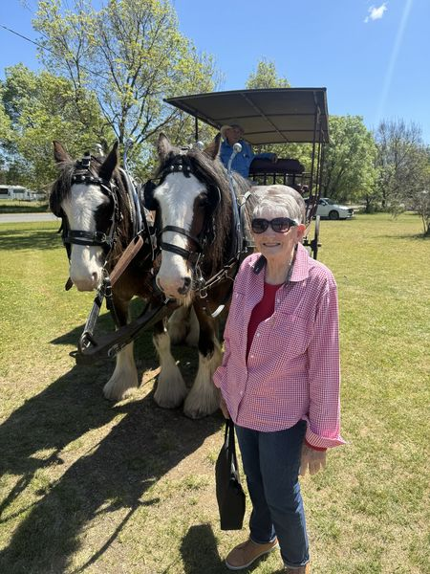
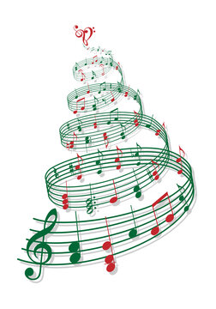
CHRISTMAS CAROLS IN THE PARK
Held in Albert Park,
this year’s carols will
take place on
Sunday 15th December
Carols start at 7pm
With activities for the
kids starting at 6pm
And includes a sausage
sizzle, face painting
and craft.

