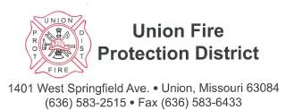

April 22, 2024

To Applicants for the Union Fire Protection District firefighter position:

- We must have your application and required documents no later than May 3, 2024, by 4:00 p.m.
- The scheduled written and practical test date is May 7, 2022, starting at 08:30. Applicants will be notified if a change in date occurs due to weather or unforeseen circumstances. The location of tests will be at the lower-level training room, 1401 West Springfield Ave, Union MO 63084.
- The written test is based on minimal training and certification levels as they pertain to firefighting and emergency service work.
- The practical agility test will follow the written test. Applicants may dress in athletic wear and will need to bring personal turnout gear, if possible. Applicants are also encouraged to bring a SCBA of their choice. If an applicant is not able to bring PPE or SCBA they will be provided.
  - A summary of the practical test is in the documents section of the www.unionfd.org website.
- You are required to have a photo ID and assigned number card.

If you have any further questions call Union Fire Protection District @ 636-583-2515

Thank you!

