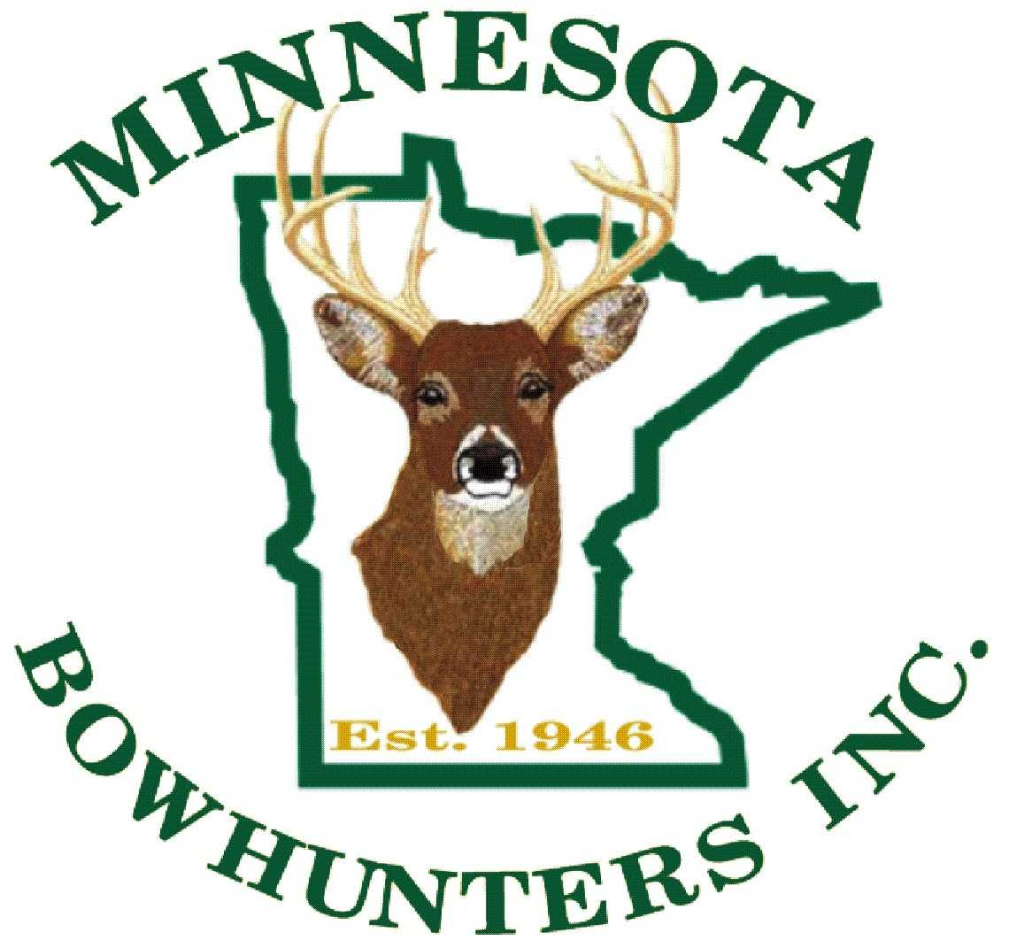
LANDOWNER PERMISSION FORM

Landowner:_____________________ Hunter/Angler: _______________________
Address: _______________________ Address: ____________________________
_______________________ ____________________________
Phone#: _______________________ Phone #: ____________________________
Vehicle ID: __________________________

As the landowner I give: __________________________ permission to hunt/fish on my lands described below for the dates: _________ to _________ according to the state or regional fish and game laws and regulations.

Property
Description: ____________________________________________________________________________
_______________________________________________________________

I, the above named hunter/angler, promise to obey all state hunting/fishing regulations and abide by any rules established by the landowner and agree to waive landowner liability during these activities while on the premises.

___________________________________.
Hunter/Angler Signature For more details see MN Statute 604A.20-604A.27

--------------------------------------------------------------------------------------------------------------------------------------------

LANDOWNER PERMISSION FORM

Landowner:_____________________ Hunter/Angler: _______________________
Address: _______________________ Address: ____________________________
_______________________ ____________________________
Phone#: _______________________ Phone #: ____________________________
Vehicle ID: __________________________

As the landowner I give: __________________________ permission to hunt/fish on my lands described below for the dates:_________ to __________ according to the state or regional fish and game laws and regulations.
Property
Description: _______________________________________________________________________
___________________________________________________________

I, the above named hunter/angler, promise to obey all state hunting/fishing regulations and abide by any rules established by the landowner and agree to waive landowner liability during these activities while on the premises.

___________________________________.
Hunter/Angler Signature For more details see MN Statute 604A.20-604A.27

