***RESTORATIVE RESCUE, INC.***

Instructions:  Please read and answer all questions. Please type or print answers to all questions. Fax or bring in completed application. Please keep a copy of your application and fax transmittal receipt for your records. A separate application must be submitted for each class you are applying for. Fax Number [443-773-2015](tel:(443)%20773-2015)

**SELECT COURSE**

PHLEBOTOMY TECHNICIANMEDICATION TECHNICIAN

**PERSONAL INFORMATION (print)**

First Name*     Middle Initial           Last Name*

Previous Names (i.e., maiden name)

Social Security Number* Birth Date*             Drivers’ license/state ID#

**CONTACT INFORMATION**

Street Address* Apartment/unit#*

City*         State*                           Zip*

Cell Phone *      Home Phone                  Email Address*

Emergency Contact Name and phone number

**EDUCATION:** Have you graduated from High School or received a High School Equivalency diploma (GED)

https://docs.google.com/drawings/d/s8wR-vClTT8soIM6fLqOrVA/image?w=25&h=25&rev=1&ac=1https://docs.google.com/drawings/d/sMOHtUFHK3RcHvSdISE1KqQ/image?w=25&h=25&rev=1&ac=1

Yes                   No   If no, circle highest grade completed

                                                        1   2   3   4   5   6   7   8   9   10   11   12

|  |  |  |  |  |  |
| --- | --- | --- | --- | --- | --- |
| School | Name & Address | Dates attended | Credit hrs. completed | Degree | Did you graduate? |
| High School |  |  |  |  |  |
| Technical/business |  |  |  |  |  |
| College/university |  |  |  |  |  |

**EMPLOYMENT INFORMATION:**

Current Employer Address Position/Title

Supervisor Name Title Business Phone

**QUESTIONNAIRE\***

**Please respond to the following questions:**

Why do you want to enroll in this Certification Training Program? *

__________________________________________________________________________________________________________________________________________________________________________________________________________________________________________

Why do you feel you would excel in this program? *

__________________________________________________________________________________________________________________________________________________________________________________________________________________________________________

**Accommodations: Qualified individuals with a disability may request special accommodations under provisions of the Americans with Disabilities Act (ADA) by contacting us.**

**Voluntary Information: to meet U.S. Department of Education, Integrated Post-Secondary Education System reporting guidelines, we are requesting your voluntarily supply for**

**following information. This data will not be considered when in evaluating your application.**

**Qualified applicants are considered for admission, without regards to race, color, religion, sex, national origin, age or marital status. Information obtained relative to above stated areas will be used for statistical analysis and not as criteria for admission. All information will remain confidential.**

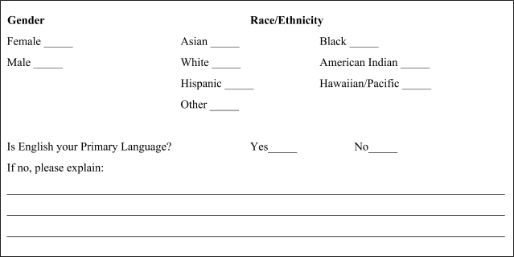  
  By signing, I ________________________________________certify that all of the information on this application is correct and complete. I understand that any misrepresentation can result in clients’ ineligibility to start companies’ Phlebotomy Certification Training Program.

________________________________ ________________________

Signature* Date*