Raising Your New Best Friend 101

About the Breed:
The Frenchie is a charmer with their beauty and brains. Frenchies are intelligent and well-tempered; They happily adapt to life with children and other animals. They do not require much outdoor and/or physical activity; a daily outdoor play session or short walk will suffice. The French Bulldog is the perfect city dog for these features as well as their compact size!
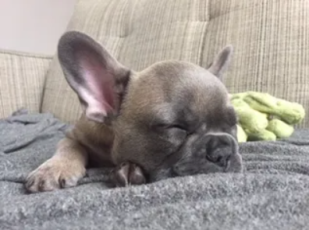
As far as size goes, Frenchies are relatively small to medium dogs. The average height of the French Bulldog is between 11-13 inches (the range is based on genetics). The weight of a Frenchie also ranges. The weight of a Frenchie is typically no more than around 28 pounds, which also is based on genetics. When adopting a Frenchie from us, feel free to ask us about our genetics--we proudly stand behind our genetics with a health guarantee!
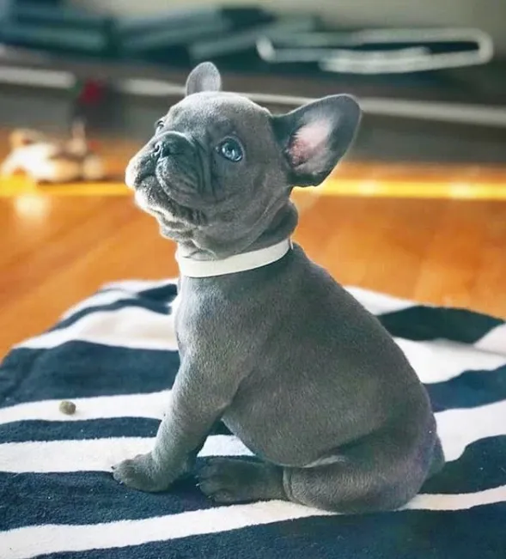
Now that you have read about the breed, you are sure a French Bulldog puppy is the perfect fit for you.. Next step? Reserve your pup! Contact (410) 353 - 8863.

Before picking up your pup...
Do Prepare in Advance! As with any breed, the basics you will need before taking your pup home remain the same. Please have food, toys, play pen or crate, food and water bowls, and a dog bed to prepare for your puppy pick-up date. We do provide small bags of dog food of what our puppies are currently on (Royal canin - puppy).
If you are planning on picking up your pup alone, please bring a carrier or crate to place him/her in as it is not safe to travel with the pup loose roaming in the car. If you are planning on traveling with another person, it is fine for the pup to be held during the car ride to their new furever home.
When taking your pup home…
- Your puppy will likely be nervous; new people, new surroundings, new smells, etc. can be overwhelming. It is important to give them a “puppy zone” where they can have a quiet and safe space. This is where toys, food, and bowls will be kept. Let your new puppy settle around to the new family in peace.
- Start potty training as soon as you can. When the puppy arrives home, take them to the designated “potty spot” and praise them when they go. Repeat. Consistency is key. Your puppy will need to go about every two hours, as soon as they wake up from a nap, and right after they eat. Again, consistency is key. And… accidents will happen. There are tons of resources online as well on tips to potty training.
- Our puppies do come microchipped, but it is also important to purchase a collar including name tags. Please (please, please, please) remember to register the microchip in the new owner’s name!
- Feel free to reach out to me for any questions! I love to see and hear updates, questions, and pictures anytime!

