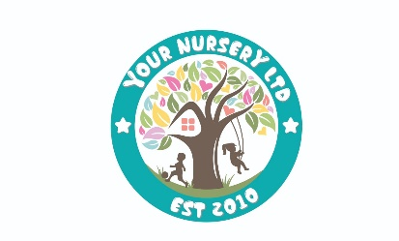

**Infection Control Policy Summary for Parents**

At Your nursery Ltd, ensuring a healthy and safe environment for children, staff, and visitors is a top priority. This policy outlines our approach to preventing and managing infections. Below is a parent-friendly summary:

**Key Practices:**

**Hygiene**

* **Handwashing:** Strict handwashing procedures are followed using liquid soap and water or antibacterial gel when necessary.
* **Cleaning:** All areas, including toys and play equipment, are cleaned regularly following detailed procedures.
* **Toilets:** Toilets are checked and cleaned throughout the day to maintain hygiene.

**Dealing with Illness**

* **Exclusion for Illness:** Children and staff with contagious diseases or sickness/diarrhoea must stay home for the recommended period (e.g., 48 hours after symptoms stop).
* **Notifiable Diseases:** If required, cases are reported to health authorities, and guidance on closures or precautions is followed.

**Managing Spills and Waste**

* **Body Fluid Spills:** These are cleaned immediately using appropriate protective equipment and disposed of safely.
* **Waste Disposal:** All waste is disposed of correctly, with additional precautions for contaminated items.

**Food and Play Safety**

* **Food Preparation:** Staff are trained in food hygiene, and temperature controls are monitored from delivery to serving.
* **Sand and Water Trays:** Extra cleaning is done during outbreaks of sickness, or these trays may be temporarily removed.

**Laundry**

* Sleep mats and linens are washed regularly, with strict separation of clean and soiled items to prevent contamination.

**How You Can Help:**

1. Keep your child at home if they are unwell.
2. Inform the nursery of any illnesses or symptoms your child may have.
3. Ensure your child practices good hygiene at home, such as regular handwashing.

This proactive approach helps us maintain a clean, safe, and healthy environment for everyone. If you have any questions or concerns, feel free to speak with our team.