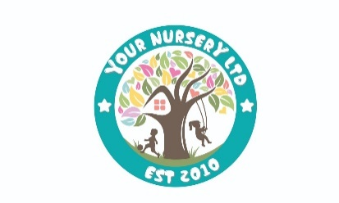

**Summary Allergies, Asthma, Medical conditions**

This policy outlines how the nursery manages allergies, asthma, and other medical conditions to ensure the safety and well-being of children and staff. Here's a summary for parents:

1. **Enrolment and Action Plans**:
   * Parents must inform the nursery of their child’s allergies, asthma, or medical conditions during enrolment.
   * An **Individual Action Plan** will be created, including medical details, emergency procedures, and medication consent. It must be signed by parents and the nursery team, updated as needed, and reviewed every six months.
2. **Staff Awareness and Training**:
   * All staff are trained to recognize and respond to allergies, asthma, and related emergencies.
   * Staff are informed about each child’s condition, and Action Plans are accessible in key locations like the child’s room, kitchen, and main office.
   * Emergency equipment, such as EpiPens, is managed by trained personnel.
3. **Food Safety and Allergies**:
   * Parents may need to supply clearly labeled food items for children with food allergies.
   * Special diets are managed using a communication log, and food for children with allergies is served on distinctive orange tableware.
   * Menus are closely monitored, and any changes are communicated promptly.
4. **Emergency Procedures**:
   * In case of allergic reactions or asthma attacks, the nursery follows the child’s Action Plan and seeks medical help if needed.
   * Parents are notified immediately of any incidents, and reports are documented.
5. **Communication**:
   * Regular newsletters remind parents to inform the nursery of any new medical conditions or allergies their child develops.

This policy ensures the nursery is well-prepared to manage individual health needs and emergencies safely and effectively.