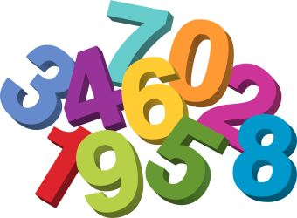

7th- Number day

We will be doing lots of activities around numbers

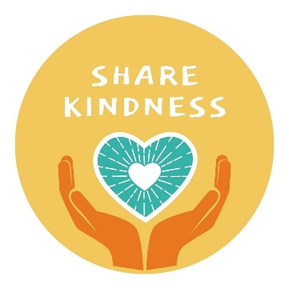

10th-14th Acts of kindness

We will be doing different acts of kindness throughout the week- look on our social media to find out what we have been up to

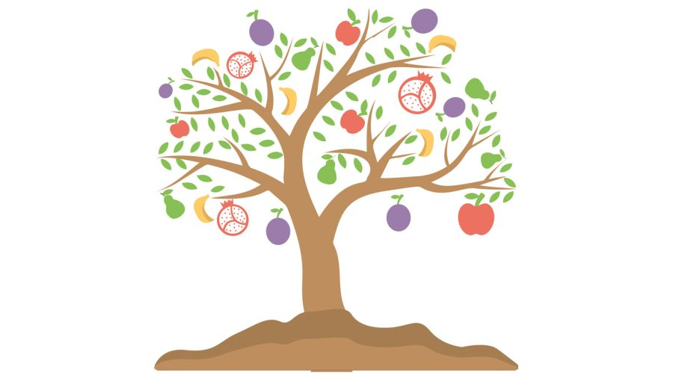

13th Tu b’shevat

A Jewish holiday that marks the "New Year of the Trees". We will celebrate by eating fruit that grows on trees.



14th Valentine’s Day

We will be wearing red and pink and spreading the love through different activities



26th National tell a fairytale day

We will be looking at a particular fairytale, reading the story and doing activities around this book.

28th Start of Ramadan