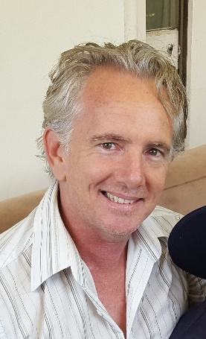 |  |  | MORE THAN YOU ARE ADHD COACHING  More than you are Coaching is owned and operated by Tim Butler. Tim is an experienced Psychiatric Nurse who has worked extensively with adolescents in an acute Mental Health setting. This has given him first-hand experience of working with patients and family experiencing mental health difficulties such as anxiety, depression, psychosis, OCD, eating disorders, BPD, bipolar as well as ADHD. This is a unique quality for a Coach that enables him to work with people who have a dual diagnosis (which is often the case).  He also has extensive knowledge and qualifications as an ADHD Coach through the ADDCA ADHD training program in New York and a strong interest in ADHD generally.  He is a member of AADPA (Aust. ADHD Professionals Assoc.) who are psychiatrists, psychologists, pharmacists, GP’s, and ADHD coaches. The association is an authority in ADHD and consult with government and advocate groups regularly.  On a personal note, Tim enjoys singing, playing guitar(badly), swimming, scuba diving and solving problems. He has a 9yo son and barracks for Hawthorn.  Other work experiences include working on TV shows, FIFO pipeline construction (local and overseas), underpinning houses, phlebotomist (taking blood) and cleaner.

Tim butler
 | 0407874706
 | tim@morethanyouare.com.au
 | morethanyouare.com.au

